CS 161 - Gayathri Iyer

Assignment #7 - Arrays

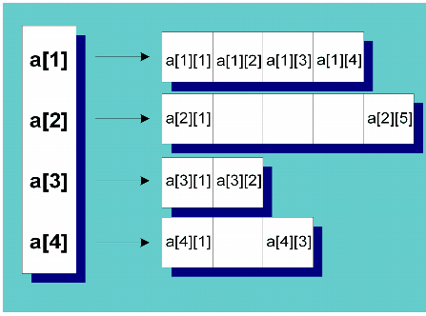

Assignment:
Write a program to calculate students’ average test scores and their grades. You may assume the following input data: Create a text file called arrays.txt with this data.

Johnson 85 83 77 91 76
Aniston 80 90 95 93 48
Cooper 78 82 22 90 73
Gupta 92 83 30 69 87
Blair 23 45 96 38 59
Clark 60 85 45 39 67
Kennedy 77 31 52 74 83
Bronson 93 94 89 77 97
Sunny 79 85 28 93 82
Smith 85 72 49 75 63

Design Considerations:
- No global variables. All variables must be inside main().
- Use three arrays: a one-dimensional array to store the students’ names, a (parallel) two-dimensional array to store the test scores, and a parallel one-dimensional array to store grades.
- Your program must contain at least the following functions: a function to read and store the data into two arrays, a function to calculate the average test score and grade, and a function to output the results. Have your program also output the class average.
- You must read from the input file into the arrays. Make sure to pass the arrays and the file stream variable (if needed) to the functions by reference.
- Points will be awarded for the following attributes of your solution:

  - If your program does not compile, you get only 3 points irrespective of what the error is.
  - If it compiles, I check and deduct points for the following:
    - Your file name must be a07.cpp
    - Your header section must have “Sources:” line to include any sources you may have used.
    - The quality of your source code (Form). In particular, pay attention to your indentation, capitalization, and so forth. Be sure to read the class C++ style guide before working on this problem. However, if you follow the style used in the book you will be fine!
    - The design considerations mentioned above must be followed.
  - Program works as specified, and does not have the above-mentioned deficits, full points will be awarded.

Deliverables:
- Please name your file a07.cpp.
- Upload into the Dropbox section of D2L your program source file (the one with an extension of .cpp) only. Please be sure this file includes your name and that of your partner, if any as the authors, assignment description and number, and date, as a program comment!
- Be sure your program header includes a //Sources: comment line where you indicate any sources of help you may have received, such as from a friend, from the Internet, and so on. If you acknowledge your sources, you run much less risk of running into problems with plagiarism. If you had no outside sources of help, the comment should read //Sources: None.
- If you work as a pair, with a partner, it is essential that you each upload the solution into the drop box, even though it should be the same as your partner’s submission. D2L makes it hard to give a grade to someone who has not submitted anything for grading. Please be sure your program comments contain both your name, and your partner’s name.
- Be certain to check that you completed the upload successfully. After you click the Upload File button, you must also click the SUBMIT ASSIGNMENT button. This is very easy to forget. You have been warned.
- You may upload as many versions as you wish prior to the due date. I will only see and grade the last one. After the due date, assignments are accepted in the drop box for 1 week, until the end date. There will be a 10% penalty for this. After that, the drop box will be closed.

