CS 161 - Gayathri Iyer

Assignment #6 - Functions

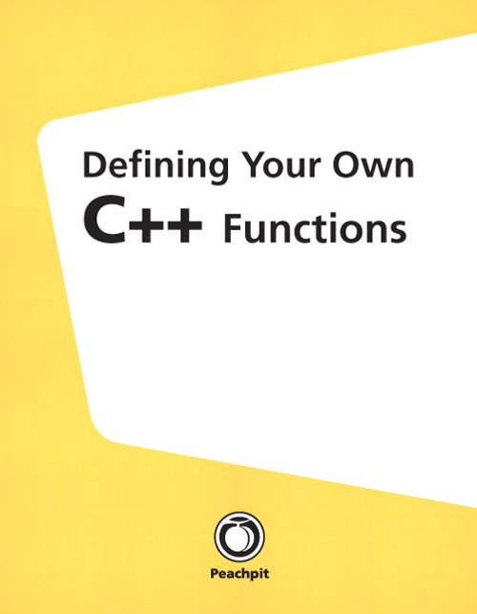

Assignment:
Write functions to do the following. Do not change the function signature. Please write the functions, using the given function signature and specifications. Finally write the main program to test the functions using a menu.

- Write a function that reads positive numbers from the user, and returns the largest number and outputs it. The function signature should be
int largest();
The function does not take any parameters. So, you can read all your input in the function. It returns an int, which is the largest number to main. Use a loop to read the numbers until the user enters -1 to quit. As you read, keep track of the largest number. When the user enters -1, stop reading and return the largest number to the main function. Do NOT use an array for this program.
- Write a function that takes as a parameter an integer, and returns the number of odd, even and zero digits. This should be a void function since a function cannot return 3 values. Here is your function signature:
void numberCount(int number, int &oddCount, int &evenCount, int &zeroCount);
So, if the user enters 34873045, the number of odd digits is 4, even digits is 3, and zeros is 1. You must use integers, do not use strings.
- The main function must display a simple menu as follows:
Welcome to my program! Please choose one of the following:
- Find the largest of a list of positive numbers (-1 to quit).
- Given a positive number, display the number of even, odd and zero digits in the number.
- quit this program.
Based on what the user picks, use a switch or an if statement and output the corresponding answer. This menu should be in a loop so it continues to display after each turn until the user enters ‘c’ to quit.

Design Considerations:
- Follow the above-mentioned specifications very carefully to receive all points.
- No global variables. All variables must be inside main().
- Points will be awarded for the following attributes of your solution:

  - If your program does not compile, you get only 3 points irrespective of what the error is.
  - If it compiles, I check and deduct points for the following:
  - Your file name must be a06.cpp
  - Your header section must have “Sources:” line to include any sources you may have used.
  - The quality of your source code (Form). In particular, pay attention to your indentation, capitalization, and so forth. Be sure to read the class C++ style guide before working on this problem. However, if you follow the style used in the book you will be fine!
  - The design considerations mentioned above must be followed.
  - Program works as specified, and does not have the above-mentioned deficits, full points will be awarded.

Deliverables:
- Please name your file a06.cpp.
- Upload into the Dropbox section of D2L your program source file (the one with an extension of .cpp) only. Please be sure this file includes your name and that of your partner, if any as the authors, assignment description and number, and date, as a program comment!
- Be sure your program header includes a //Sources: comment line where you indicate any sources of help you may have received, such as from a friend, from the Internet, and so on. If you acknowledge your sources, you run much less risk of running into problems with plagiarism. If you had no outside sources of help, the comment should read //Sources: None.
- If you work as a pair, with a partner, it is essential that you each upload the solution into the drop box, even though it should be the same as your partner’s submission. D2L makes it hard to give a grade to someone who has not submitted anything for grading. Please be sure your program comments contain both your name, and your partner’s name.
- Be certain to check that you completed the upload successfully. After you click the Upload File button, you must also click the SUBMIT ASSIGNMENT button. This is very easy to forget. You have been warned.
- You may upload as many versions as you wish prior to the due date. I will only see and grade the last one. After the due date, assignments are accepted in the drop box for 1 week, until the end date. There will be a 10% penalty for this. After that, the drop box will be closed.

