Improving TCDB Protein Family Annotations with Machine Learning

Introduction
Machine Learning (ML) and Deep Learning (DL) have emerged as powerful tools for large-scale classification and pattern discovery in bioinformatics.[2,3] In this study, we apply ML methods to classify protein families and evaluate whether the assignments of protein to families in the Transporter Classification Database (TCDB) are biologically coherent and internally consistent. Using customized negative-control sets within our test datasets, we benchmark predictions at both the family and subfamily levels with comprehensive evaluation metrics. By detecting potential misclassifications and analyzing related domain architectures, this program provides an alignment-free approach to improve the annotations and hierarchical knowledge representation of TCDB. This program will also be integrated into the TCDB platform, allowing users to upload protein information and get classification results based on the provided input.

Benchmark Dataset
We used the transport protein dataset from Transporter Classification Database(TCDB) for training our machine learning and deep learning models. Officially adopted by the International Union of Biochemistry and Molecular Biology (IUBMB) in 2001, TCDB serves as a key resource for researchers to study transporter function. The database contains over 15,500 transport systems, classified into 1,536 families and 82 superfamilies. [1]
The training and testing sets at different levels were splitted based on the following rules: (i) if a class contained only one member, it was included in both the training and testing sets; (ii) if a class contained two members, it was split 1:1 between training and testing; and (iii) if a class contained more than two members, it was split 80% for training and 20% for testing. To evaluate whether the models can correctly distinguish proteins that belong to a specific target class from proteins outside that class, an additional true negative set was created. For each target class, proteins from different superfamilies were selected as negative controls and added to the test set. If a target class had no superfamily assignment, negative controls were drawn from proteins whose families did have superfamily assignments. The size of the negative control set was balanced against the number of positive samples, with a minimum of five negatives included when the positive set was small. Details of the data are shown in Table 1.
Table 1. Dataset Details
Dataset resource | Number of Family | Number of Subfamily | Number of Proteins
TCDB Database | 762 | 1127 | 5173
 |  |  | Family Level |  | Subfamily Level
 |  |  | Training | Testing | Training | Testing
 |  |  | 3868 | 1347 | 3784 | 1561
Data Modeling & Encoding
Compared to other models that typically rely on raw amino acid sequences as input [4,5], our program takes another alignment-free approach based on the domain architecture of the protein. We represent each protein using the following set of information: protein accession, sequence length, family/subfamily accession, domain accession with corresponding positions, and separators that indicate the spaces between domains within the protein.
To prepare the data for machine learning models, we constructed a representation of each protein by encoding its domain architecture. The classification target (Family or Subfamily) was label-encoded, and a global vocabulary was created from all unique domain accessions. Each protein and its corresponding domain architecture were transformed into six features:
(i) a binary vector of length |V| indicating the presence or absence of each domain from the global vocabulary.
(ii) for each domain, we included its start and end positions (normalized by total protein length), yielding a 2×|V| matrix that was flattened.
(iii) a score vector of length |V| was computed from domain E-values, where each present domain was assigned a score of -log10(max(evalue, 10^-300)) and absent domains were assigned 0. Thus, smaller E-values yield larger scores, indicating stronger domain matches.
(iv) The sequential order of domains within the protein was captured by a vector of domain indices.
(v) a separator feature is formed by triplets of start, end, and length $[s, e, (e−s)]$.
(vi) domain count in the protein.
After concatenating these features, it yields a feature vector of dimension 4|V| + 111, where V represents the number of unique domains. The additional 111 dimensions correspond to 60 separator features, 50 domain-order features, and 1 domain-count feature. Finally, the entire feature matrix was standardized using z-score normalization.

Machine Learning Algorithms and Neural Network Architecture
To evaluate our feature engineering strategy, we implemented a pipeline including classical machine learning algorithms and a feed-forward deep neural network (DNN), and then benchmarked the performance of all models. The baselines of the ML algorithms include Random Forests, Extra Trees, Logistic Regression, k-Nearest Neighbors, Gaussian Naïve Bayes, XGBoost [7,8,9,10,11,12]. All models are given the same feature representation extracted from the protein (see Data Encoding) and using the same random seed. The neural network is a three-block multilayer perceptron with architecture D → 512 → 256 → 128 → C, where each hidden block consists of Linear → ReLU → BatchNorm1d → Dropout(0.4) and the classifier is a final linear projection to the number of classes. Linear layers are initialized with Kaiming normal weights and zero biases, and batch-norm scales and shifts are initialized to one and zero, respectively. Training proceeds on GPU using cross-entropy loss and AdamW optimizer with learning rate 0.001 and weight decay 0.01.

Results
We used similar evaluation metrics consistent with those described in “An improved deep learning model for hierarchical classification of protein families” [4]. The classification accuracy was calculated as$(TP+TN)/(TP+TN+FN+FP)$. The definition of those metrics are the following:
TP (True Positives): cases in which the model correctly predicted that a protein belongs to the target family.
FN (False Negatives): cases where a protein from the target family was incorrectly classified as a member of another family.
TN (True Negatives): cases where the model correctly rejected a protein not belonging to the target family.
FP (False Positives): cases where a protein outside the target family was incorrectly classified as the member to it.
We also used the AUC-ROC [6] metric to evaluate the model’s ability to discriminate between classes across varying confidence thresholds. The ROC curve is a graph that has the true positive rate (TPR) on the y-axis against the false positive rate (FPR) on the x-axis. Specifically, TPR ($TP/TP+FN$) indicates the proportion of proteins correctly predicted as belonging to the target family among all proteins in the target family, while FPR ($FP/FP+TN$) represents the proportion of proteins from outside the target family that were incorrectly classified as members of it.
For AUC, it corresponds to the area under this curve, which provides a scalar measure of classification performance ranging from 0.5 (random prediction) to 1.0 (perfect discrimination). Table 2 presents the results of different models evaluated on the custom train/test split described above.

Table 2. Classification Performance of TCDB Dataset In Each Level
Method | Family |  |  |  |  | Subfamily
 | Accuracy(%) | Precision(%) | Recall(%) | F1-Score(%) | AUC(%) | Accuracy(%) | Precision(%) | Recall(%) | F1-Score(%) | AUC(%)
Extra_trees | 96.79 | 99.06 | 93.96 | 96.12 | 97.67 | 91.77 | 99.01 | 76.10 | 86.05 | 86.22
K-Nearnest Neighbor | 91.87 | 97.85 | 82.74 | 89.66 | 92.11 | 89.52 | 98.03 | 69.99 | 81.67 | 77.81
Logistic Regression | 95.99 | 98.43 | 92.07 | 95.14 | 96.62 | 91.02 | 97.99 | 74.63 | 84.73 | 81.65
Naive Bayes | 96.22 | 98.74 | 92.31 | 95.42 | 66.10 | 91.05 | 98.38 | 74.40 | 84.72 | 62.75
Neural Network | 96.32 | 98.68 | 92.60 | 95.54 | 98.04 | 91.36 | 98.17 | 75.51 | 85.36 | 86.65
Random Forest | 96.82 | 99.06 | 93.41 | 96.15 | 95.82 | 91.96 | 98.79 | 76.85 | 86.45 | 84.32
Xgboost | 94.69 | 98.63 | 88.78 | 93.45 | 92.46 | 88.74 | 97.96 | 67.65 | 80.02 | 84.19

Figure 1 Accuracy Comparison (Family Level) Figure 2 AccuracyComparison (Subfamily Level)
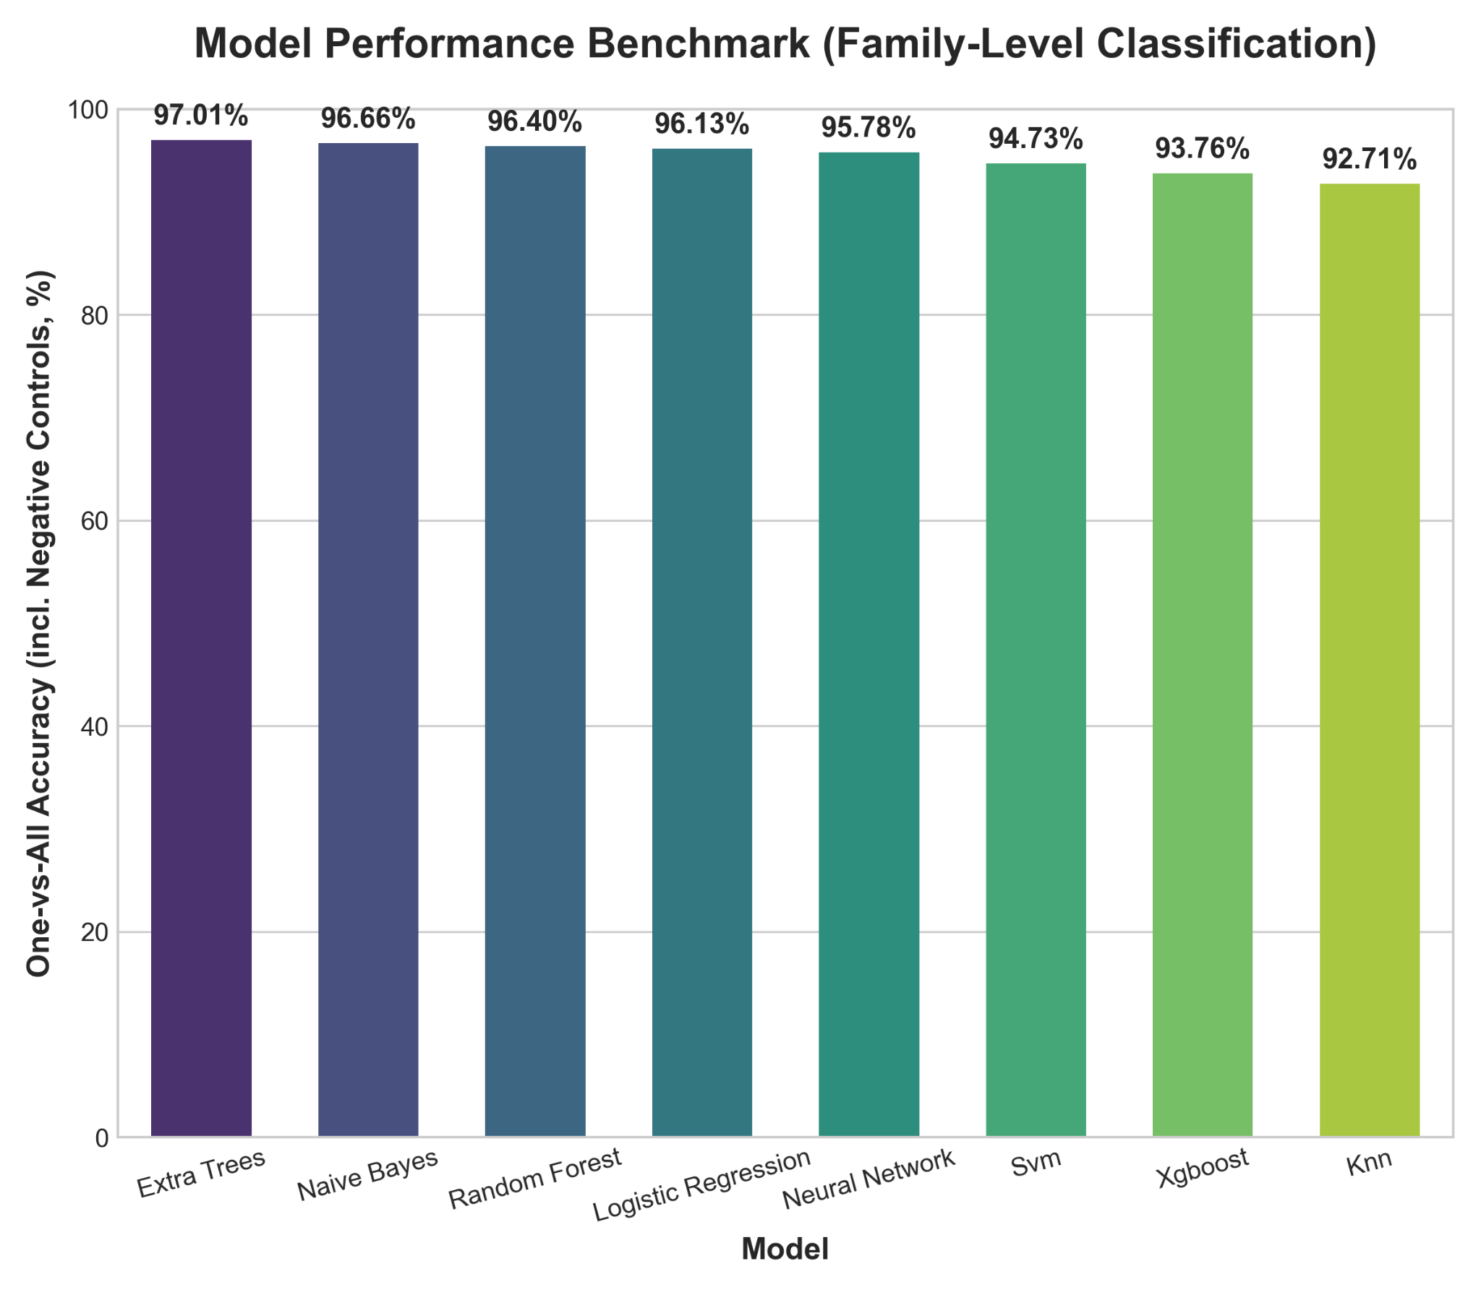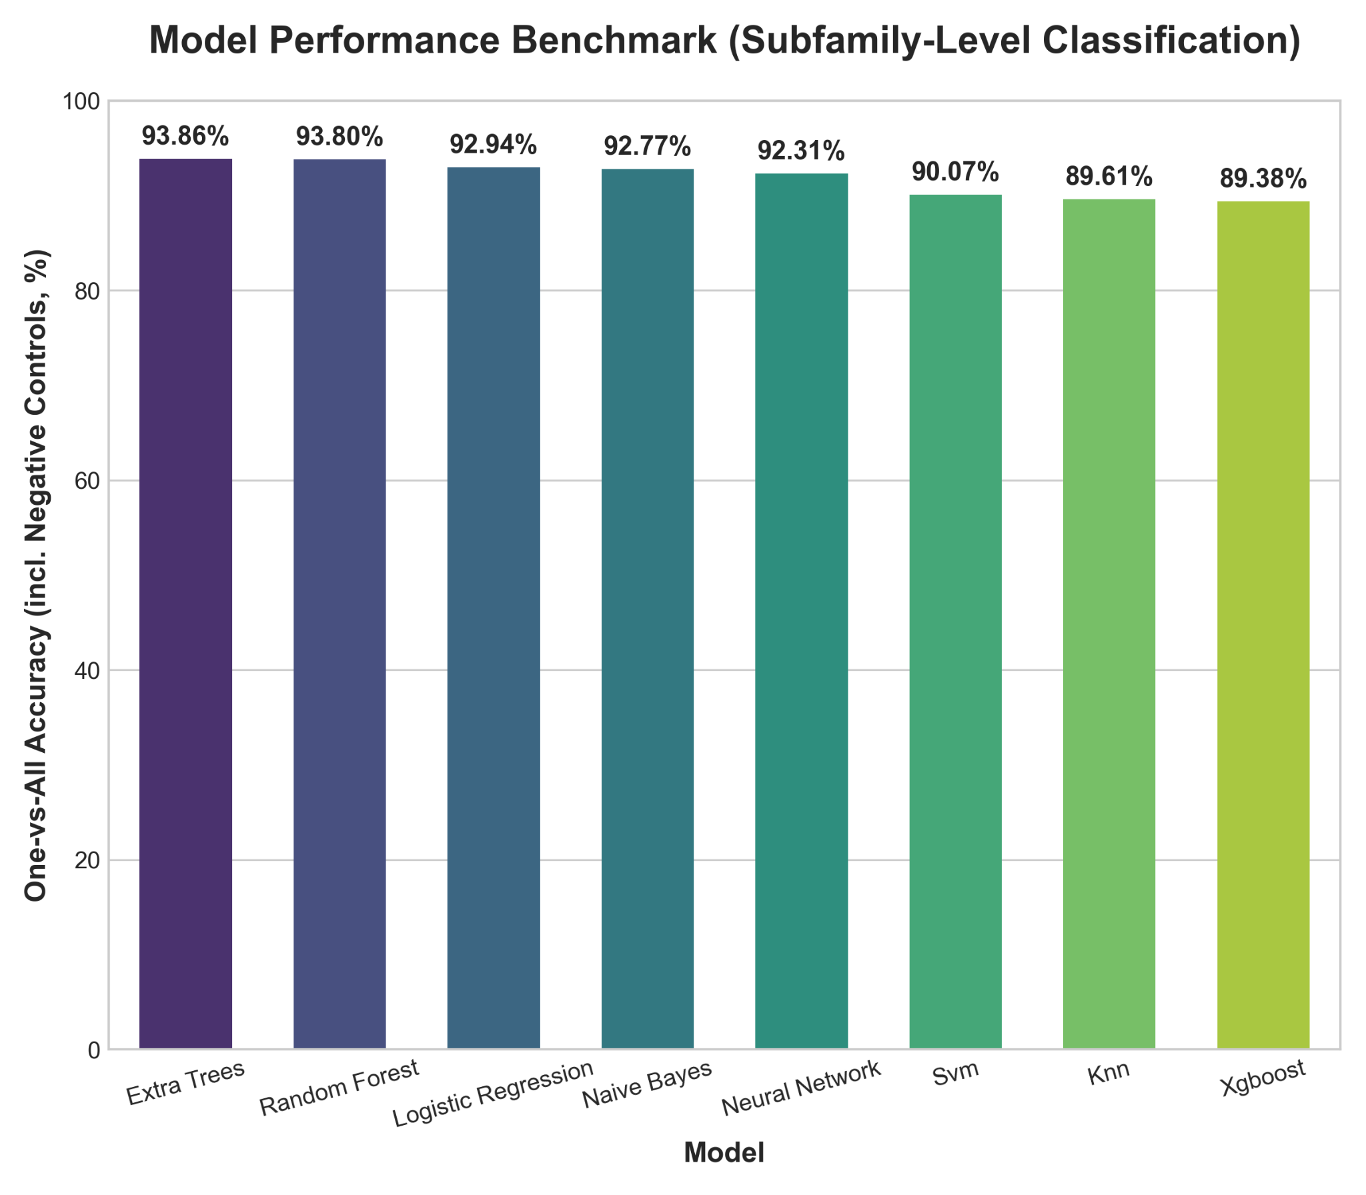
Under this evaluation protocol, most models achieved very high accuracy (>95%) at the family level. However, the accuracy values were generally lower at the subfamily level. Among the tested methods, the Neural Network and Extra Trees demonstrated the most balanced and consistent performance, especially in the subfamily-level. Neural Network, in particular, achieved the highest AUC score among all models at both family and subfamily levels.

Discussion
In conclusion, by encoding domain architecture, our approach provides an interpretable and alignment-free framework for protein family classification. We did not incorporate architecture such as the transformer, primarily because our data encoding strategy differs from conventional sequence-based representations. Future work could explore integrating domain-based features with transformer architecture to further improve classification accuracy and robustness.

Reference resource: Reference_Most_Updated
(Images can be accessed at: https://github.com/PatrickTangwen/paper-img)

[1]: Milton H Saier, Vamsee S Reddy, Gabriel Moreno-Hagelsieb, Kevin J Hendargo, Yichi Zhang, Vasu Iddamsetty, Katie Jing Kay Lam, Nuo Tian, Steven Russum, Jianing Wang, Arturo Medrano-Soto, The Transporter Classification Database (TCDB): 2021 update, Nucleic Acids Research, Volume 49, Issue D1, 8 January 2021, Pages D461–D467, https://doi.org/10.1093/nar/gkaa1004

[2]: Jamialahmadi, H., Khalili-Tanha, G., Nazari, E., & Rezaei-Tavirani, M. (2024). Artificial Intelligence and Bioinformatics: A Journey from Traditional Techniques to Smart Approaches. Gastroenterology and Hepatology from Bed to Bench, 17(3). https://doi.org/10.22037/ghfbb.v17i3.2977
[3]: Min, S., Lee, B., & Yoon, S. (2016). Deep learning in bioinformatics. Briefings in Bioinformatics, bbw068. https://doi.org/10.1093/bib/bbw068
[4]: Sandaruwan PD, Wannige CT. An improved deep learning model for hierarchical classification of protein families. PLoS ONE. 2021;16(10):e0258625. https://doi.org/10.1371/journal.pone.0258625
[5]: Seokjun Seo, Minsik Oh, Youngjune Park, Sun Kim, DeepFam: deep learning based alignment-free method for protein family modeling and prediction, Bioinformatics, Volume 34, Issue 13, July 2018, Pages i254–i262, https://doi.org/10.1093/bioinformatics/bty275
[6]: Bradley, A. P. (1997). The use of the area under the ROC curve in the evaluation of machine learning algorithms. Pattern Recognition, 30(7), 1145–1159. https://doi.org/10.1016/s0031-3203(96)00142-2
[7]: Breiman, L. Random Forests. Machine Learning 45, 5–32 (2001). https://doi.org/10.1023/A:1010933404324
[8]: Geurts, P., Ernst, D. & Wehenkel, L. Extremely randomized trees. Mach Learn 63, 3–42 (2006). https://doi.org/10.1007/s10994-006-6226-1
[9]: Maalouf M. Logistic regression in data analysis: an overview. International Journal of Data Analysis Techniques and Strategies. 2011;3(3):281. doi:10.1504/ijdats.2011.041335
[10]: T. Cover and P. Hart, "Nearest neighbor pattern classification," in IEEE Transactions on Information Theory, vol. 13, no. 1, pp. 21-27, January 1967, https://doi.org/10.1109/TIT.1967.1053964
[11]: Berrar, D. (2018). Bayes’ theorem and naive Bayes classifier. In Elsevier eBooks (pp. 403–412). https://doi.org/10.1016/b978-0-12-809633-8.20473-1
[12]: Tianqi Chen and Carlos Guestrin. 2016. XGBoost: A Scalable Tree Boosting System. In Proceedings of the 22nd ACM SIGKDD International Conference on Knowledge Discovery and Data Mining (KDD '16). Association for Computing Machinery, New York, NY, USA, 785–794. https://doi.org/10.1145/2939672.2939785

