## Image filters

## Convolutional Layers

### What is so special about CNNs vs ANNs?

They’re much better at analysing images because they give you spatial information.

They also only connect to a local neuron.

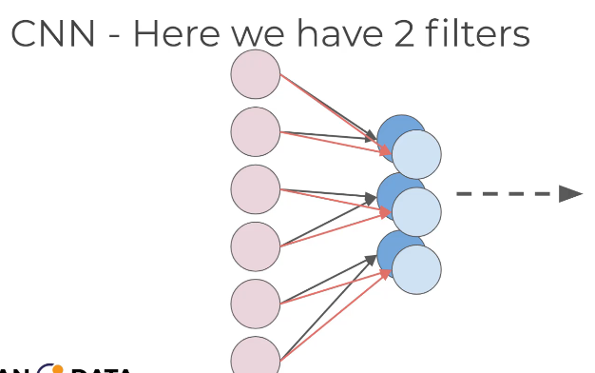

### What is the stride length?

The step size an image filter is applied

### Why is it called a convolution layer?

Because in order to apply an imaging filter on a 3 channel image, there needs to be 3 2-dimensional imaging filters. The 3 filters are layers of a convolution matrix.

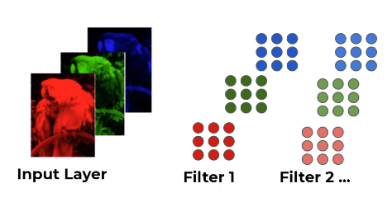

## Pooling layers

### What are pooling layers called sometimes?

Subsampling or down sampling layers

### Why do we use pooling layers?

To decrease the number of parameters that need to be used.

### How is it done?

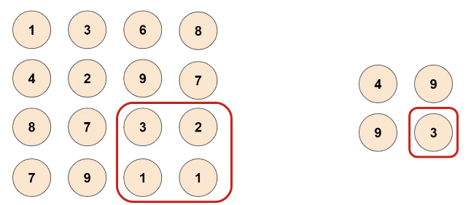

This is max pooling, but average pooling is possible too. This is a kernel of 2x2 and a stride of 2.

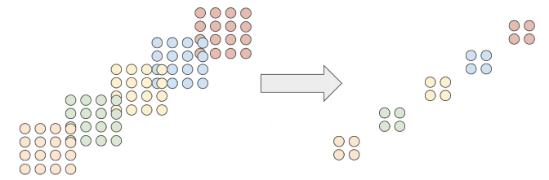

### What is another way of speeding up the network?

Dropout

### How does it work?

Units are randomly dropped, along with their connections.

### Does this allow an infinite configuration between convolution and pooling layers?

Yes

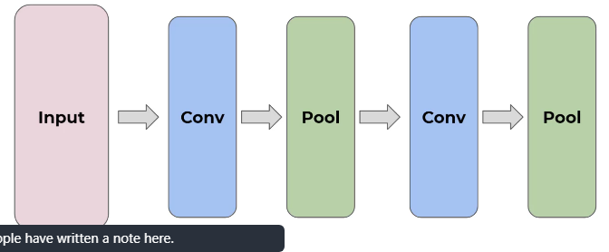

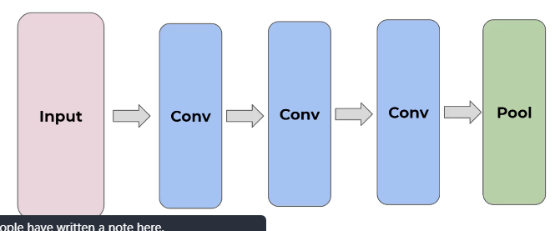

### What layer must be inserted before the output layer?

A Fully Connected layer.

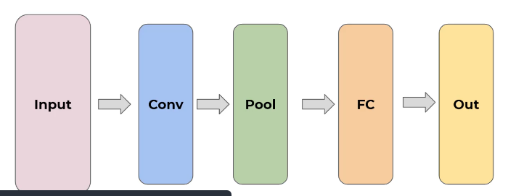

## CNN on MNIST

### What activation function should be used for your output layer when you want to output multiple classes?

A softmax function

### What is the general order of layers input into the model?

1. Define if it’s sequential
2. Convolution layer and pooling layer
3. Possibly any number of convolution or pooling layer
4. Flatten Layer

### What are the parameters of the model are set values based on your data?

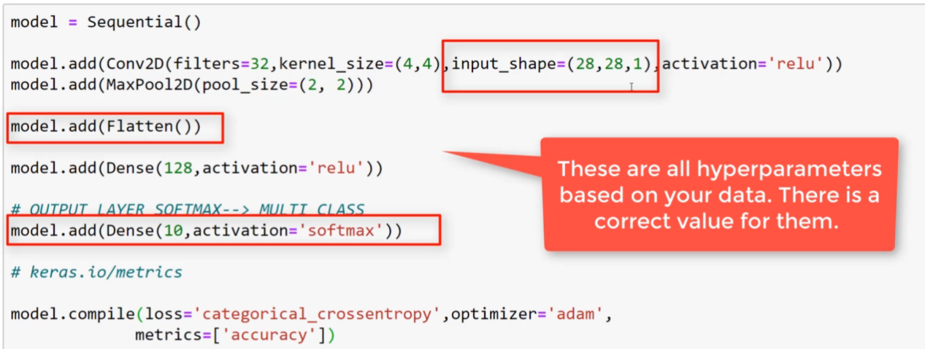

### What are the parameters of the model that you can play and experiment with to get the best output?

