### What is unsupervised learning?

This is using data that isn’t labelled to train the model

### What is semi-supervised learning?

This is where there is label on the historical data, but can’t produce metrics such as accuracy or RMSE.

### What is an auto-encoder?

A feed forward network trained to reproduce its input at the output layer by reducing it’s dimensions.

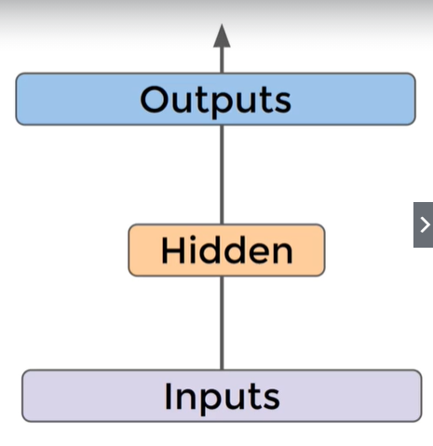

### What is the difference between an autoencoder and a typical multi layer perceptron network?

In an autoencoder, the number of input neurons is equal to the number of output neurons.

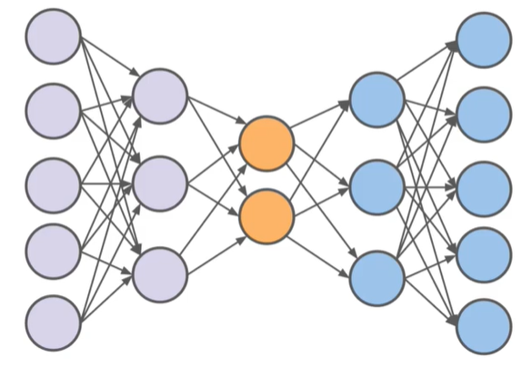

### With dimensionality reduction, are certain features thrown away, or are they combined to represent the original data?

Combined to represent the original data.

### What is the encoder and decoder of the model?

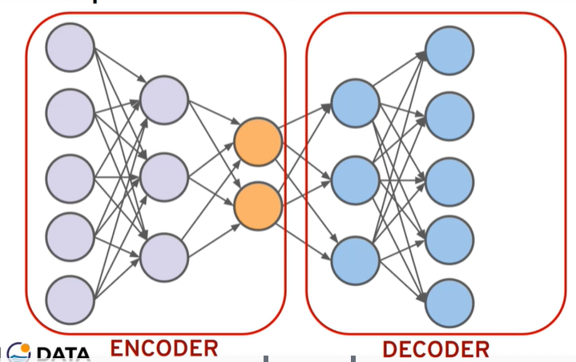

### What is dimensionality reduction used for?

1. Compress data
2. Visualise data in lower dimensions, because there may be too many dimensions e.g. 10 -> 3 to visualize.
3. Reveal hidden relationships not clearly seen in higher dimensions

### How many dimensions does an image with 28 x 28 pixels have?

28 x 28 = 784

### How are autoencoders useful for images?

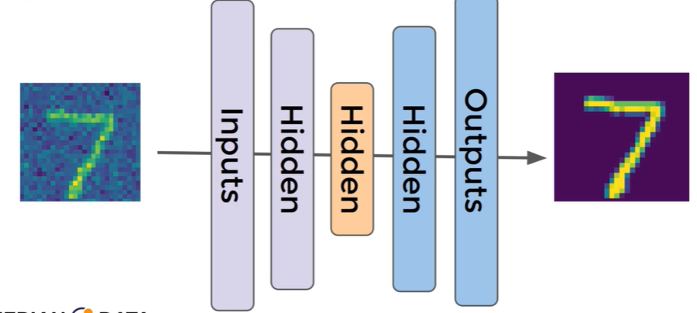

They can de-noise images.