# Generative Adversarial Networks

## What are generators?

It is known as the counterfeiter. It outputs data. The goal is to create images that fool the discriminator.

## What is the discriminator?

Tries to classify real and fake images. Which is a binary classification.

## How does it work?

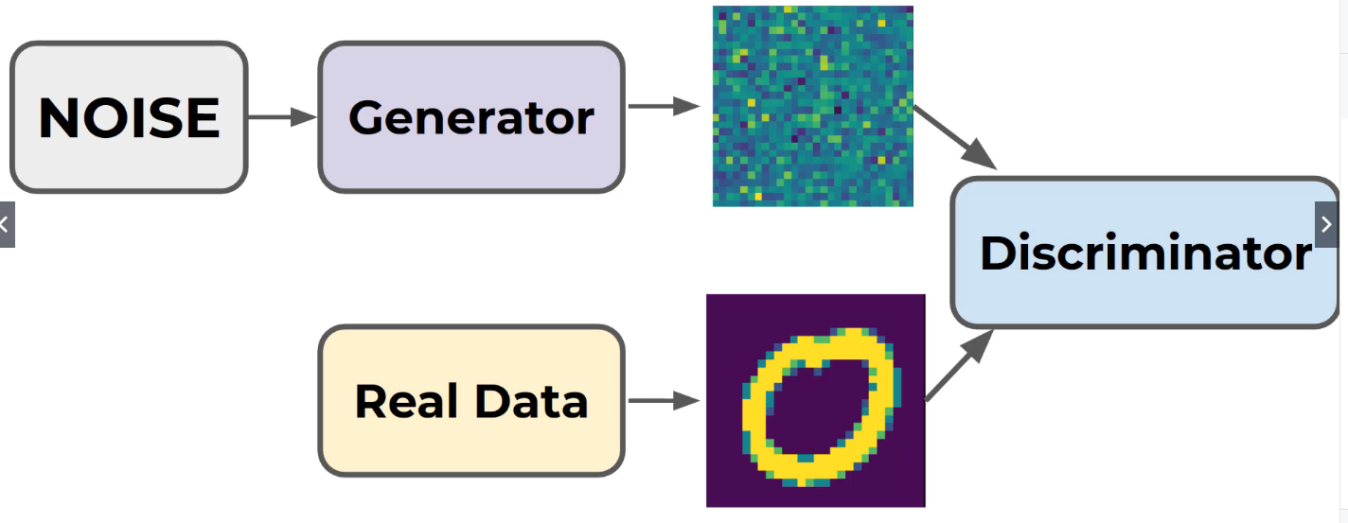

Images from the generator are made, which is basically noise.

This trains the generator to fool the discriminator.

## How many phases are there in the training, and what do they do?

2 phases. (I don’t really understand this)

Phase 1 -

## Does the generator ever see the real images?

No.

## What are the difficulties with GANs?

* Training resources
* Mode collapse
* Instability

## What is Mode Collapse?

The generator figures out one answer for the discriminator and keeps using that to fool the discriminator.

## How to solve Mode Collapse?

Use Deep Convolutional GANs or punish similar batch of images.

## How to fix instability?

Experiment with hyperparameters.

## What is the first phase of setting up a GAN?

Training the discriminator with labeled data.

### Creating a GAN – Part Two – The Model

5:15 Setting up the Generator

7:00 Explaining what size layers generators should be

9:30 Combining the generator and discriminator

10:15 Compiling the GAN model

11:15 Explaining why the generator isn’t compiled, since it’s trained by the discriminator

### Creating a GAN – Part Three – Model Training

0:47 Setting the batch size

1:25 Setting up the dataset for the GAN

4:00 Looking at the how to access the generator or discriminator separately

5:30 Writing a for loop to run the GAN

7:50 Setting up the discriminator training phase in the for loop

8:45 Generator creates some noisy images

9:30 Concatenating images?

11:00 Making the labels for the discriminator

15:15 Training the Generator

18:15 Looking at the results of the first run

20:40 Mode collapse example

### DCGAN – Deep Convolutional Generative Adversarial Networks

1:20 Difference between GAN and DCGAN – images are reshaped and rescaled

3:15 Setting up the layers of the generator

4:18 Layers of the discriminator