**Optimizing Product Pricing**

**Background**

The Book Emporium wants to price books to optimize profits. The spreadsheet for this homework has sales data on *Harry Potter* book 7. For each week, the Book Emporium varied prices on *Harry Potter* book 7 to determine a demand curve. The percent of customers who visited BookEmporium.com and purchased *Harry Potter* book 7 is shown in the spreadsheet. J.K. Rowling has announced a sequel to the *Harry Potter* series. Determine the price for the sequel.

**Resources**

Use the data set SCM 651 Homework 3 Book Prices spreadsheet.

**Definitions**

Price what you will charge each customer who purchases the new book

Book Cost what you must pay the publisher for each book

% purchased in your pricing test, the percent of people who bought at that price

Predicted % your regression model estimate of the percent sold based on price

Predicted sales estimate of number of customers who buy the book from you

Revenue total revenue generated (price * predicted sales)

Profit (price – book cost) * predicted sales

**Assumptions**

1. Assume that the demand for the book sequel will be similar to *Harry Potter* book 7.
2. Assume that 100,000 customers will consider purchasing a book from you.
3. The data is not an entirely accurate prediction of the demand, but a regression on the data using a power model will give a reasonable prediction.
4. Assume that you pay the publisher $5.00 for each book.

**Assignment**

**What’s due:**

Submit an analysis **before the live class in week 8**. Suggested length is 5 pages but should not exceed 10 pages, single-spaced, 12-point font. Use Excel to analyze the data and document your results in a Word document.

This is a group assignment; each student should upload a copy of the assignment to the learning management system. The paper must be a Microsoft Word document.You should also submit the Excel spreadsheet with the regression and optimization analysis. **Submit both your Word and Excel files.** Name the files HW3_Team# where # is your team number. Be sure to include the names of everyone on the team on the first page of the paper. Late assignments will not be accepted. Failure to follow directions will be penalized.

**Outline and grading criteria:**

1. Regression analysis (35%)

a. Graph the percent purchased against price. (5%)

**Table 1**

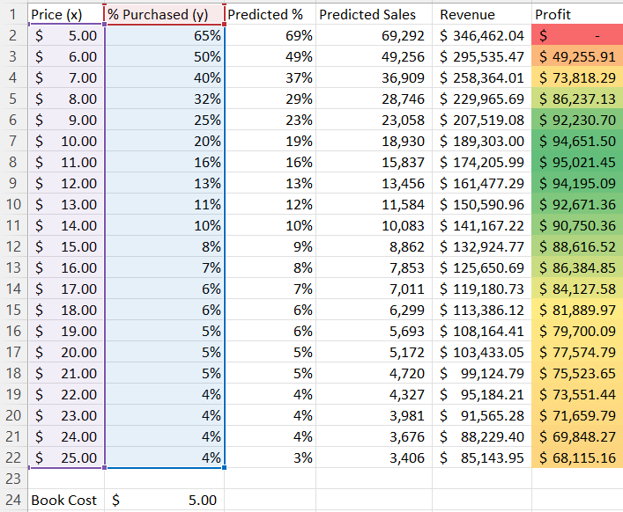

b. Perform a regression using **power** regression to determine the predicted % column.

**Table 2**

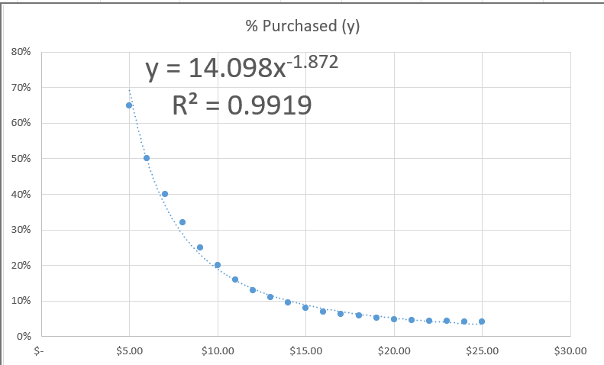

* + 1. Estimate the equation of the line. (5%)

Y = 14.098X-1.872

* + 1. What does the R2 mean? (5%)

R square means that 99.19% of the purchased sale can be predicted by the price.

c. Assuming there are 100,000 customers who visit your website, and the publisher cost is $5.00, estimate the number of books sold (predicted sales column). (5%)

See Table 1.

d. Calculate the revenue column (price * predicted sales). (5%)

See Table 1.

e. Calculate the profit column ((price – book cost) * predicted sales). (5%)

See Table 1.

f. Use conditional formatting to highlight the profit values for all prices. (5%)

See Table 1.

2. Optimization analysis (with constraints) (35%)

a. Calculate the price point for the highest profit possible.

i. The publisher will sell the books to you at $5.00 each with no minimum order. (10%)

ii. The publisher has agreed to sell you the books at $4.50 each if you sell at least 30,000. (10%)

iii. The publisher has agreed to sell you the books at $4.00 each if you sell at least 50,000. (10%)

b. Which solution results in the highest profit? What price do you charge customers? What cost do you pay the publisher? (5%)

**Table 3**

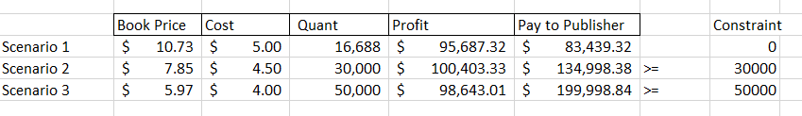

The highest profit occurs when selling 50,000 orders at $5.97, and 30,000 orders at $7.85, and 16,688 orders at $10.73.

Your pay to the publisher in scenario 1 will be $83,439.32

Your pay to the publisher in scenario 2 will be $134,998.38

Your pay to the publisher in scenario 3 will be $199,998.84

3. Discussion (30%)

a. What are the risks of using *Harry Potter* book 7 data in predicting your new demand curve for the *Harry Potter* sequel? (15%)

The risk of using Harry Potter book 7 in predicting the new demand curve is that the next sequel may not be as good as book 7, and inflation rate may cause the publisher to change the cost of each book. Since it has been many years since book 7 came out and the Harry Potter series finished, there may not be the same level of demand or excitement around a sequel. We cannot assume that people will be as excited about a sequel as they were for the last book in a series.

b. What other data would you like to have to perform your analysis? (15%)

Inflation rate and the reader review rating may be helpful in predicting such the demand curve. Surveys asking people if they would be interested in a sequel to the Harry Potter series, both from longtime fans of the series and new potential readers.