**Loan Analysis**

**Background**

Using the Universal Bank data, determine the factors that influence whether a customer takes out a loan.

**Resources**

Use the data set SCM 651 Homework 4 Universal Bank spreadsheet.

**Assignment**

**Team members**

Patrick Walsh, Vu Ton, Excel Ansong

**What’s due:**

Submit a logit, probit, and neural network analysis of loan acquisition behavior **before the live class in week 10**. Suggested length is 5 pages but should not exceed 10 pages, single-spaced, 12-point font.

This is a group assignment; each student should upload a copy of the assignment to the learning management system. The paper must be a Microsoft Word document. You should also submit the Excel spreadsheet with the prediction models and sensitivity analyses. Name the file HW4_Team# where # is your team number. Be sure to include the names of everyone on the team on the first page of the paper. Late assignments will not be accepted. Failure to follow directions will be penalized.

**Outline and grading criteria:**

1. *Perform a logit and probit analysis of the variables that affect whether a customer takes out a loan. Consider only main effects (main variables, no moderating effects). Which variables are significant? How do the significant variables influence the likelihood of taking out a loan? Copy screen snapshots of your analysis in R to your report. (20%)*

Logit, all variables have positive coefficients. The variables which are significant are:

* Income, Family, Education, CCAvg, CDAccount since their P values are less than 0.05.

Additionally:

* Having a CDAccount increases the chance of taking a personal loan.
* Higher CCAvg increases the chance of taking a personal loan
* Having higher education increases the chance of taking a personal loan
* More family members increase the chance of a taking a personal loan
* Higher income increases the chance of taking a personal Loan

**Output of Logit analysis**

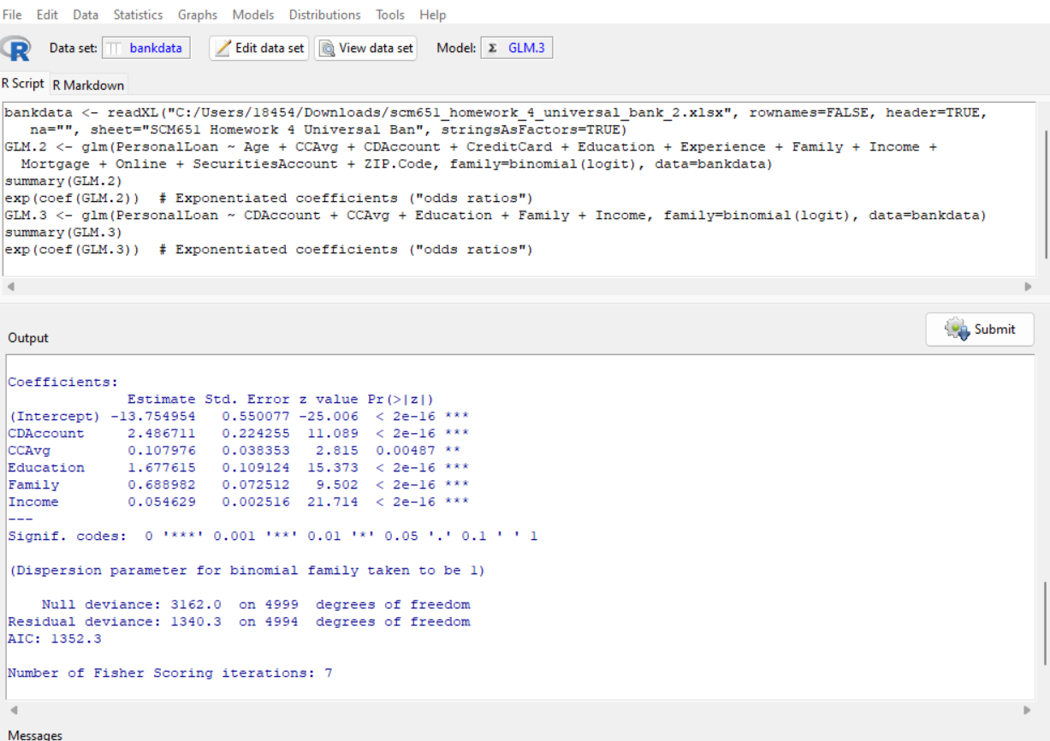

Probit, all variables except Family have positive coefficients. This means the more family members, the less likely you take a personal loan.

**Output of Probit analysis**

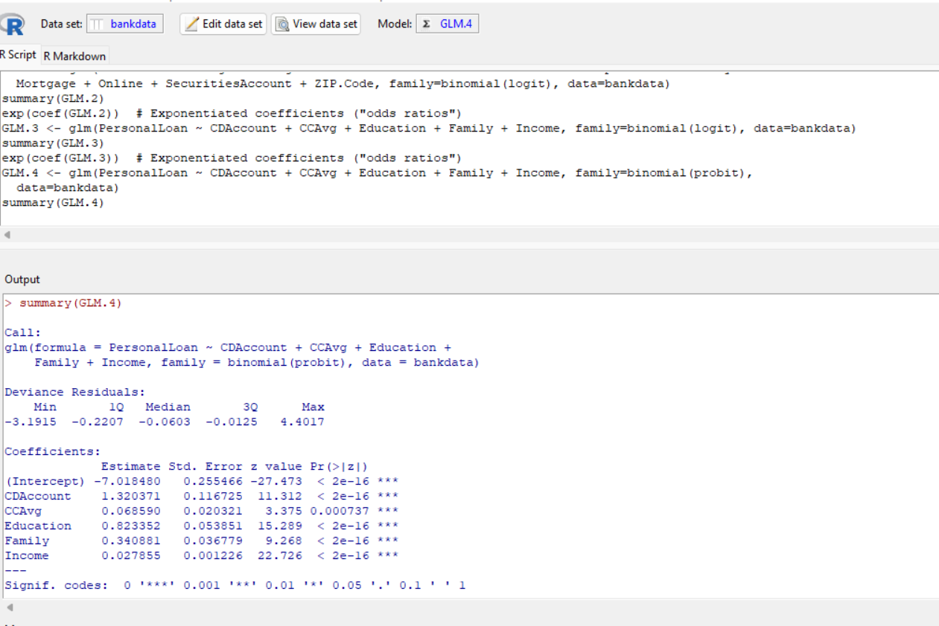

1. *Add moderating effects (interactions of variables). Which interactions make sense conceptually? Which interactions are statistically significant? How do you interpret the coefficients on these variables? Copy screen snapshots of your analysis in R to your report. (20%)*

CCAvg and Income conceptually make sense since the more income you have the more you spend. This interaction is also statistically significant. Family and Income does not make sense conceptually, but it is still statistically significant due to small p value. The interaction between Family and Education makes sense and they are also statistically significant.

**Output of Logit analysis**

1. *Create a final regression model with the variables that you feel are important (both main effects and interaction terms). Use the moderating effect that was significant and its two individual main effects. Create a spreadsheet prediction of the model. Perform a sensitivity analysis as seen earlier in the semester. Which variables have the greatest influence on the customers’ loan behavior (combined main effects and interaction effects)? Copy screen snapshots of your analysis in R to your report. (20%)*

We used education and family as the main effects because they are both statistically significant and they have a relatively weak correlation to each other. We think weak correlation would make the moderating effect more significant. Also, it intuitively makes sense that education and family greatly influence someone’s decision to take a personal loan.

We tried multiple combinations of variables but there were only a few pairs that were statistically significant. We settled on education and family because this pair was statistically significant and produced a good model using a neural network.

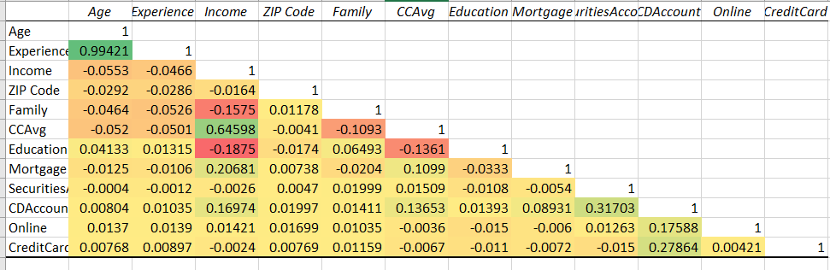

1. *Perform a neural network analysis of the variables in part 3 above. Copy screen snapshots of your final neural network model in R to your report. (20%)*

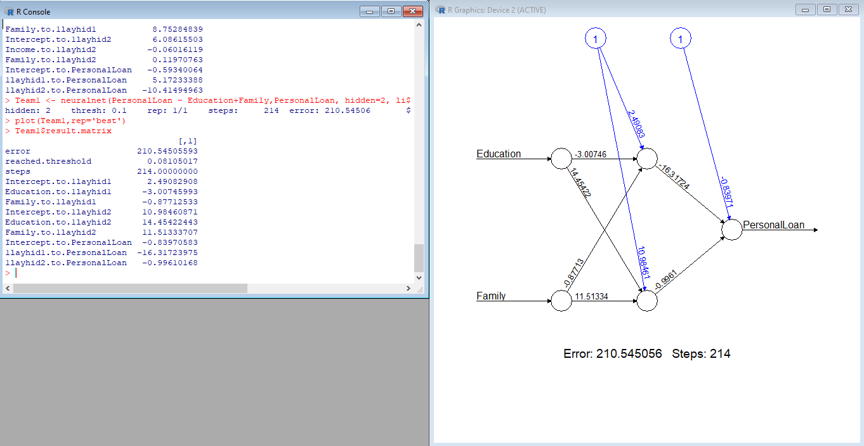

1. *Create a prediction model of the neural network in part 4. Using the prediction model, perform a sensitivity analysis for the neural network model like the logit and probit sensitivity analysis. (20%)*

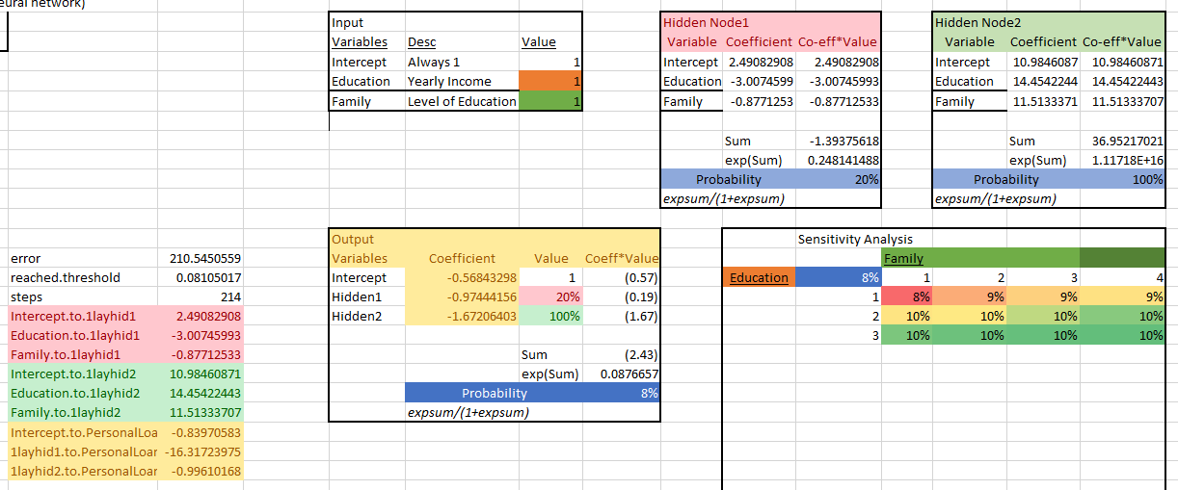

Justify your answers. Provide a snapshot of output from your analysis in your final paper.

**Universal Bank Data Fields**

ID unique identifier

Personal Loan did the customer accept the personal loan offered (1=Yes, 0=No)

Age customer’s age

Experience number of years of profession experience

**Income**  annual income of the customer ($000)

Zip code home address zip code

**Family**  family size of customer

**CCAvg**  average spending on credit cards per month ($000)

**Education** education level (1) undergraduate, (2) graduate, (3) advanced/professional

Mortgage value of house mortgage ($000)

Securities does the customer have a securities account with the bank? (1=Yes, 0=No)

**CDAccoun**t does the customer have a certificate of deposit with the bank? (1=Yes, 0=No)

Online does the customer use internet banking facilities? (1=Yes, 0=No)

CreditCard does the customer use a credit card issued by Universal Bank? (1=Yes, 0=No)