Recruiting Advertising Strategy

Background

The Whitman School of Management launched an internet recruiting campaign from February 2011 through December 2014, using Google Ads and Delta Airlines’ flight magazine advertisements. An assessment of opportunities and results is now necessary to establish the direction for a campaign one year from today.

Resources

Use Google Analytics to examine the Whitman Graduate Programs internet marketing campaigns. All data can be accessed via Google Analytics. If you have any questions, please send me an email.

Assignment

Team Members

Patrick Walsh, Vu Ton, Excel Grace

What’s due:

Submit an advertising analysis before the live class in week 6. Suggested length is 5 pages but should not exceed 10 pages, single-spaced, 12-point font.
Use Google Analytics to analyze the data to identify patterns and opportunities. Your goal is to recruit the best United States students, measured by GMAT scores, but you are limited to a budget of $100,000. The budget must cover advertising costs, but no Whitman administration costs. The campaign starts one year from today.
This is a group assignment; each student should upload a copy of the assignment to the learning management system. The paper must be a Microsoft Word document. Name the file HW2_Team# where # is your team number. Be sure to include the names of everyone on the team on the first page of the paper. Late assignments will not be accepted. Failure to follow directions will be penalized.

Outline and grading criteria:

- What were the time frames for each marketing campaign? How much was spent on each campaign? What was the effectiveness of previous campaigns? Create a table listing campaign, start date, end date, cost, and all other measures listed in Google Analytics. Discuss the effectiveness of each campaign. (40%)

Campaign | Sessions | Impressions | Clicks | Cost | Bounce Rate | Pages / Session | CTR | CPC | Start Date | End Date
whitman.syr.edu | 7,313 | 52,215,085 | 9,636 | $37,851.36 | 78.20% | 1.84 | 0.02% | $3.93 | Feb 2011 | Aug 2011
MBA Marketing - iMBA | 3,170 | 3,135,539 | 5,931 | $82,403.98 | 89.50% | 1.13 | 0.19% | $13.89 | Feb 2012 | Oct 2012
MBA Marketing - Full-time | 4,293 | 2,276,784 | 10,246 | $82,488.03 | 82.53% | 1.27 | 0.45% | $8.05 | Oct 2012 | Jul 2013
Delta (cost of one-month quarter page ad was $10,000) | 23 |  |  | $10,000.00 | 43.48 | 2.65 |  | $434.78 | Sep 2013 | Nov 2013

  - whitman.syr.edu
  - MBA Marketing – iMBA
  - MBA Marketing – Full-time
  - Delta (cost of one-month quarter page ad was $10,000)
- The whitman.syr.edu campaign was the most effective, having a CPC of only $3.93 and a total of 9,636 clicks. The bounce rate was relatively low compared to the other campaigns, at only 78.2%. The pages/session was also relatively high compared to the other campaigns at 1.84.
- The MBA Marketing - Full-time campaign was the second most effective, having a CPC of $8.05 and a total of 10,246 clicks. The bounce rate was slightly higher than whitman.syr.edu at 82.53%, but the pages/session was relatively high at 1.27.
- The MBA Marketing - iMBA was less effective than the first two campaigns, with a CPC of $13.89 and a total of only 5,931 clicks. The bounce rate was higher at 89.5% and the pages/session was lower at only 1.13.
- The Delta had some missing information but was by far the least effective campaign in terms of cost. The number of clicks was unknown, but there were only 23 sessions. Extrapolating by the number of sessions, we estimate the CPC to be at $434.78. The bounce rate was by far the lowest at 43.48% and the pages/session was also the highest at 2.65. However, we still consider this campaign to be the least effective because of the low number of sessions generated with the amount the campaign cost.

- Create a prediction of cost per click and a prediction of advertising cost per student for Google Ads for next year (a year from today’s date). Use either the prediction technique or Excel’s forecast option. Do not include Delta. If using the forecast option, assume the years below. Number of students recruited from the advertisements is listed below. (10%)
  - whitman.syr.edu (2011 – 50 students enrolled)
  - MBA Marketing – iMBA (2012 – 24 students enrolled)
  - MBA Marketing – Full-time (2013 – 15 students enrolled)

- The predicted CPC in 2023 is $36.33 with lower bound $16.41 and upper bound $56.25
- The predicted cost per student in 2023 is $29,874.53 with lower bound of $29,188.69 and upper bound $30,560.38

- Identify the key aspects of a United States campaign for next year. (20%)
In which geographic region, states, or cities would you advertise? Why?
What keywords would you use? Why?
Which days of the week and what time of day would you advertise? Why?

Data Range Jan 1, 2011, to Feb 2, 2022
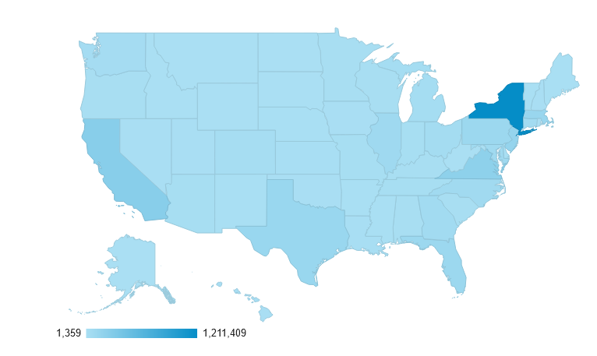

- I would focus on the state of New York because it alone generated 37.63% of all sessions across the country, with emphasis on the cities of Syracuse and New York. Within the entire state, Syracuse generated 38.8% of all sessions and New York City generated 22.47% of all sessions. In raw numbers, there were a total of 469,976 sessions in Syracuse during that period and 272,150 sessions in New York City for a total of 742,126 sessions. Across the entire country, there were 3,218,958 sessions, which means that 23.1% of all sessions across the country were generated by the cities of Syracuse and New York. At the city-level, the top 3 cities that had the most traffic are Syracuse, New York City, and Ashburn.

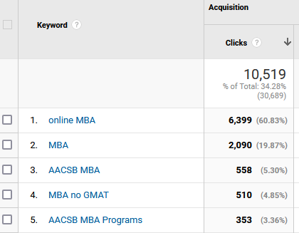
- I would use the keywords ‘online MBA’ and ‘MBA’. These two keywords together generated 80.7% of all clicks during the timeframe, with ‘online MBA’ alone accounting for 60.83% of all clicks. The CPC for these two keywords was higher than other keywords, but they still garnered by far the most clicks.

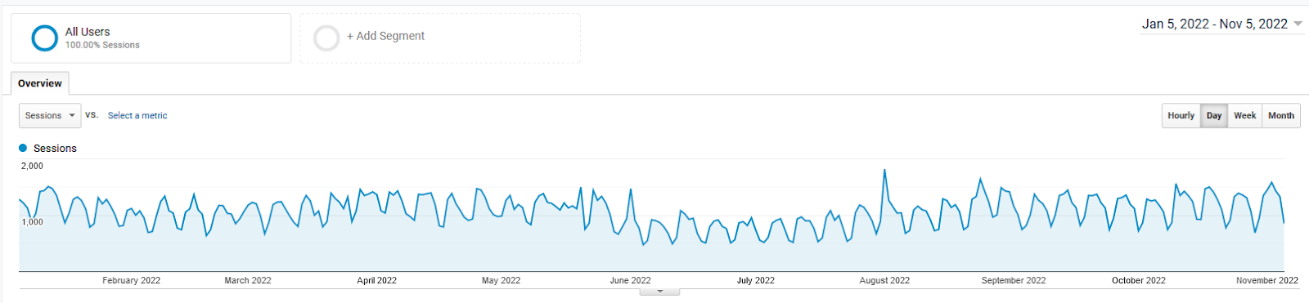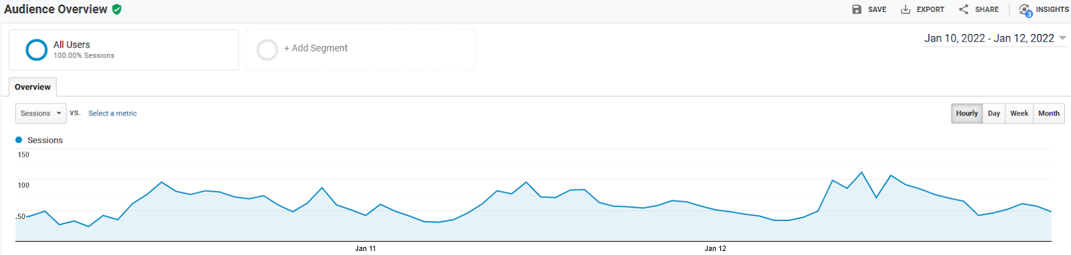

- The days of the week that saw the most traffic are Mondays, Tuesdays, and Wednesdays, and traffic slowed down significantly on the weekends. As for time of day, the biggest spike in sessions occurred between 8:00AM to 5:00PM.

- How would you measure performance of your decisions after implementation? (20%)

I would use clicks, sessions, bounce rate, and pages/session to measure the success of the campaign. We want to generate a lot of clicks which result in the highest number of sessions possible. We also want a low bounce rate which means people are interacting with the website and not leaving immediately after landing on the page. The pages/session helps us also determine the level of engagement with the website since a high number of pages/session means people are looking at multiple pages.

- What other factors or considerations are important? What other data would help in developing an internet advertising strategy if you could collect it? (10%)

We must balance the engagement metrics mentioned above with CPC since budgets are limited and a campaign cannot be considered effective if the cost is too high. Other helpful data to have could be the audience graduation year from college, their highest degree attained, hobbies, job and job title, their GPA from previous classes, and years of experience in the industry.

