House Price Analysis

Background

Using the House Prices data, determine the factors that influence the price of a home.

Resources

Use the data set SCM 651 Homework 1 House Prices spreadsheet.

Assignment

What’s due:

Submit a categorization, visualization, correlation, and regression analysis of house prices before the live class in week 4. Suggested length is 5 pages but should not exceed 10 pages, single-spaced, 12-point font.
This is a group assignment; each student should upload a copy of the assignment to the learning management system. The paper must be a Microsoft Word document. You should also submit the Excel spreadsheet with the visualization, correlation, and regression analysis. Name the file HW1_Team# where # is your team number. Be sure to include the names of everyone on the team on the first page of the paper. Late assignments will not be accepted. Failure to follow directions will be penalized.

Outline and grading criteria:

- Develop a categorization of your data using pivot tables. Develop two pivot tables: One pivot table of average price, varying type of construction (brick) and neighborhood as the two dimensions; a second pivot table of average square feet varying type of construction (brick) and neighborhood as the two dimensions (20%). What patterns do you see?

Pivot Table 1
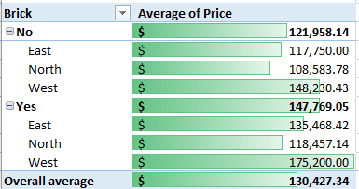

Pivot Table 2
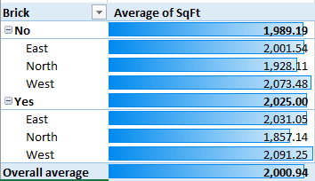

Patterns observed

- Brick houses are more expensive, on average, than non-brick houses ($147k vs. $121k).
- The West neighborhood is, on average, the most expensive neighborhood, whether the houses are brick or not.
- The North neighborhood is, on average, the cheapest neighborhood, whether the houses are brick or not.
- The average square footage does not vary much across all neighborhoods, with the lowest average at 1,857 sq feet and the highest average at 2,091 sq feet.
- The average square footage also does not vary much between brick and non-brick houses, though brick houses are 2,025 sq feet on average, while non-brick houses are 1,989 sq feet on average.
- Brick houses tend to be slightly larger than non-brick houses.
- Houses in the West neighborhood are the largest, on average, while houses in the North neighborhood are the smallest, on average.
- There appears to be a positive correlation between price and square footage, i.e., as price increases so does square footage.

- Using the two pivot tables above, generate pivot charts for average price and average square feet by type of construction (brick) and neighborhood. (10%)

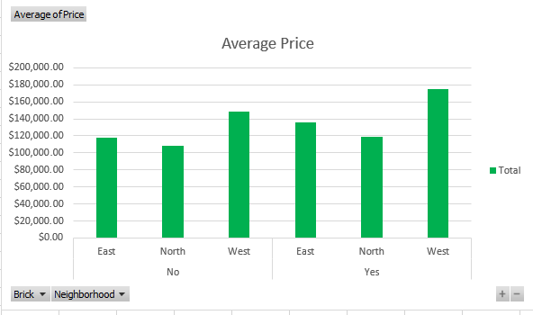
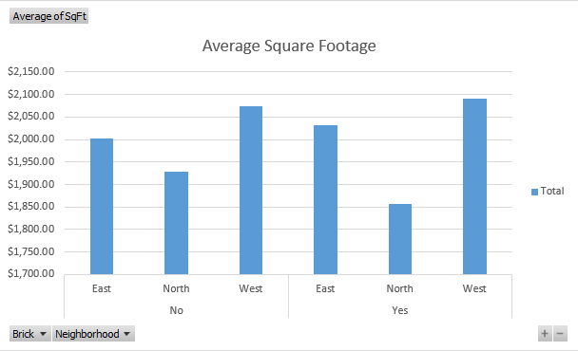

- Perform a correlation analysis of all quantitative variables except ID. Which two variables have the strongest (largest magnitude) correlation? Which two variables have the weakest (smallest magnitude) correlation? What does the largest magnitude imply if we perform a regression analysis next? Are there any negative correlations? Are these correlations intuitive? If not, why not? (20%)

Which two variables have the strongest (largest magnitude) correlation?
Price and Square Footage (55.3% correlation).

Which two variables have the weakest (smallest magnitude) correlation?
Number of bedrooms and number of offers (11.4% correlation).

What does the largest magnitude imply if we perform a regression analysis next?
The largest magnitude implies that a stronger correlation may result in larger differences in regression.

Are there any negative correlations?
Yes, the number of offers has a negative correlation with price (-31.4%).

Are these correlations intuitive? If not, why not?
Yes, they all seem intuitive. There is a positive correlation between price and square footage, number of bedrooms, and number of bathrooms. The higher the square footage, and the higher the number of bedrooms and bathrooms, the higher the price. Also, more expensive houses will have fewer potential buyers than cheaper houses. For example, million-dollar houses will only have a few potential buyers compared to $100k houses which will have many potential buyers. So, it seems intuitive that there is a negative correlation between price and number of offers.

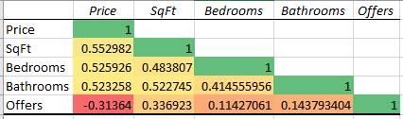

- Perform an initial regression analysis of the quantitative variables excluding the ID. Do not include type of construction or neighborhood. Which variables are statistically significant? What does each coefficient mean in a real-world sense? Are these coefficients intuitive? If not, why not? What does the R-squared mean? (15%)

Which variables are statistically significant?
They are each statistically significant because their p-values are less than 0.05 (5%).

What does each coefficient mean in a real-world sense?
The intercept represents the mean value of our predicted price of the house if all other variables (square footage, bedrooms, bathrooms, and offers) are zero. In the real-world, the intercept in this regression analysis has no meaning since the price will never be a negative value.

Square feet means that for each additional square foot, the average price of the house increases by $61.84.

The number of bedrooms means that for each additional bedroom, the average price of the house increases by $9,319.75.

The number of bathrooms means that for each additional bathroom, the average price of the house increases by $12,646.35.

The number of offers means that for each additional offer, the average price of the house decreases by $13,601.01.

Are these coefficients intuitive? If not, why not?
Yes, they seem intuitive to me. The square footage will typically increase the price of a house, but I would not expect increasing the size by only a single square foot to make a significant increase in price. However, the price between say, a 2-bedroom and a 3-bedroom house can be much more significant, so it makes sense that this variable would have a greater effect on price. The same goes for the number of bathrooms. The number of offers decreasing the price of the house significant also makes sense because cheaper houses will typically receive more offers than expensive homes.

What does the R-squared mean?
R-squared is the percentage that the predicted value y can be explained by the x variable(s). In this case, 69.82% of the change in price can be explained by changes in square footage, number of bedrooms, number of bathrooms, and number of offers.

- Perform a second regression including variables from part 4 and dummy variables for type of construction and neighborhood. What does each coefficient mean in a real-world sense? Are these coefficients intuitive? If not, why not? What does the R-squared mean? (10%)

What does each coefficient mean in a real-world sense?
For each square foot increase, the average price increases by $52.99.
For each bedroom increase, the average price increases by $4,246.79.
For each bathroom increase, the average price increases by $7,883.29.
For each number of offers increases, the average price decreases by $8,267.49.
The average price of a brick house is $17,297.35 more than a non-brick house.
The North neighborhood p-value is greater than 0.05 (5%) so we cannot make any statements about this analysis with confidence.
The average price of a house in the West neighborhood is $22,241.62 more than a house in the East neighborhood.

Are these coefficients intuitive? If not, why not?
Yes, the North neighborhood coefficient is not intuitive because the average price of homes in this neighborhood is less than those in the East neighborhood, but since the p-value of this coefficient is greater than 0.05, we cannot draw any conclusions from this analysis with confidence.

What does the R-squared mean?
R-squared is the percentage that the predicted value y can be explained by the x variable(s). In this case, 86.86% of home price can be predicted by square footage, number of bedrooms, number of bathrooms, number of offers, whether the home is brick or not, and the neighborhood it resides in (excluding the North neighborhood).

- Create a spreadsheet prediction of the regression model from part 5. Perform a two-way sensitivity analysis and use conditional formatting to highlight the results. (15%)

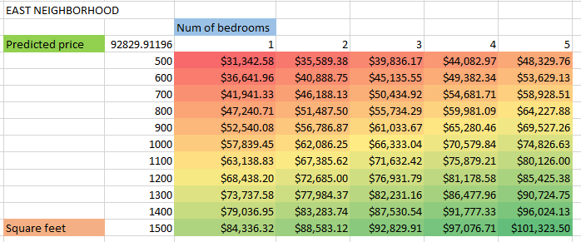

- What would explain nonintuitive results in your regression using the data that you were provided? What additional data would assist you in explaining the nonintuitive results? (10%)

All the results seemed intuitive to me, but non-intuitive results could be explained by other data not provided in the analysis. In our case, data such as age of the homes, crime rates, school ratings, and income of homeowners could affect prices and could explain results that seem unintuitive based on our analysis.

Justify your answers. Provide a snapshot of output from your analysis in your final paper.

House Price Data

ID unique identifier
Price price of home in dollars
SqFt square feet of area of home
Bedrooms number of bedrooms
Bathrooms number of bathrooms
Offers number of offers received on home before sale
Brick Yes/No on brick construction
Neighborhood location of home in east, west, or north quadrants of city

