**The last set of plots has the best k value!!!!!!**

# System properties.

# k = 1.0873

AsigTr_ = [0.0269]

Asiga_ = [0.1152]

Avsig_ = [0.00641,0.169]

AsigS_ = [0.015561] # 0.00155

AD_ = [1.2627,0.3543]

# k = 0.977

BsigTr_ = [0.0274]

Bsiga_ = [0.108]

Bvsig_ = [0.0055,0.146]

BsigS_ = [0.0157]

BD_ = [1.2427,0.3543]

# k = 1.21

CsigTr_ = [0.0263]

Csiga_ = [0.119]

Cvsig_ = [0.00746,0.186]

CsigS_ = [0.0156]

CD_ = [1.2627,0.3543]

# k = 1.44

DsigTr_ = [0.0254]

Dsiga_ = [0.1097]

Dvsig_ = [0.00873,0.198]

DsigS_ = [0.0155]

DD_ = [1.2627,0.3543]

WsigTr_ = [0.0494]

Wsiga_ = [0.0197]

Wvsig_ = [0.0,0.0]

WsigS_ = [0.0494]

WD_ = [1.13,0.16]

Z = 2000cm

D of fuel element = 20cm

D of water = 15cm

5 mesh per element

10 mesh per In z

LoadingPattern = [FuelA,FuelC,FuelB,FuelD,Water]

K = 1.07494266252

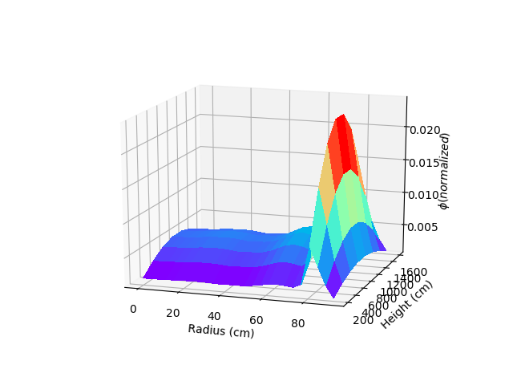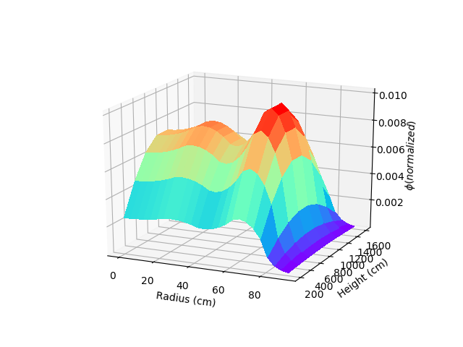

5 mesh per element

10 mesh per In z

LoadingPattern = [FuelB,FuelA,FuelB,FuelC,Water]

K = 1.00823848115

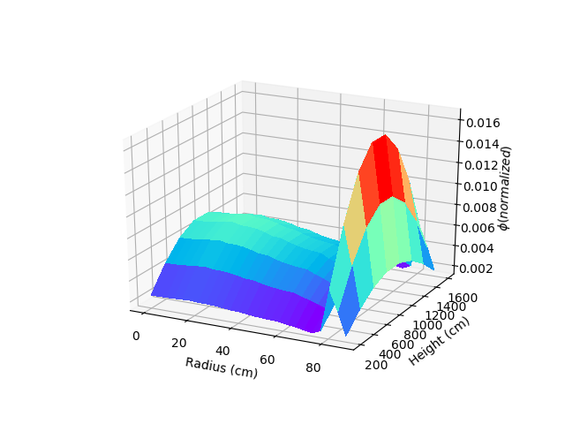

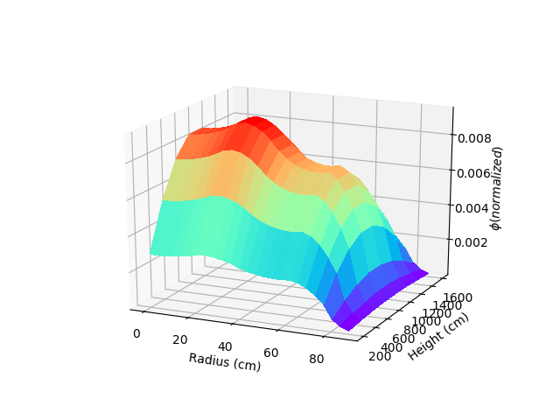

5 mesh per element

10 mesh per In z

LoadingPattern = [FuelB,FuelA,FuelB,FuelA,Water]

K = 0.996174846504

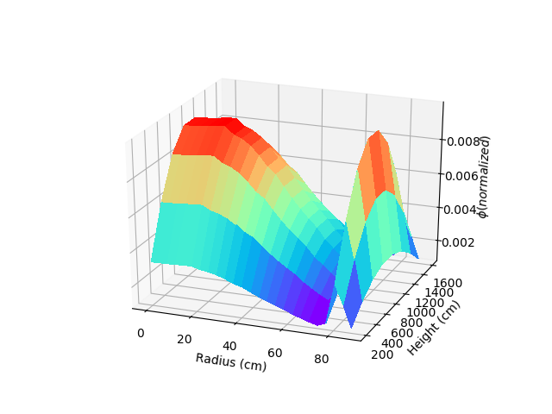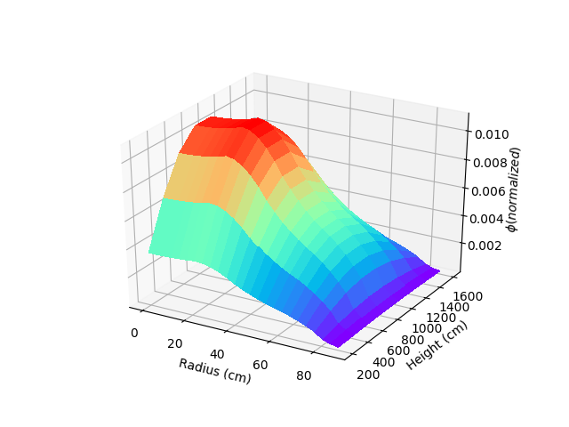

5 mesh per element

10 mesh per In z

LoadingPattern = [FuelD,FuelD,FuelD,FuelD,Water] All fresh

K = 1.20790060525

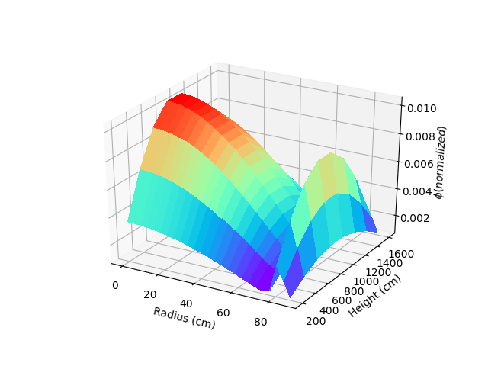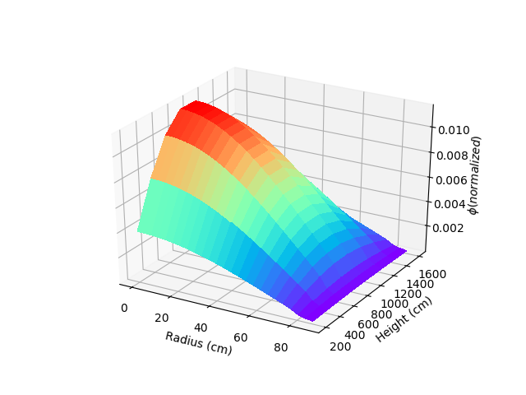

5 mesh per element

10 mesh per In z

LoadingPattern = [FuelB,FuelB,FuelB,FuelB,Water] Most burnt

K = 0.967264281277

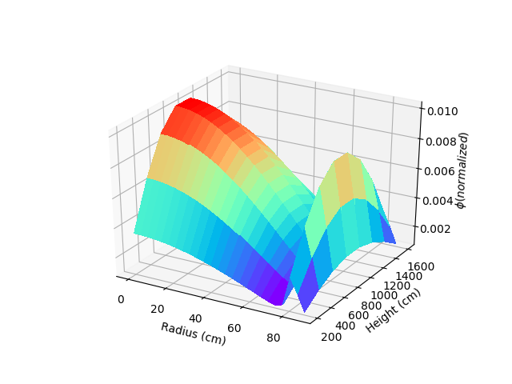

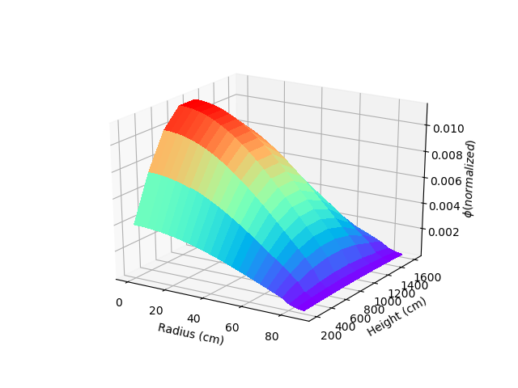

Z = 2000cm

D of fuel element = 18cm

D of water = 15cm

5 mesh per element

10 mesh per In z

LoadingPattern = [FuelB,FuelA,FuelB,FuelC,Water]

K = 1.00253673468

