CYBER@UCR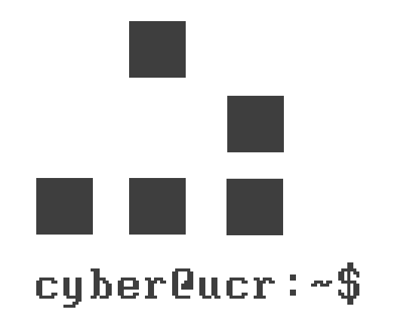

CODE OF ETHICS

horizontal line

LAST EDITED AS OF: 09/21/16

DRAFTED ON: 10/02/16

# UPON SIGNING THIS DOCUMENT, I AGREE TO THE FOLLOWING:

# 1. I agree to abide by all federal, state and school laws.

# 2. I agree that my research and practice of techniques at Cyber@UCR are purely for academic and educational purposes. They will only be used responsibly in order to further my understanding of security.

# 3. Everything learned and used in this club will not be used maliciously unless there is consent from all parties involved. Malicious activity includes, but is not limited to, stealing information and data, accessing systems not owned by yourself, and attacking networks.

# 4. Respect personal privacy - do not use others’ resources or view their information without their consent.

# 5. I will not become involved with any black hat societies during my time in Cyber@UCR.

# 6. I will acknowledge fully the intellectual property of others, and will never claim another’s work as my own - whether it be from a member or from elsewhere.

# 7. Act with appropriate confidentiality when working on projects related to Cyber@UCR. Any information obtained from outside parties must be handled according to their wishes.

# 8. I will avoid and be alert to any circumstances or actions that might lead to conflicts of interest or the perception of conflicts of interest.

# 9. I will not advance private interests at the expense and/or detriment of others.

# 10. I will not withhold any knowledge of software/network vulnerabilities that may result in damage from the appropriate software authors/network administrators. In addition, I will withhold knowledge regarding these vulnerabilities to anyone else until they are rectified.

# 11. I understand collaboration regarding any cases violating these rules can potentially implicate me.

# 12. Should I choose to break any of the above rules, I understand that I may be passed to higher authorities for appropriate punishment in addition to having my standing in Cyber@UCR compromised. This will, of course, depend on a case by case basis.

# 13. I agree to cooperate with the Ethics Director in an investigation if I am suspected of violating any part of the Code of Ethics. Should I feel the investigation is unwarranted in any way, I will report the Ethic Director’s actions to the President or a higher power.

horizontal line

# BY SIGNING HERE, I, __________________________________________________________________ , AGREE TO ALL TERMS IN THE CYBER@UCR CODE OF CONDUCT.

horizontal line

### PRINTED NAME: ______________________________________________________________________________________

### SCHOOL EMAIL: ______________________________________________________________________________________