CSCI 240

Qiguang Yang

Jordan Ringenberg

Homework #1

9/13/2015

/****************************************

Name: Qiguang Yang

Date: 9/10/2015

Course: CSCI240

Properties: Calculating federal taxes for an individual

Inputs: Name, SSN, income

Outputs: Name, SSN, income, income tax and tax rate.

*****************************************/

#include <iostream>

#include <string>

#include <fstream>

#include <iomanip>

using namespace std;

int main(){

string Name;

int SSN;

double Income;

double Tax;

double rate;

double Taxrate;

ifstream inFile("tax_statement.txt");

ofstream outFile("tax_data.txt");

//Declear tax rate in 2015

const double rate1 = 0.10;

const double rate2 = 0.15;

const double rate3 = 0.25;

const double rate4 = 0.28;

const double rate5 = 0.33;

const double rate6 = 0.35;

const double rate7 = 0.396;

//Declear Single Filers' income brackets in 2015

const double level1 = 9225;

const double level2 = 37450;

const double level3 = 90750;

const double level4 = 189300;

const double level5 = 411500;

const double level6 = 413200;

//Declear upper limit of tax due in each brackets

const double taxLevel1 = 922.5;

const double taxLevel2 = 5156.25;

const double taxLevel3 = 18481.25;

const double taxLevel4 = 46075.25;

const double taxLevel5 = 119401.25;

const double taxLevel6 = 119996.25;

//Read tax statements from document

getline(inFile, Name);

inFile >> SSN;

inFile.ignore();

inFile >> Income;

//Evaluate tax due

if( Income <= level1 ){

Tax = Income * rate1;

rate = rate1;

}

else if( Income > level1 & Income <= level2){

Tax = (Income - level1) * rate2 + taxLevel1;

rate = rate2;

}

else if( Income > level2 & Income <= level3){

Tax = (Income - level2) * rate3 + taxLevel2;

rate = rate3;

}

else if( Income > level3 & Income <= level4){

Tax = (Income - level3) * rate4 + taxLevel3;

rate = rate4;

}

else if( Income > level4 & Income <= level5){

Tax = (Income - level4) * rate5 + taxLevel4;

rate = rate5;

}

else if( Income > level5 & Income <= level6){

Tax = (Income - level5) * rate6 + taxLevel5;

rate = rate6;

}

else {

Tax = (Income - level6) * rate7 + taxLevel6;

rate = rate7;

}

//Calculate tax due in percentage of total income

Taxrate = Tax / Income * 100;

//Output tax data and save in an document

outFile << setw(50) << setfill('-') << "-" << endl;

outFile << "|Name:" << setw(43) << setfill('.');

outFile << Name << "|" << endl;

outFile << "|SSN:" << setw(35) << setfill('.') << ".";

outFile << setw(9) << setfill('0') << SSN << "|" << endl;

outFile << "|Income:" << setw(41) << setfill('.');

outFile << fixed << setprecision(2) << Income << "|" << endl;

outFile << setw(50) << setfill('-') << "-" << endl;

outFile << endl;

outFile << "Federal Income Tax Due: $" << fixed << setprecision(2) << Tax;

outFile << " (" << setprecision(1) << Taxrate << "% of income)" << endl;

outFile << setw(50) << setfill('-') << "-" << endl;

outFile << endl;

inFile.close();

outFile.close();

return 0;

}

Data1

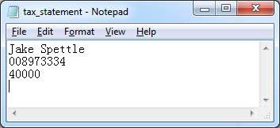

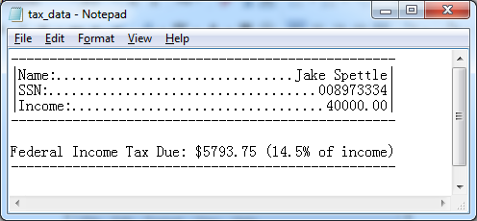

Data2

