Project Name: Precrime

Team member: Zheng Guo, Patrick Yang, and Ken Ellorando

Starting time: 11/11/2017 2:30 PM

Ending time: 11/12/2017 10:10 AM

Time cost: 18 hours

Description: Precrime utilizes data from the Chicago Police to determine if your location is dangerous, preventing possible crime.

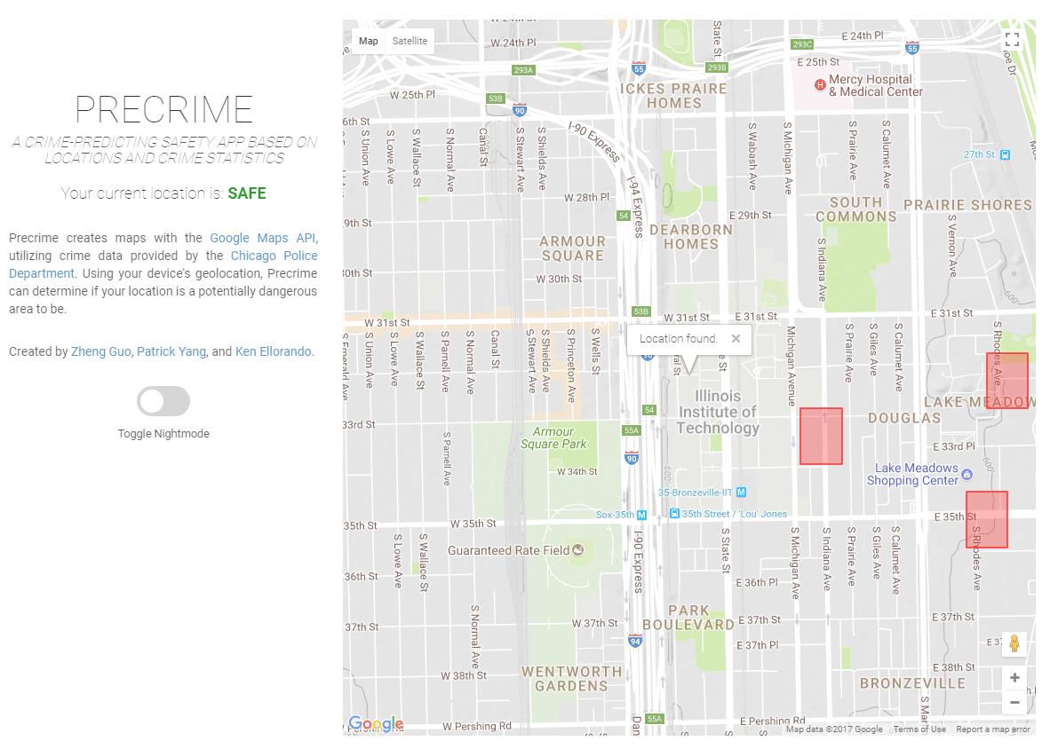

## Inspiration

IIT Students are robbed around Chicago far too frequently. This app will hopefully help all residents of Chicago avoid areas where strings of crimes have been occuring.

## What it does

Precrime extracts data about certain crimes such as robbery and assault, and maps them onto a Google Map. Then, using geolocation, Precrime can determine if you are approaching areas that are considered "dangerous".

## How we built it

Our team separated work into different phases, collecting data, displaying data on the map, and calculating if a user's location is in a range of danger. We also provided a night mode for potential users who may be walking around in the dark.

## Challenges we ran into

Google Map API was difficult to transfer Chicago Police data too because it had a specific format of acceptable data. Also, it was a struggle to make the map continually follow the user's location.

## Accomplishments that we're proud of

We customized a Google Map, displayed information we want on Google Map

## What we learned

We learn how to fetch data from database by API. How to invoke Google map on our own website.

We improved our skills of using JavaScript, CSS and Html. We improved teamwork ability.

## What's next for Precrime

Adding another function that could help users avoid dangerous area while navigating.(Safe path on map)