.

**Creation of EC2 instance for Lempstack server**

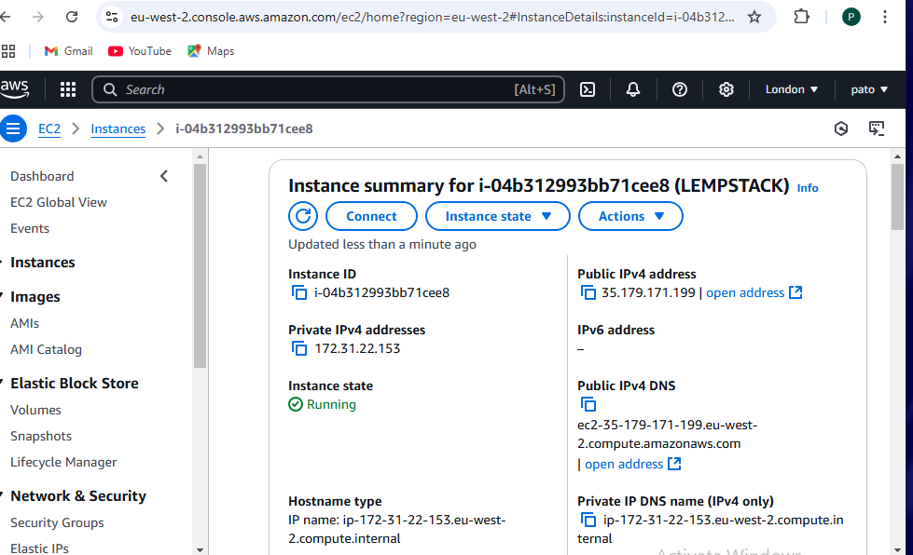

2.Install Components:

Install Nginx, MySQL, and PHP packages using package manager commands.

Apt update

**Step 1: Update Package Index**

Before installing anything, it's a good practice to update your package list to ensure you're installing the latest versions available from the repository.

sudo apt update

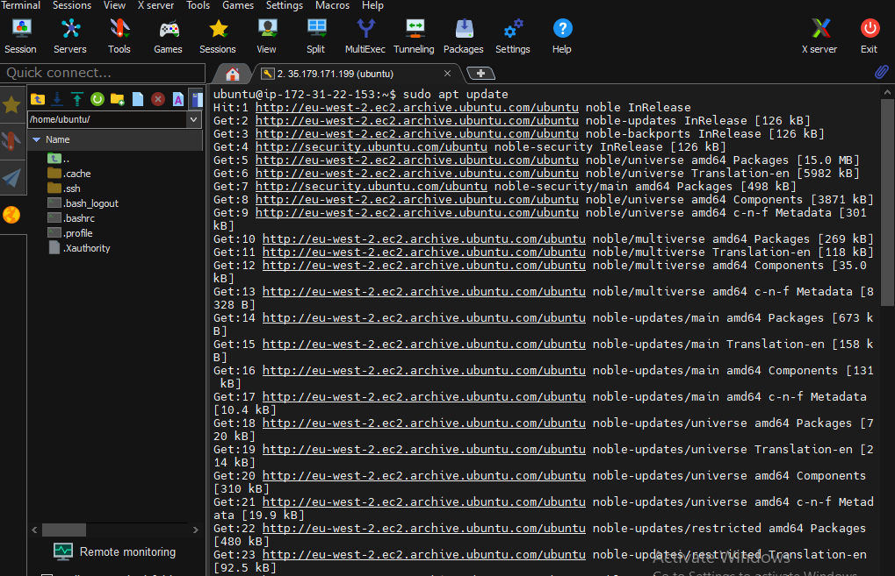

**Step 2: Install Nginx**

To install Nginx, run the following command:

sudo apt install nginx

Once installed, you can start and enable Nginx to run on boot:

sudo systemctl start nginx

sudo systemctl enable nginx

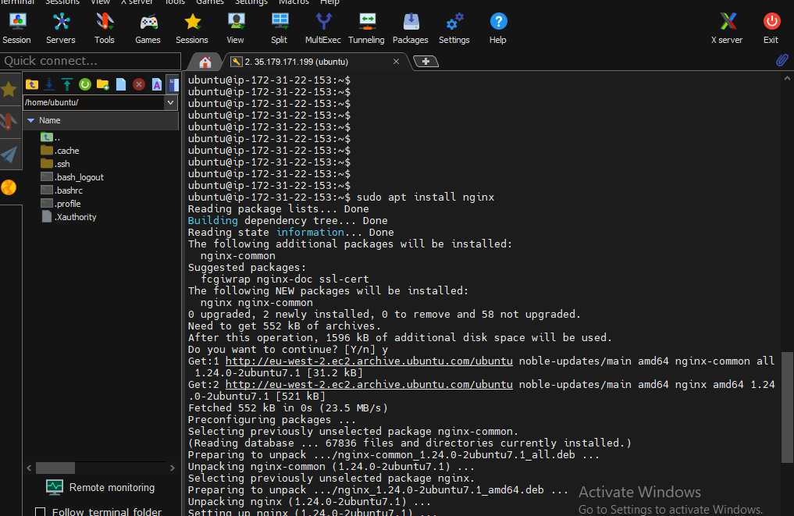

**Step 3: Install MySQL Server**

To install MySQL server, use the following command:

sudo apt install mysql-server

After installation, you can secure the MySQL installation by running:

sudo mysql_secure_installation

This will guide you through some important security settings for MySQL, like setting the root password.

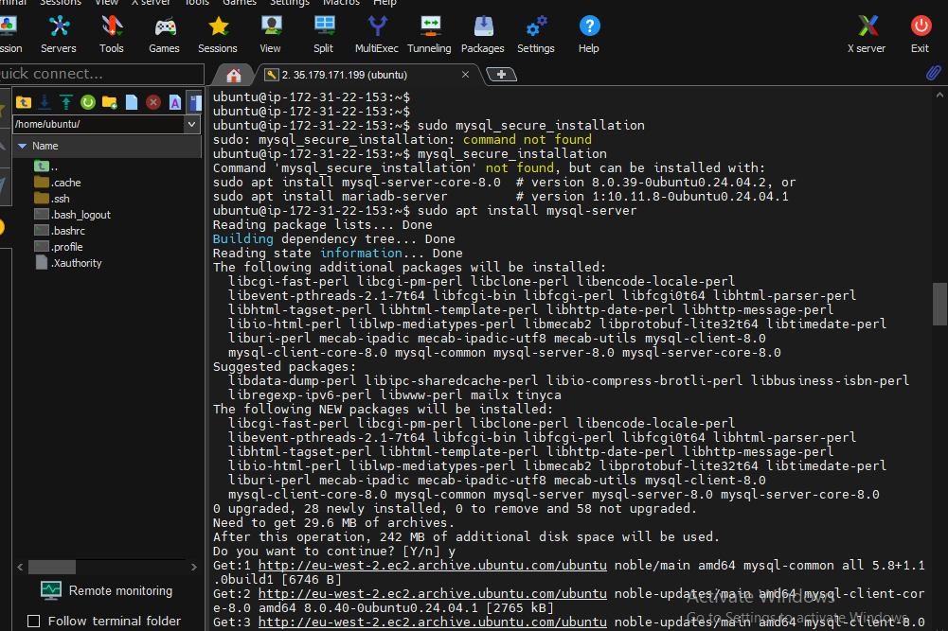

After installation, you can secure the MySQL installation by running

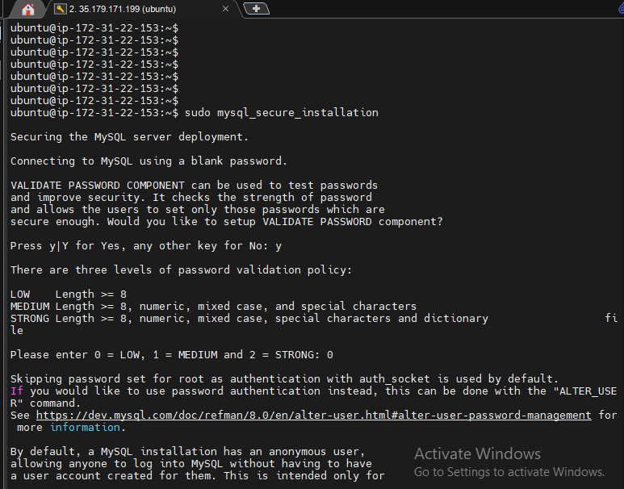

**Step 4: Install PHP and PHP-FPM**

To install PHP along with PHP-FPM (FastCGI Process Manager for handling PHP requests with Nginx), you can install PHP along with some common extensions:

sudo apt install php-fpm php-mysql php-cli php-common php-curl php-xml php-mbstring

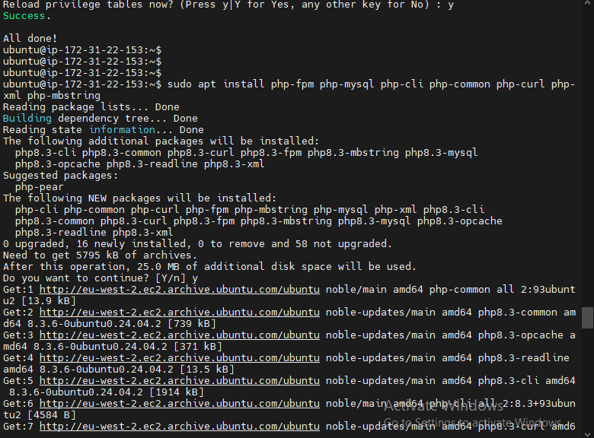

**Step 5: Configure Nginx to Use PHP**

After installing Nginx, MySQL, and PHP, you need to configure Nginx to process PHP files.

1. Open the default server block configuration for editing:
2. sudo nano /etc/nginx/sites-available/default
3. Update the server block to pass PHP requests to PHP-FPM. Ensure that the following lines are in place (under the location / block):
4. location ~ \.php$ {
5. include snippets/fastcgi-php.conf;
6. fastcgi_pass unix:/var/run/php/php7.x-fpm.sock; # Use your PHP version here (e.g., php7.4-fpm)
7. fastcgi_param SCRIPT_FILENAME $document_root$fastcgi_script_name;
8. include fastcgi_params;
9. }

Be sure to replace php7.x with the actual PHP version installed (e.g., php7.4).

1. Test the Nginx configuration for errors:
2. sudo nginx -t
3. Restart Nginx to apply the changes:
4. sudo systemctl restart nginx

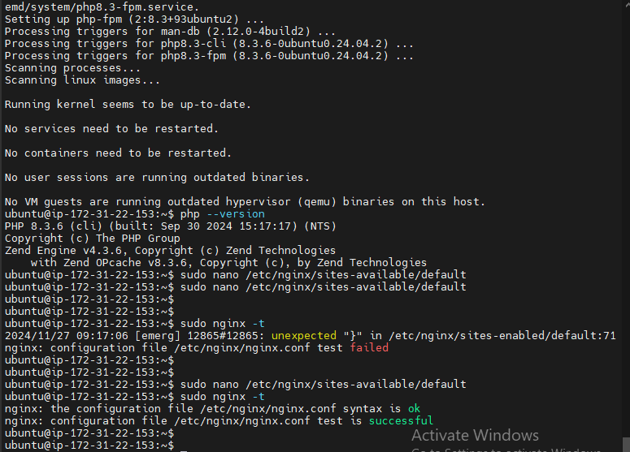

**Step 6: Verify the Installation**

To check if everything is working properly:

1. Create a PHP info file to test PHP processing:
2. sudo nano /var/www/html/info.php
3. Add the following code to the info.php file:
4. <?php
5. phpinfo();
6. ?>
7. Visit http://your_server_ip/info.php in your browser. You should see the PHP information page, confirming that Nginx is processing PHP requests.

