**LAUNCHING OF EC2 INSTANCE FOR LAMPSTACK SETUP**

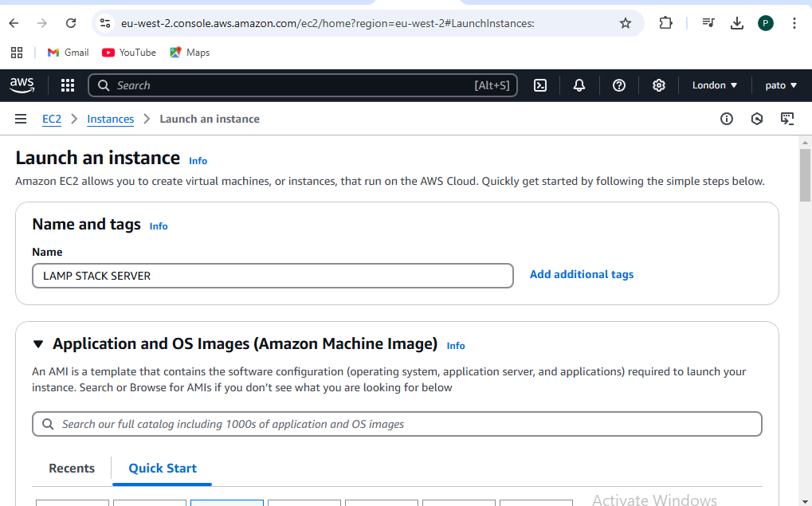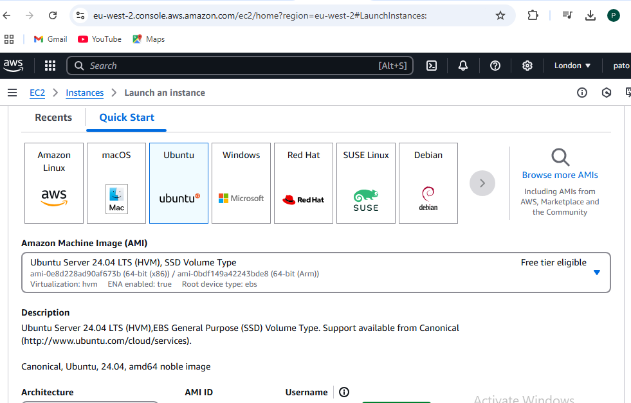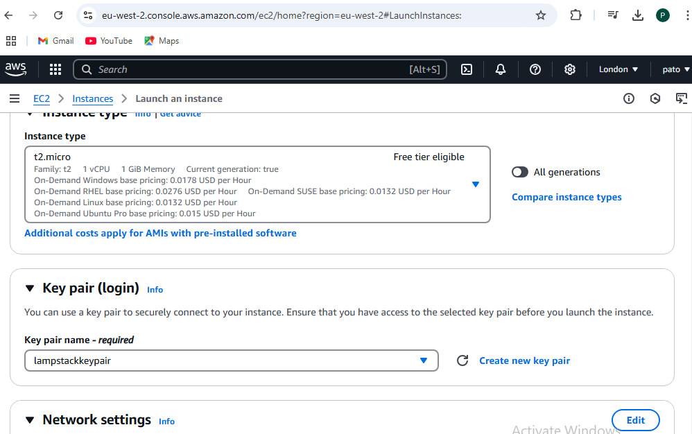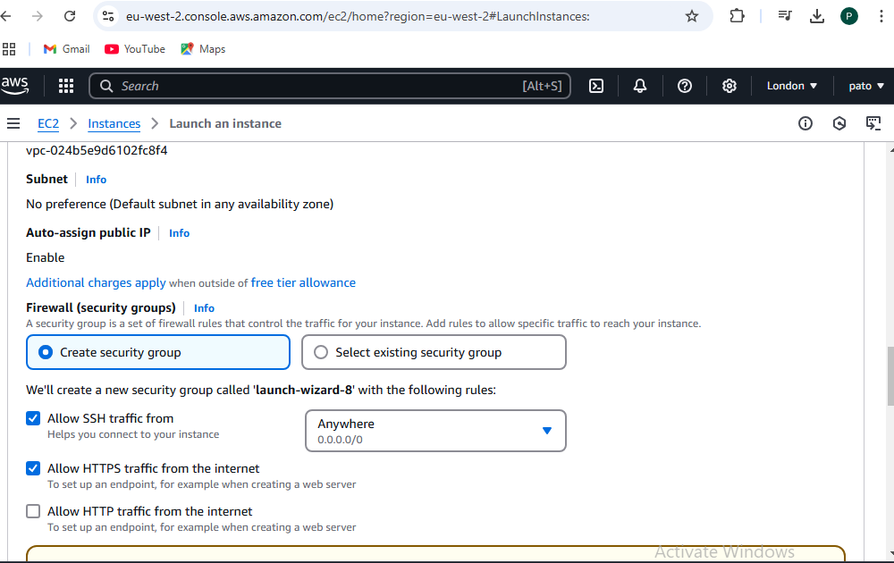

Running instance

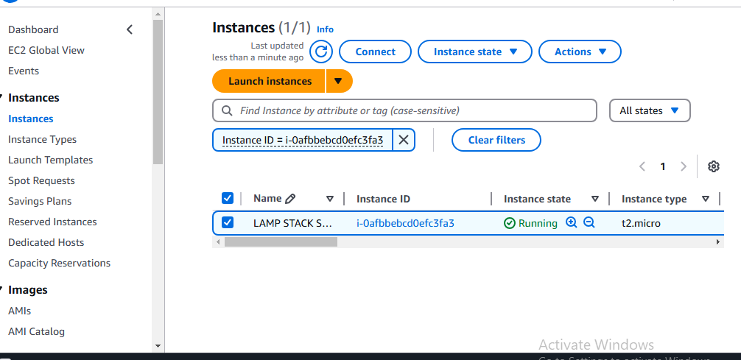

Signed in to Ubuntu server using mobaxterm

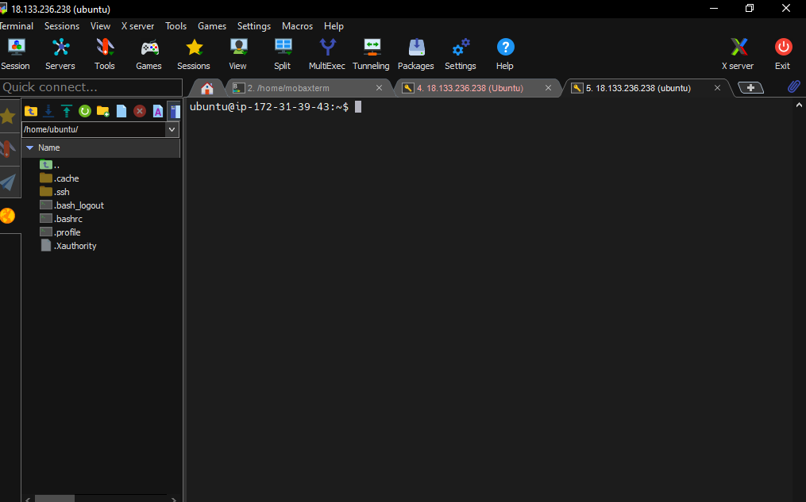

***Install Apache, MySQL, and PHP packages using package manager commands.***

**Step 1: Update the package list**

Before installing any software, it's a good idea to update the list of available packages and their versions:

sudo apt update

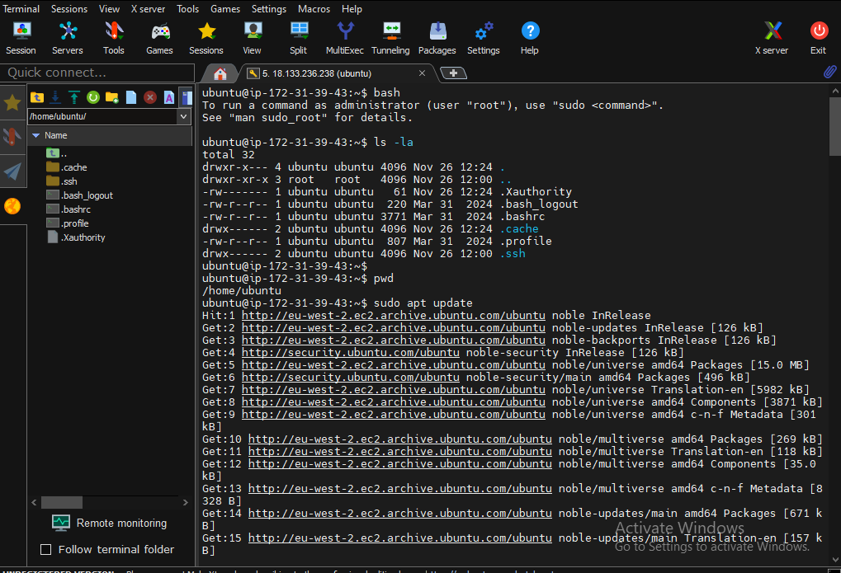

**Step 2: Install Apache (Web Server)**

To install Apache, run the following command:

sudo apt install apache2

After installation, Apache will automatically start. You can verify this by visiting your server's IP address in a web browser. You should see the default Apache welcome page.

To check the Apache status:

sudo systemctl status apache2

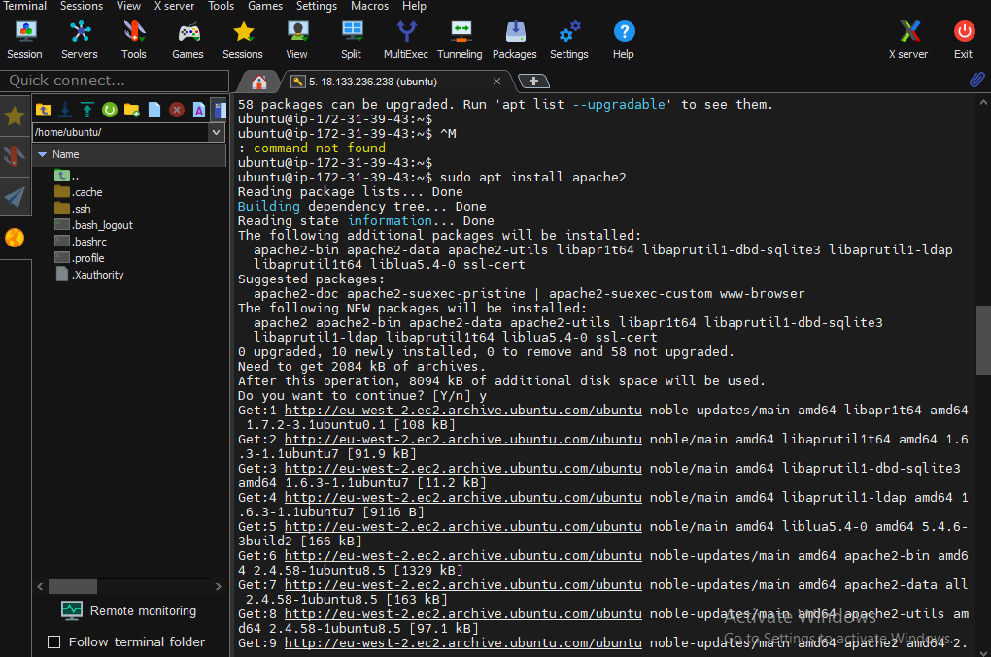

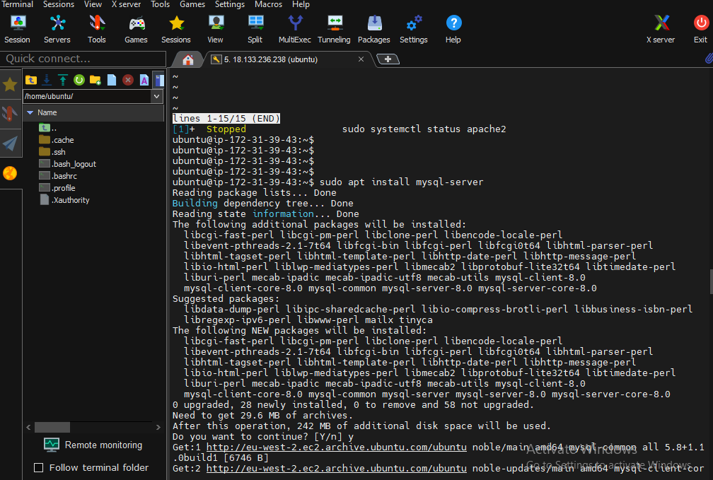

**Step 4: Install PHP (Programming Language)**

To install PHP and the necessary modules to work with Apache and MySQL, run:

sudo apt install php libapache2-mod-php php-mysql

This will install PHP, the Apache PHP module, and the MySQL module for PHP.

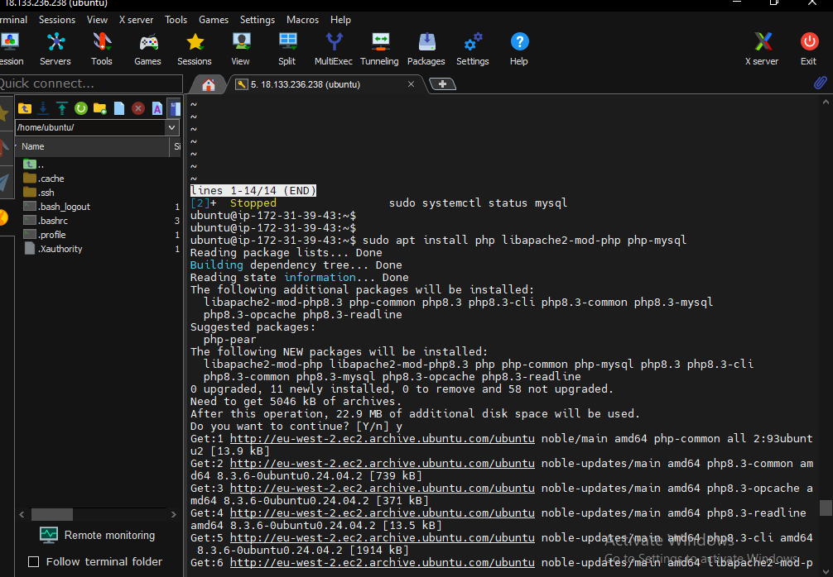

**Step 5: Restart Apache**

After installing PHP, restart Apache to apply the changes:

sudo systemctl restart apache2

**Step 6: Test PHP**

To verify that PHP is working with Apache, you can create a PHP test file. Create a new file called info.php in the /var/www/html directory:

sudo nano /var/www/html/info.php

Add the following PHP code:

<?php

phpinfo();

?>

Save and exit the file. Then, open a web browser and navigate to http://localhost/info.php. You should see a page displaying detailed information about your PHP installation.



 