Q1. Write a function that randomly shuffles an array of integers and explain the rationale behind its implementation

In a worst case the run time would be O(n) because it will only fun for the amount of items in the list

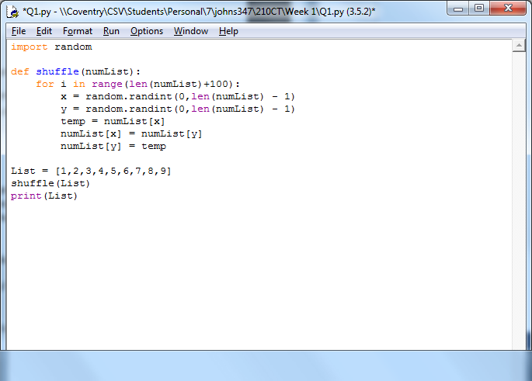

1

1

N+100

N+100

N+100

N+100

N+100

1

1

1

5N + 505 therefore the Big O notation for this algorithm would be O(n)

Q2. Count the number of trailing 0s (number of 0s at the end of the number) in a factorial number