<Title of Capstone Project>

A Capstone Project by

<Name 1>
<Name 2>
<Name 3>
<Name 4>

Submitted to the Information Technology Department, College of Technologies
Bukidnon State University

In Partial Fulfillment
of the Requirements for the Degree
<Degree>

<Month and year of degree conferral, not date of submission>

APPROVAL SHEET
This capstone project entitled <Title>, prepared and submitted by <Name 1>, <Name 2>, <Name 3>, <Name 4> in partial fulfillment of the requirements for the degree <Degree> is hereby accepted.

<Adviser (CAPSLOCK)>
Capstone Project Adviser
<Chair (CAPSLOCK)>
Chair, Defense Panel
<Panelist 1 (CAPSLOCK)> | <Panelist 2 (CAPSLOCK)>
Panel Member | Panel Member

Accepted and approved for the conferral of the degree <Degree>.

SALES G. ARIBE JR., DIT MARILOU O. ESPINA, DIT
Department Head, Information Technology Dean, College of Technologies

DEDICATION
This portion is optional but perhaps you have someone or some people who have inspired you to push on with your studies. A dedication would be a fitting way to acknowledge their impact on your success.

ACKNOWLEDGMENTS
The road to this point in your studies couldn’t have been travelled alone. Along the way, someone somewhere helped you. This is your chance to thank them.
By the way, exercise the liberty to be personal to reflect the sincerity of your gratitude.

TABLE OF CONTENTS
APPROVAL SHEET ii
DEDICATION iii
ACKNOWLEDGMENTS iv
TABLE OF CONTENTS v
LIST OF TABLES vii
LIST OF FIGURES viii
ABSTRACT ix
1 INTRODUCTION 1
1.1 Background of the Study 1
1.2 Objectives of the Study 2
1.3 Significance of the Study 2
1.4 Scope and Delimitations 3
2 REVIEW OF RELATED LITERATURE 4
2.1 Related Literature 4
2.2 Related System 4
2.3 Concept of the Study 5
2.4 Definition of Terms 5
3 METHODOLOGY 6
3.1 Materials 6
3.1.1 Software 6
3.1.2 Hardware 6
3.1.3 Data 6
3.2 Methods 6
3.2.1 Research Design 6
3.2.2 Process Model 6
3.2.3 Procedures for the different phases 7
3.2.4 Evaluation 7
4 RESULTS AND DISCUSSION 8
4.1 Results by phase of study 8
4.2 Verification studies 8
5 SUMMARY, CONCLUSIONS, AND RECOMMENDATIONS 9
5.1 Summary 9
5.2 Conclusions 9
5.3 Recommendations 9
REFERENCES 10
APPENDICES 11
CURRICULUM VITAE 12

LIST OF TABLES
Table 1-1. ML approaches in forecasting HIV. 1
Table 2-1. From "References" > Insert Caption > Table 4

LIST OF FIGURES
Insert the List of Tables using the “References” tab > “Insert Table of Figures” > Figures
Figure 2-1. From "References" > Insert caption > Figure 5
Figure 3-1. Golf course tricks. 7

ABSTRACT
Insert your abstract here. This portion is not to be indented and should be clear, concise, and complete. As much as possible, limit the introductory part to a few sentences and make sure that the last sentence reiterates the achievement of the general objective of the research.

INTRODUCTION

Background of the Study
The background of the study is the story of your research. In this portion, you give a narrative or storyline of the research.
It is suggested that you use an inverted triangle approach in the story telling, starting with a general overview and moving on to the specifics (deductive reasoning). Take note of the narrative elements in writing introduction (opening sentence, problematization, motivation and outline). You should be generous in your citations because it lends credence to your work. You should specifically cite statements of facts to support your arguments.
Table 1-1. ML approaches in forecasting HIV.
ML Algorithm | Scope of Study | References
LSTM, GRNN, ES, ARIMA | HIV incidence data of Guangxi, China from 2005 to 2016 were obtained to obtain the most suitable models. | (Wang et al., 2019)
GARCH | Utilizing the RIMA-GARCH (1,1) model, it analyzed the global HIV prevalence data in terms of the number of HIV-positive individuals. | (Xie, 2018)
MoT | The model was modified, put to use, and parameterized using reliable biobehavioral surveillance data from important populations, common data sources, and literature reviews. | (Kouyoumjian et al., 2018)
Box-Jenkins “Catch All” Model | This study used the method of examining univariate time series data to predict new HIV infections using time series data collected every month on new HIV diagnoses at Silobela District Hospital. | (Nyoni & Nyoni, 2020)

It is suggested that you give the statement of the problem at the end of the background. The solution to the problem would be identified in the next section.

Objectives of the Study
Start with the general objective of the research. The general objective should provide the answer to the problem just stated above or what you expect to achieve in general terms. In a way, the general objective is a restatement of the title of the research.
The specific objectives must break down the general objectives into smaller, logically connected parts that systematically address the various aspects of the problem. Must use a colon at the end:
- The specific objectives must be measurable;
- They should have a one-to-one correspondence to the conclusions you will make in Chapter 5.

Significance of the Study
Insert the significance of the study. Be exhaustive. These are people or organizations who may be benefitted from your findings. You may not include the significance of the study to you as a student.

Scope and Delimitations
Insert the scope and delimitations here. Note that the scope details what your study will explore, such as the target population, extent or study duration. Delimitations are factors and variables not included in the study.

REVIEW OF RELATED LITERATURE

Related Literature
It is a section in a research paper that discusses the relevant studies, theories, and concepts that have been published in academic journals, books, or other sources that are related to the research topic.
For the review of related literature, make sure to touch on the most important aspects of your study. Use a topical outline. In your style of discussion, be sure to adopt a storyline. Do not forget to cite all statements of facts, main ideas/trends, equations, findings, etc. Use APA format for the citation. As much as possible, use most recent journal articles (5 years recency). Use books sparingly. And no Wikipedia, please!
For tables, use the following format:
Table 2-1. From "References" > Insert Caption > Table
Indent the Table label to start of table; table label should be in sentence structure | Only the table number is capitalized, the label is not.
The List of Tables should be automatically generated | The Chapter number is included in the table number, followed by dash and sequence number
Table header is bold

Related System
It is a section in a research paper that discusses the system related to the project.

Concept of the Study
Figure should be centered. The List of Figures must be automatically generated. Note that Figure number represents the Chapter number, dash and sequence number (see below)

Figure 2-1. From "References" > Insert caption > Figure
Provide a conceptual framework in the form of a single diagram which should show all the aspects of the study. Provide a description of the framework after the diagram.

Definition of Terms
Word 1 Definition for Word 1
Word 2 Definition for Word 2

METHODOLOGY

Materials

Software
Describe all the software that you used including names and other details.

Hardware
Describe the hardware that you used.

Data
Indicate the source of the data, type of data, year of acquisition, and other pertinent details.

Methods
The headings given here for the methods are only suggestive. Adopt what is appropriate for your research. For example, you would have experimental design if you used one such as multivariate method and the like which would describe the number of tests you did and the conditions for testing.

Research Design

Process Model

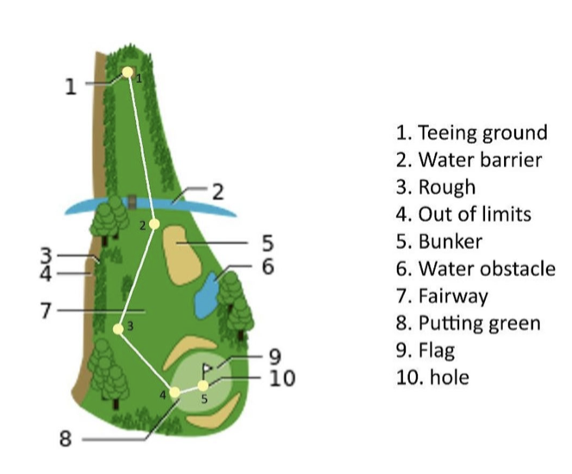
Figure 3-1. Golf course tricks.

Procedures for the different phases
Phases be as follows depending on the methods used:
- Use Case Diagram
- Data Flow Diagram
- System Architecture
- Flowchart
- Database Schema
- Etc.

Evaluation

RESULTS AND DISCUSSION

Results by phase of study
Name the phases of your study and give the results. Have as many headings as necessary depending on the number of experiments or studies you did. Provide the discussions. It may have one-to-one correspondence with your specific objectives.

Verification studies
The headings above are only suggestive. Follow what is appropriate for your research work.

SUMMARY, CONCLUSIONS, AND RECOMMENDATIONS

Summary
Provide a rather concise summary of the research work.

Conclusions
The conclusions are direct statements that would prove the achievement of the specific objectives. The conclusions should have one-to-one correspondence to the specific objectives, i.e. if you have 4 specific objectives (a to d) then you should have 4 conclusions (1 to 4).

Recommendations
Number the recommendations and start the statement with action word.

REFERENCES
Use APA formatting for all references (in the body and in the listing here).
Use Mendeley software for easy referencing (mandatory).

APPENDICES

<Appendix A:> <Title>
Place your appendices here. Please be sure that these have been referenced in the body of document.

CURRICULUM VITAE
PHOTO HERE
2x2
Name:
Address:
Contact Number:
Email Address:
Educational Attainment:

Membership in Organization:

Skills:

