

**ELECTRICAL AND ELECTRONICS ENGINEERING**

**ELECTRICAL TECHNOLOGY**

**LEVEL: III**

**STREAM: B**

TURNING ON BULB LAMP USING PIR

**PREPARED BY: NDAHIRO PATRICK**

**MUSHIMIYIMANA COLETTE**

**ABSTRACT**

This Project of turning on bulb lamp Using Arduino and PIR Sensor can be used to turn ON and OFF the illumination system of home / office routinely by sensing the existence of human. Such Automatic Room Lights systems can be implemented in Classrooms, garages, staircases, bathrooms, etc. where we do not need constant light but only when individuals are existing. Also, with the assistance of this system, we can save the energy bill as power will be consumed only when human is present i.e. when required lights will be spontaneously turned ON or OFF. This paper of turning on bulb lamp light using Arduino and PIR sensor and relay module. PIR sensor will spot the human activity and based on response of PIR sensor unit will control the switching action. Proposed method can help us to reduce the consumption of electricity and lifespan of the system will increase.

**PROBLEM STATEMENT**

By using suggested system, the problem of wastage of electricity can be reduced as electrical appliance will be automatically turned ON or OFF based on the presence of the human being with the help of PIR sensor while no need to turn on the lamps while arriving in your room and also no need to turn off the lamps while leaving it. This is the main enhancement of the projected system.

**BLOCK DIAGRAM**

ARDUINO

AC SUPPLY

AC LAMP

RELAY

PIR SENSOR

**BLOCK DIAGRAM DESCRIPTION**

Firstly, when there is no human movement, the PIR Sensor doesn’t detect any individual and its OUT pin stays LOW. As the individual enters the room, the change in infrared radiation in the room is identified by the PIR Sensor. As a result, the output of the PIR Sensor becomes HIGH. Since the Data OUT of the PIR sensor is connected to Digital Pin of Arduino, whenever it develops HIGH, Arduino will trigger the relay by making the relay pin LOW (as the relay module is an active LOW module). This will turn the Light ON. The light stays turned ON as long as there is movement in front of the sensor. If the person takes a nap or leaves the room, the IR Radiation will become stable (there will be no change) and hence, the Data OUT of the PIR Sensor will become LOW. This in turn will make the Arduino to turn OFF the relay (make the relay pin HIGH) and the room light will be turned OFF.

**SOURCE CODES**

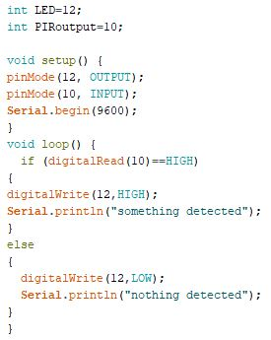

**CIRCUIT IN PROTEUS**

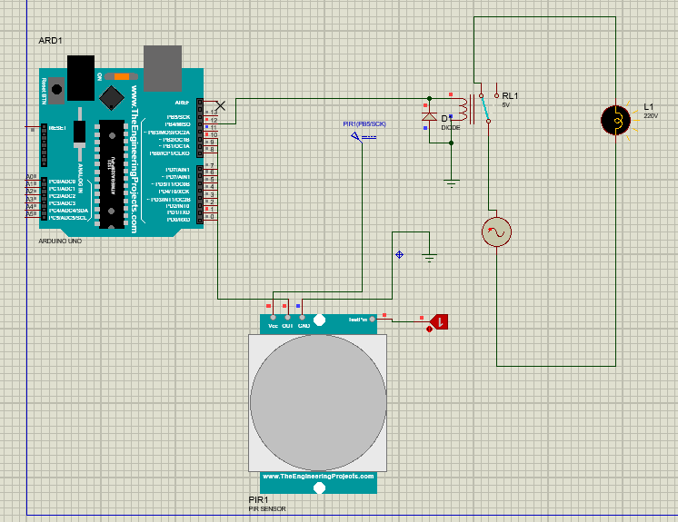

**CIRCUIT IN FRITZING**

