Adjustments & Comments 2023/07/12 (PB):

* Add genotype to line title
* Already normalized within batch to end up with same y axes
* I think 1 or 3 is a good example to show established alpha early and struggle in lower animals  
  for KO I think 10 is most aligned with the idea that they show continuous struggle to establish a clear social hierarchy.

Adjustments & Comments 2023/07/12 (PB):

* Added zero line
* Added genotype as titles
* Reordering
* Labels

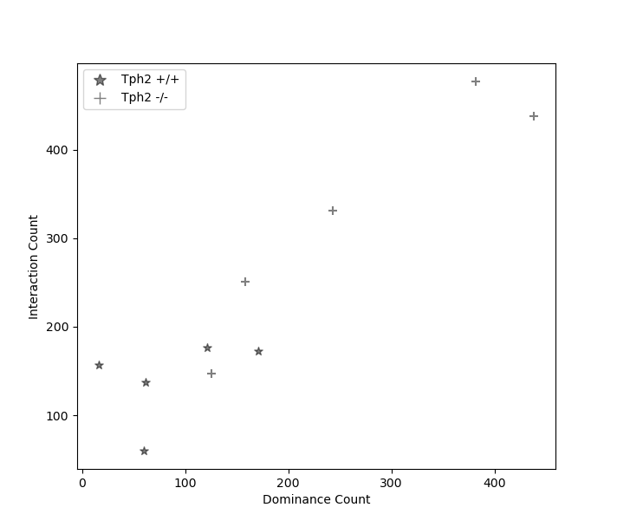

Count of interactions until dominant animals remains on top.