Adjustments & Comments 2023/07/12 (PB):

* Add genotype to line title

<- where is it I don’t see it in the figure above. < is on the left side above glicko rating

* I think 1 or 3 is a good example to show established alpha early and struggle in lower animals  
  for KO I think 10 is most aligned with the idea that they show continuous struggle to establish a clear social hierarchy.

<- ok then let’s take 3 (wt) and 10 (ko)

Can you please create a figure where 3 and 10 are on top of each other for our Panel A of the figure.

* The font of the labels and the width of the x/y axis and tick lines are too thin. I think it is already the time for this sort of esthetic grooming.

For inspiration you can look at figure 2 and 4 in the paper. I copy it here too for rapid check.

* While you finalise Panel A, please add/modify the text of the legend of the figure (panel A) and write (here?) what we should not forget to add to the M&Meth (if it changes form the last version of the paper. Please have a look directly in the paper to double check.

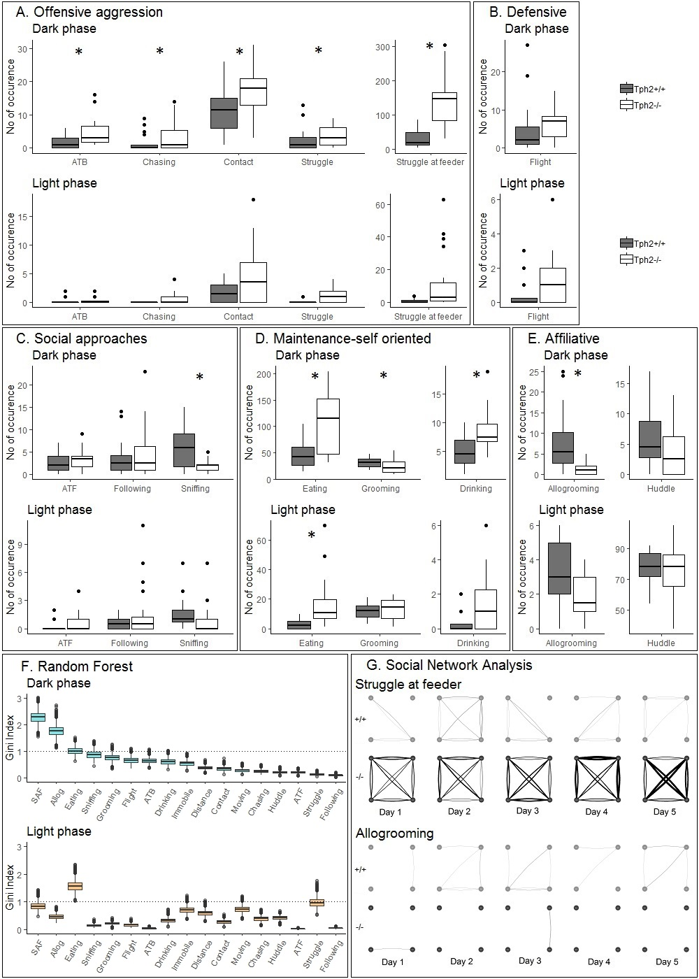

Adjustments & Comments 2023/07/12 (PB):

* NEW: are the batches numbers here the same as in Panel A?
* Can you already try to combine A and B (this one is B) and apply the same esthetic changes (mentioned above and using Fig 4. As an example for the font and thickness of lines)
* While you finalise Panel B, please add the text for the legend of the figure (panel B) and what we should not forget to add to the M&Meth ( how the normalization is done…)

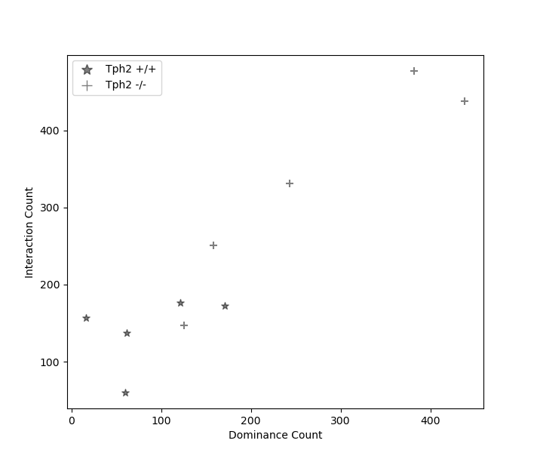

Count of interactions until dominant animals remains on top.

MR 13.07.

* I am not sure what is “dominance count” and if it brings something more.
* If like I think it does not, can you have all the dots positioned one above the other (x=+/- 1, =jitter format)slightly shifted right/left so they don’t touch
* I like the stars as symbols but maybe we should use open circles for ko and black filled circles for controls for consistency with the rest of the paper.
* This would be panel C and the legend of the figure should be positioned outside the figure (you can have a look at the other figures in the paper for inspiration)
* Can you already combine A, B and C (top of the third and last “column”) panels?
* Like the other panels, please draft the text for the legend and what we should adjust in the M&M.

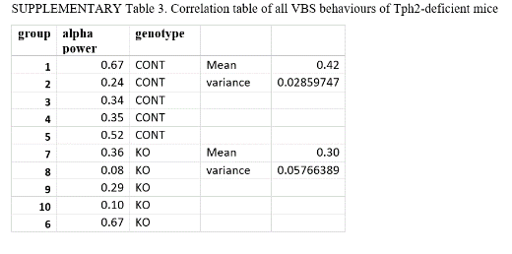

Despotism – Table

MR 13.07

* How could we represent that nicely? Similarly looking as panel C?
* Can you already combine A, B and C (top) and D (bottom of the last column) panels?
* Like the other panels, please draft the text for the legend and what we should adjust in the M&M.

|  |  |  |  |
| --- | --- | --- | --- |
| **Batch** | | **Alpha power** | **Genotype** |
| 1 | 0.72634221 | | 'Tph2 +/+' |
| 2 | 0.12006807 | | 'Tph2 +/+' |
| 3 | 0.41795572 | | 'Tph2 +/+' |
| 4 | 0.318799 | | 'Tph2 +/+' |
| 5 | 0.48404251 | | 'Tph2 +/+' |
| 6 | 0.6447772 | | 'Tph2 -/-' |
| 7 | 0.37285729 | | 'Tph2 -/-' |
| 8 | 0.06270942 | | 'Tph2 -/-' |
| 9 | 0.40184848 | | 'Tph2 -/-' |
| 10 | 0.08169612 | | 'Tph2 -/-' |

Despotism defined via alpha power. Alplha power was defined as the ratio of power (glicko rating difference) projected from alpha male to beta male as a ratio of power projected from alpha male to delta male.