Adjustments & Comments 2023/07/12 (PB):

* Add genotype to line title

<- where is it I don’t see it in the figure above. < is on the left side above glicko rating

* I think 1 or 3 is a good example to show established alpha early and struggle in lower animals  
  for KO I think 10 is most aligned with the idea that they show continuous struggle to establish a clear social hierarchy.

<- ok then let’s take 3 (wt) and 10 (ko)

Can you please create a figure where 3 and 10 are on top of each other for our Panel A of the figure.

* The font of the labels and the width of the x/y axis and tick lines are too thin. I think it is already the time for this sort of esthetic grooming.

For inspiration you can look at figure 2 and 4 in the paper. I copy it here too for rapid check.

* While you finalise Panel A, please add/modify the text of the legend of the figure (panel A) and write (here?) what we should not forget to add to the M&Meth (if it changes form the last version of the paper. Please have a look directly in the paper to double check.

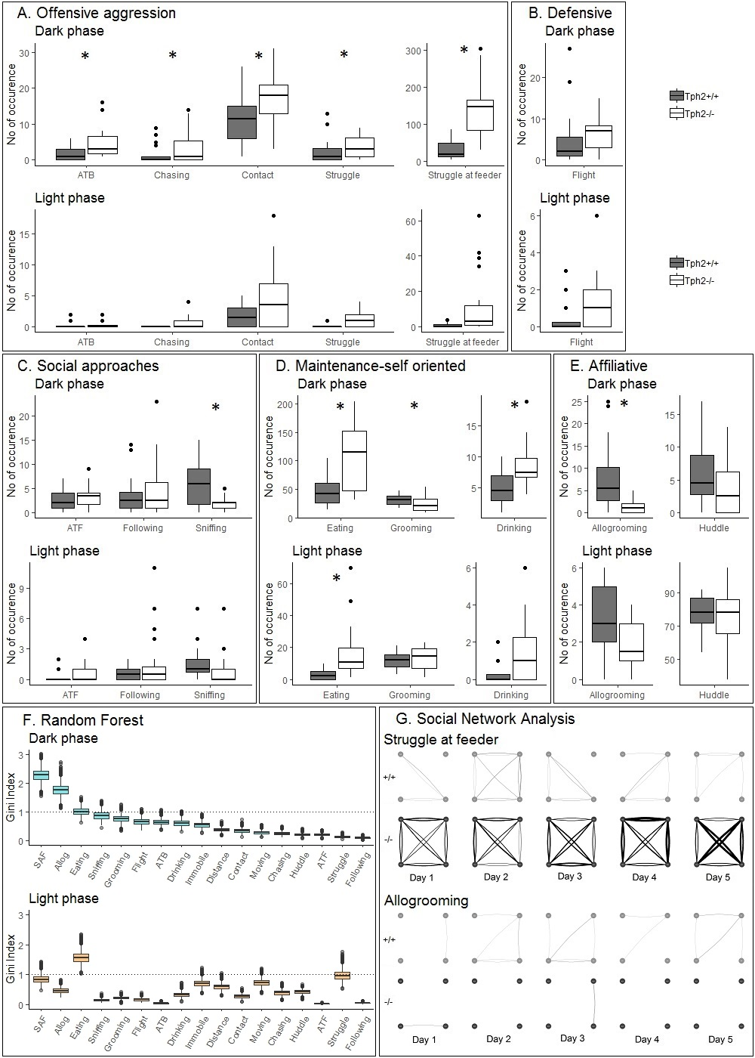

Adjustments & Comments 2023/07/12 (PB):

* NEW: are the batches numbers here the same as in Panel A?
* Can you already try to combine A and B (this one is B) and apply the same esthetic changes (mentioned above and using Fig 4. As an example for the font and thickness of lines)
* While you finalise Panel B, please add the text for the legend of the figure (panel B) and what we should not forget to add to the M&Meth ( how the normalization is done…)

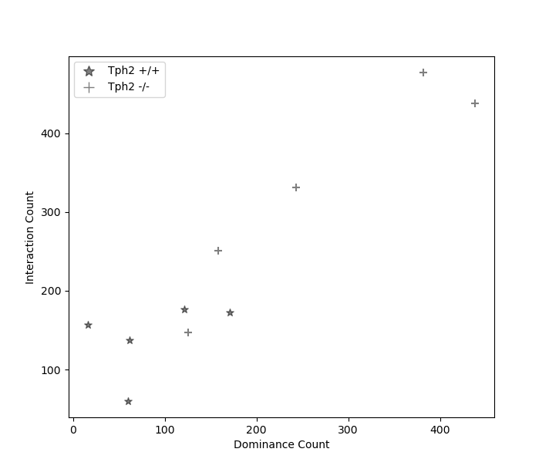

Count of interactions until dominant animals remains on top.

MR 13.07.

* I am not sure what is “dominance count” and if it brings something more.
* If like I think it does not, can you have all the dots positioned one above the other (x=+/- 1, =jitter format)slightly shifted right/left so they don’t touch
* I like the stars as symbols but maybe we should use open circles for ko and black filled circles for controls for consistency with the rest of the paper.
* This would be panel C and the legend of the figure should be positioned outside the figure (you can have a look at the other figures in the paper for inspiration)
* Can you already combine A, B and C (top of the third and last “column”) panels?
* Like the other panels, please draft the text for the legend and what we should adjust in the M&M.

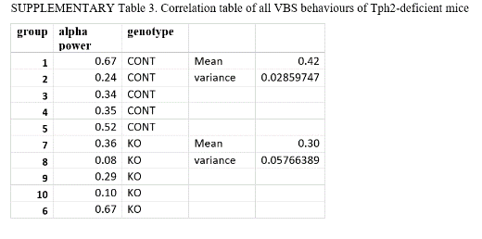

Despotism – Table

MR 13.07

* How could we represent that nicely? Similarly looking as panel C?
* Can you already combine A, B and C (top) and D (bottom of the last column) panels?
* Like the other panels, please draft the text for the legend and what we should adjust in the M&M.

|  |  |  |  |
| --- | --- | --- | --- |
| **Batch** | | **Alpha power** | **Genotype** |
| 1 | 0.72634221 | | 'Tph2 +/+' |
| 2 | 0.12006807 | | 'Tph2 +/+' |
| 3 | 0.41795572 | | 'Tph2 +/+' |
| 4 | 0.318799 | | 'Tph2 +/+' |
| 5 | 0.48404251 | | 'Tph2 +/+' |
| 6 | 0.6447772 | | 'Tph2 -/-' |
| 7 | 0.37285729 | | 'Tph2 -/-' |
| 8 | 0.06270942 | | 'Tph2 -/-' |
| 9 | 0.40184848 | | 'Tph2 -/-' |
| 10 | 0.08169612 | | 'Tph2 -/-' |

Despotism defined via alpha power. Alpha power was defined as the ratio of power (glicko rating difference) projected from alpha male to beta male as a ratio of power projected from alpha male to delta male.

**29.07.2023 update**

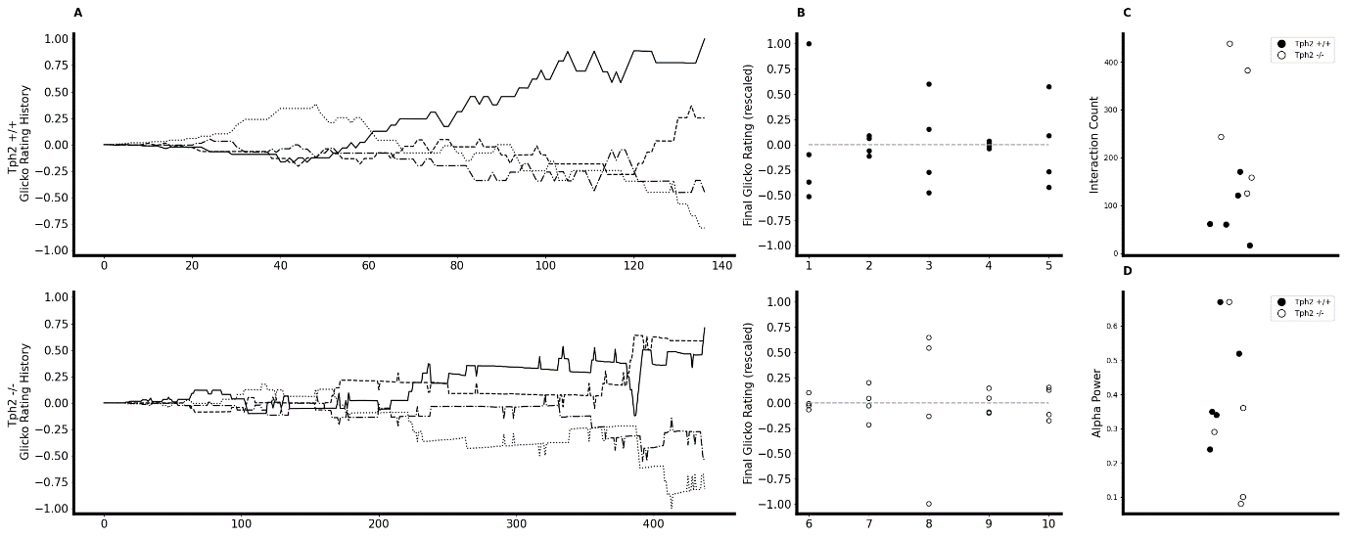

Tph2 +/+

Tph2 -/-

MR 010823 –

1. the font of the text is not readable as such, the font used for this figure (below) is readable. This should be the goal for TEXT, NUMBERS and size of the DOTS. It is ok if it is Big.
2. C and D are not +/+ or -/- only so we need to add the genotype as I show and remove it from the y axis title
3. Legend can be removed from D
4. Ticks are not visibles
5. In general more space between the panels is ok (allowing bigger font) and less space within each figure (less long) is also ok.

PB 010823

Does that fix the aesthetics?

MR 02082023

mainly yes – last changes:

A: x=0 closer to y axis line

Width of lines a bit bigger so we don’t lose sight of the omega

Need a title to the x axis (can be placed under the -/- figure only

B: Need a title to the x axis (can be placed under the -/- figure only

C: legend :text and dot bigger + remove the line of the box around it

D: can you have the 2 black dots around 0.35 less overlapping?

All: ABCD bigger font (see figure below) and not bold

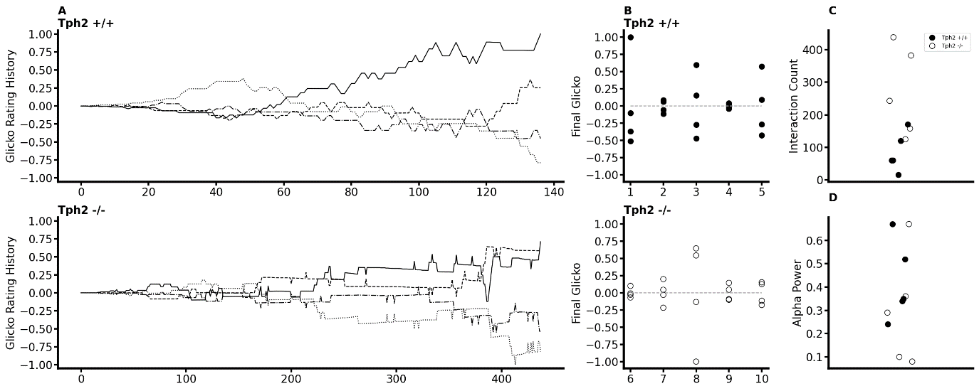



Using old values for despotism in panel D

Caption:

**Fig.5. Temporal and social properties of individual Glicko ratings for Tph2-control groups (labeled 1-5) and Tph2-deficient groups (6-10). (A)** The change in individual Glicko ratings over time. Each line represents the ratings of one individual while the solid black line represents the final alpha male. Ratings are recalculated for every individual after each agonistic interaction and are plotted on the y axis against the ranking updates on the x axis. Rating values are normalized as ratio of absolute maximum rating within given batch history. Exemplary batches 3 (top) and 10 (bottom) are displayed. **(B)** The final rankings within each batch are shown normalized to the absolute maximum rating within a given genotype. Initial rating value is shown as vertical line at zero. Knock out batches (bottom) show a reduced variance around the initial condition compared to wild type (top), indicating reduced expression of clear social hierarchical structure at the end of the rating period. **(C)** Dominance establishment count given as the minimal number of agonistic interactions before the final alpha male established top Glicko rating and remains the rank until the end of the rating period. **(D)** Despotic alpha power shows the ratio of absolute power exhibited from the alpha toward the beta male over the total power expressed toward the lowest ranking animal.