**Patrik Parkkonen** **RESUME**

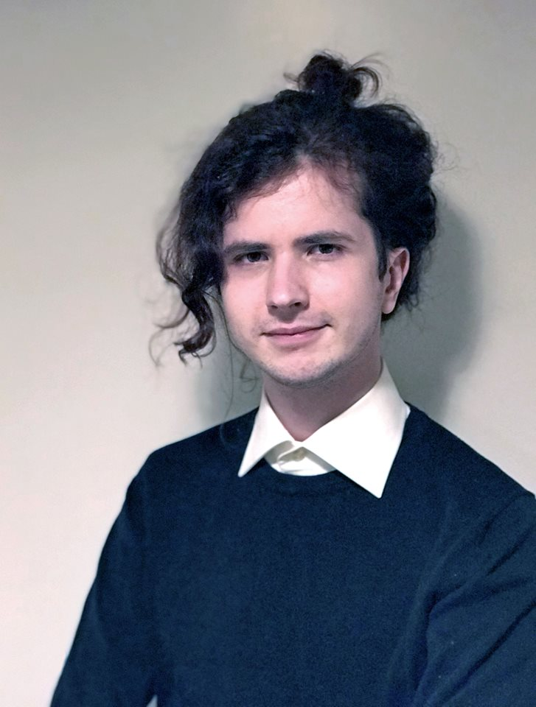

s. 4.7.1994

Topeliuksenkatu 36 A 8

00270 Helsinki

050 – 468 6156 31.1.2025

patrik.parkkonen@gmail.com

**PROFILE**

Recently graduated with a bachelor’s degree in business information technology. Always motivated to learn new things. Enjoys customer service as well.

**EDUCATION**

**Bachelor in Business Information Technology**

**Haaga-Helia University of Applied Sciences, 2017-2025**

Business Information Technology

**Töölön yhteiskoulun aikuislukio, 2014-2016**

Graduate

**The English School (High School), 2010-2014**

45/75 courses*.*

**JOB EXPERIENCE**

**Lumoa Oy, 08/2022-03/2023**

Junior Software Developer, Test Engineer

*Front End development, bug fixes, and working on various features using React. Helped create new automation test environment using Cypress and moving to it from Robot Framework.*

**Helsinki City Library, 10/2016-4/2017**

Librarian

*Worked as a librarian in the library’s mobile library unit.*

**Iltalehti (freelance), 10/2008-12/2009**

Gaming Journalist

*Wrote numerous game reviews as a freelancer.*

**LANGUAGES**

Finnish native

English excellent (Laudatur)

Swedish passable

**IT SKILLS**

JavaScript decent

Java basics

React good

Python basics

Microsoft Office Suite decent

Cypress decent

Git good

HTML/CSS good

Robot Framework basics