HR ANALYTICS SYSTEM
Architecture Guide
Version 1.0

Document purpose | Explain the architecture, design decisions and verified behaviour of Phases 1 and 2.
Project stage | Domain Model and Persistence Layer complete
Quality baseline | 55 automated tests passing
Prepared for | Engineer Sambo / Peck Solutions learning portfolio

A professional reference for understanding not only what the system does, but why it is structured this way.

Document Control
Field | Value
Version | 1.0
Status | Baseline after completion of Persistence Layer
Scope | Phases 1–2
Test baseline | 55 passing tests
Primary language | Python
Persistence format | JSON
Next planned phase | Application Services

Contents
1. Executive Summary
2. System Goals and Scope
3. Architecture Principles
4. Layered Architecture
5. Domain Model
6. Aggregate and Business Rules
7. Persistence Architecture
8. Waiting-Room Reconstruction Algorithm
9. Save and Load Sequences
10. Testing Strategy
11. Architectural Decisions
12. Project Structure
13. Risks and Future Evolution
14. Phase 3 Handover Checklist

1. Executive Summary
The HR Analytics System is being developed as a learning and portfolio project using professional software-engineering practices. The first two phases establish a tested domain model and a persistence layer that can safely serialize and reconstruct the complete Company aggregate.
The architecture deliberately separates business rules from file storage. Company, Department and Employee model the business. CompanyRepository coordinates persistence. JsonStorage reads and writes JSON without understanding the domain. This separation keeps responsibilities clear, tests focused and future replacement of JSON with a database practical.

Current milestone
Area | Status | Evidence
Domain model | Complete | Employee, Department and Company implemented and tested
Persistence | Complete | JsonStorage and CompanyRepository implemented and tested
Aggregate reconstruction | Complete | Out-of-order manager dependencies handled
Automated testing | Green | 55 tests passing
Application services | Not started | Planned as Phase 3

2. System Goals and Scope

Goals
- Represent core HR concepts using a clean domain model.
- Protect business invariants through validation and aggregate ownership.
- Persist and reconstruct the full company state without leaking JSON concerns into the domain.
- Provide a stable foundation for reporting, analytics, APIs, databases and data pipelines.
- Develop engineering habits: design first, test behaviour and document decisions.

Current scope
Version 1.0 documents only the completed foundation: the Domain Layer and Persistence Layer. User interfaces, application services, reporting, databases, APIs, Airflow, cloud deployment and AI features remain outside this baseline.

3. Architecture Principles
Principle | How it is applied
Separation of concerns | Business objects do not read or write JSON. Storage does not understand employees or departments.
Single responsibility | Each class has one primary reason to change.
Aggregate ownership | Company controls departments, employees and cross-entity rules.
Dependency injection | CompanyRepository receives a configured storage object.
Public contracts | Higher layers rely on tested public methods such as to_dict(), save() and load().
Fail fast | Invalid types, missing managers and circular relationships raise clear exceptions.
Test behaviour | Tests describe contracts and workflows rather than implementation details.
The guiding engineering sequence is: understand the business, assign responsibilities, design the workflow, implement, test, document and commit.

4. Layered Architecture
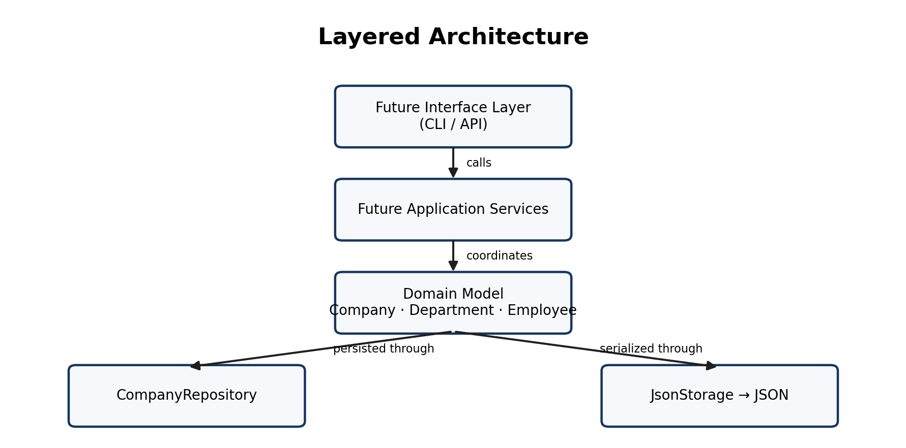
The domain layer remains central. Future interfaces and application services will call the domain rather than bypass it. Persistence is accessed through CompanyRepository, which translates between the aggregate and storage.

Dependency direction
Future Interface → Application Services → Domain Model
↓
CompanyRepository → JsonStorage
The direction prevents file-format details from contaminating business logic and keeps future infrastructure changes localized.

5. Domain Model
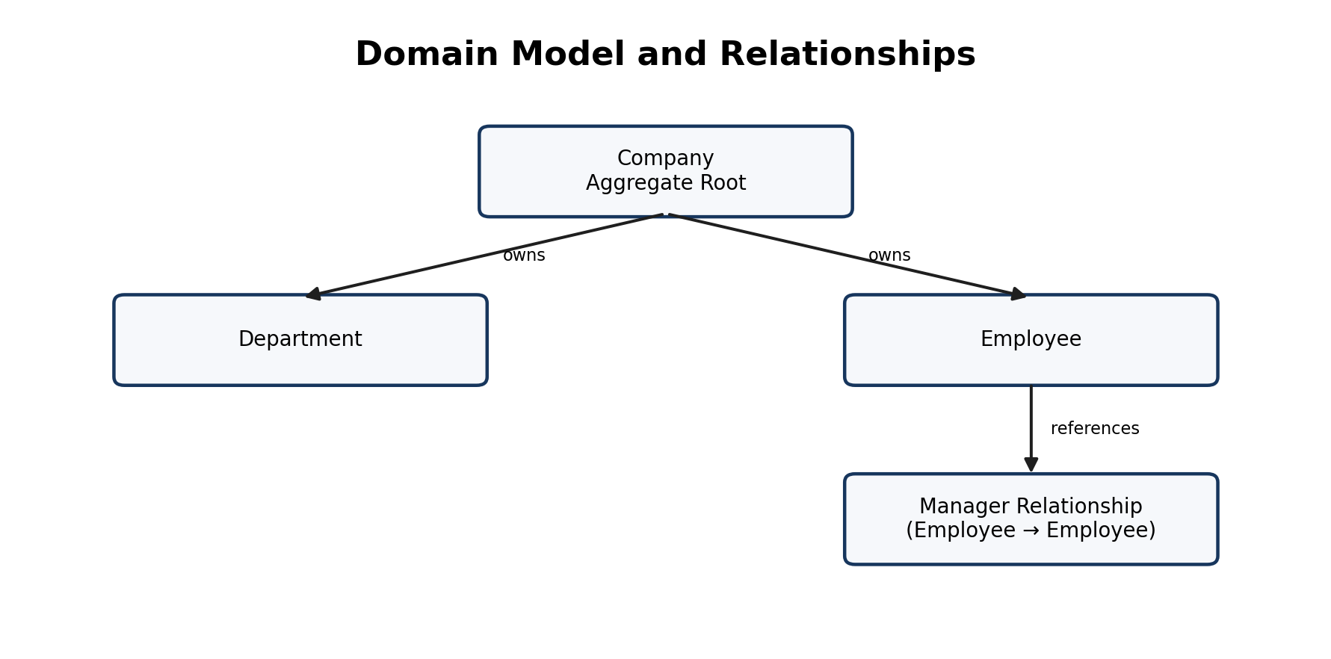

Employee
Represents an individual worker. It contains identity, name, department assignment, salary, optional manager reference and employment status. Validation protects the integrity of these values.

Department
Represents an organizational unit with its own identity, name and status. Departments are owned by the Company aggregate.

Company
Acts as the aggregate root. It owns the authoritative collections of departments and employees and coordinates business rules involving more than one entity.

Why Company is the aggregate root
- Employees must reference departments that belong to the same company.
- Manager relationships must resolve to employees in the company.
- Cross-entity operations require one consistency boundary.
- Persistence saves and restores the complete aggregate through one repository.

6. Aggregate and Business Rules
Rule | Protected by
A department must be valid before being added | Department and Company
An employee must reference an existing department | Company
A manager reference must point to an existing employee | Company reconstruction/business rules
Circular or permanently unresolved manager references are invalid | Waiting-room algorithm
The complete company state is serialized through one aggregate | Company.to_dict()
Reconstruction produces a valid aggregate or fails | Company.from_dict()
The aggregate boundary means callers should not independently persist employees and departments. Saving partial pieces could violate relationships that Company is responsible for protecting.

7. Persistence Architecture

JsonStorage
JsonStorage is infrastructure. It receives dictionaries, writes them to a configured path and loads dictionaries back. It has no knowledge of Company, Department or Employee.

CompanyRepository
CompanyRepository is the persistence gateway for the aggregate. It coordinates serialization and reconstruction:
save(company):
storage.save(company.to_dict())

load():
data = storage.load()
return Company.from_dict(data)

Why use a repository?
- It gives the application one domain-focused persistence interface.
- It hides JSON-specific details from business code.
- It enables future replacement with PostgreSQL or another storage implementation.
- It centralizes aggregate save/load behaviour.

8. Waiting-Room Reconstruction Algorithm
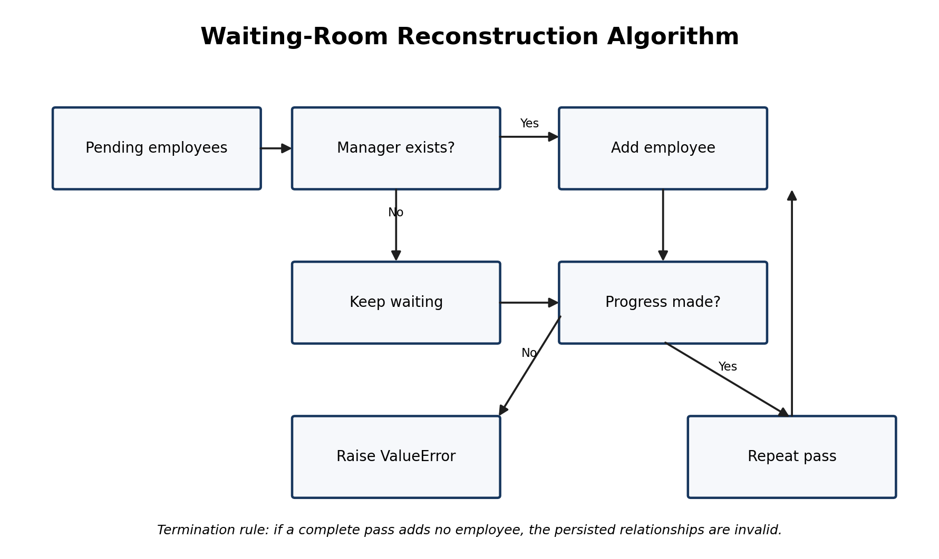
Persisted employees may not be ordered by dependency. An employee can appear before their manager. A single-pass loader would fail even when the data is valid. The waiting-room algorithm solves this through repeated passes.

Algorithm
- Reconstruct the Company using its saved name.
- Reconstruct and add all departments first.
- Reconstruct all employees into a pending collection.
- During each pass, add employees whose manager is absent or already present.
- Keep unresolved employees pending for the next pass.
- If a pass adds nobody, raise ValueError because the remaining dependencies cannot be resolved.

Failure cases detected
- A manager ID that does not exist in the persisted employees.
- Two or more employees forming a circular management chain.
- Any dependency cycle that prevents progress.

9. Save and Load Sequences

Save sequence
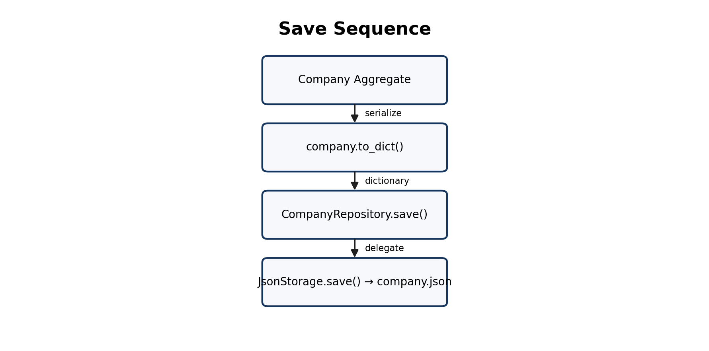
The Company defines its serialized representation. The repository coordinates the operation, and JsonStorage performs the file write.

Load sequence
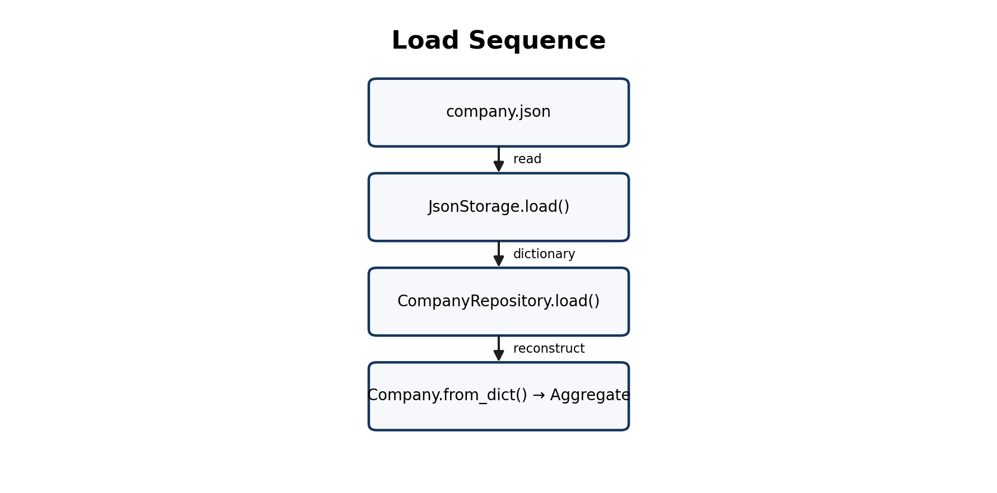
JsonStorage reads raw data. The repository delegates reconstruction to Company.from_dict(), which restores a valid aggregate using the waiting-room algorithm where necessary.

10. Testing Strategy
The project uses pytest and follows a layered testing strategy. Lower-level contracts are tested first; higher-level tests then rely on those public behaviours instead of duplicating every assertion.
Test area | Purpose
Employee tests | Validate construction, properties, rules and serialization.
Department tests | Validate construction, state and serialization.
Company tests | Validate aggregate ownership, relationships, serialization and reconstruction.
JsonStorage tests | Validate paths, JSON writing, loading and error behaviour.
CompanyRepository tests | Validate constructor contract, save coordination and load reconstruction.
Round-trip test | Verify that save followed by load preserves the complete aggregate data.

Testing principles
- Exception tests are concise because pytest.raises() is the assertion.
- Save tests inspect the JSON file directly rather than verifying save through load.
- Load tests prepare input through the already-tested storage layer.
- The round-trip test intentionally combines components to prove integration.
- Whole dictionaries are compared when the contract is complete data preservation.

Current baseline
All 55 automated tests pass. This baseline should remain green before beginning Phase 3.

11. Architectural Decisions
Decision | Reason | Consequence
Company is the aggregate root | Cross-entity rules need one consistency boundary | All aggregate modifications flow through Company
Serialization lives on domain objects | The domain owns its meaningful state representation | Repository remains small and focused
JsonStorage accepts dictionaries only | Storage should not depend on domain types | Infrastructure can be reused
Repository receives storage by injection | Avoid hidden file-path creation and improve testability | Tests use tmp_path and alternate storage becomes possible
Multi-pass reconstruction | Persisted employee order cannot be trusted | Valid out-of-order data loads; cycles fail clearly
Compare to_dict() in persistence tests | Avoid duplicating field-by-field knowledge | Tests remain concise and resilient
Round-trip integration test | Users care that saved state returns intact | Full persistence workflow is verified

Design lesson
Programming writes instructions. Software engineering decides where those instructions belong. The design remains the focus.

12. Project Structure
hr_analytics_system/
├── domain/
│ ├── employee.py
│ ├── department.py
│ └── company.py
├── repositories/
│ └── company_repository.py
├── storage/
│ └── json_storage.py
└── tests/
├── test_employee.py
├── test_department.py
├── test_company.py
├── test_json_storage.py
└── test_company_repository.py
Exact package names may differ in the repository, but the responsibility boundaries shown above should remain.

13. Risks and Future Evolution
Risk / limitation | Planned response
JSON is suitable for learning and small datasets, not concurrent enterprise use | Introduce a database repository in a later phase
Application code may call domain methods directly | Add Application Services to orchestrate use cases
No reporting or analytics layer yet | Build reporting and analytics after service workflows stabilize
No external interface | Add CLI first, then REST API
No operational pipeline | Introduce ETL and Airflow in the Data Engineering phase
No deployment automation | Add Docker, CI/CD and AWS in the Cloud phase

Evolution path
Domain → Persistence → Application Services → Reporting → Analytics
→ CLI → Database → REST API → Data Engineering/Airflow
→ Cloud/AWS → AI-assisted capabilities

14. Phase 3 Handover Checklist
☐ Commit the completed Persistence Layer as a milestone.
☐ Keep all 55 tests green.
☐ Review public methods exposed by Company for service orchestration.
☐ Define the first application use cases before creating service classes.
☐ Decide naming and boundaries for HRService or separate use-case services.
☐ Write tests for each application service before implementation.
☐ Avoid moving business invariants out of the domain model.
☐ Update this guide when Phase 3 decisions are finalized.

Recommended first Phase 3 use cases
- Hire an employee
- Transfer an employee between departments
- Terminate an employee
- Assign or change a manager
- Apply a salary increase
- Generate a basic company summary

Conclusion
Phases 1 and 2 provide a strong, test-backed foundation. The system now has a clear domain model, a persistence boundary, reliable aggregate reconstruction and an integration test proving that company data survives a complete save/load cycle. Phase 3 can build on this foundation without coupling application workflows to JSON or weakening domain ownership.
Architecture Guide v1.0 is the baseline record of these decisions. Future versions should document application-service boundaries, reporting models, database mappings, API contracts and data-pipeline design as those phases are completed.

