Generate a report showing the bestselling product by month, quarter, and year
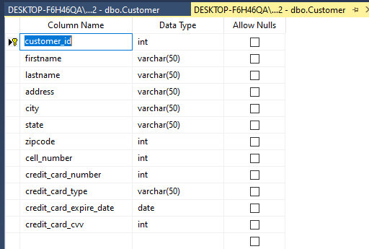

Generate a report to show the worst-selling product by month, quarter, and year
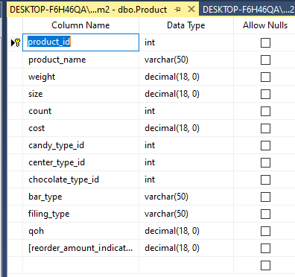
Generate a report to show the total revenue for each product sold between January 2022 and June 2022.

