**PC-Clinic Documentation**

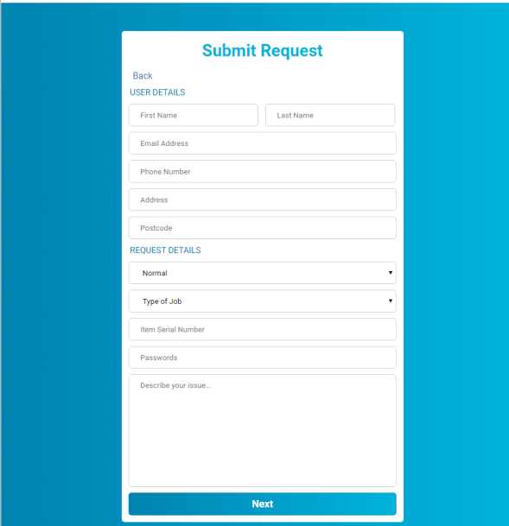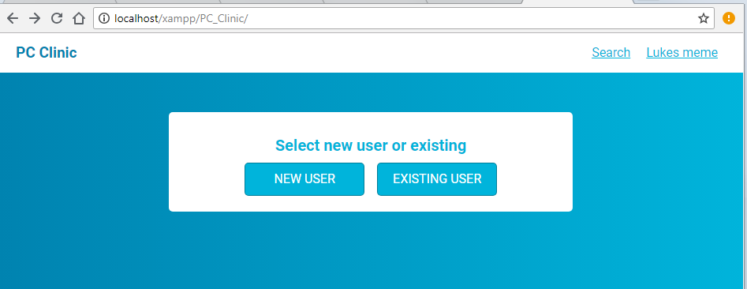Upon entering the website, you are greeted with 2 simple options: Are you a **New User**, or are you an **Existing User?**

Choosing **New user** will send you to a Submit request page; The submit request page allows you to input details such as **User details** (name, email address, etc) and **Request details** (Priority of request, Type of Job, etc). This is the page you will be putting a request for your PC in, whether it be for Repairs, exchanging, or simply upgrading.

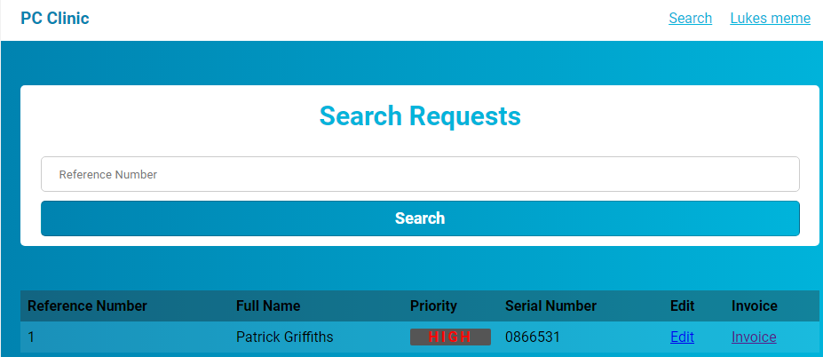

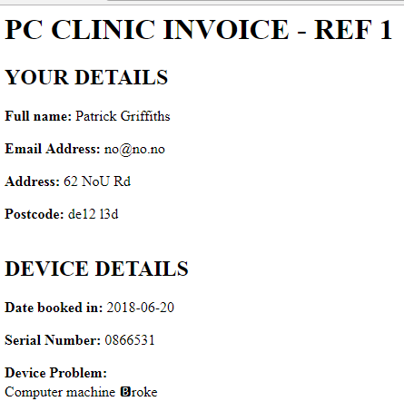After inputting all the required data, you will be sent to the **Search requests** page; this allows you to keep track of jobs that need to be done. You can search for a specific job through the **Reference number**. This page shows all the information required for the jobs, such as the clients Name, Priority of the Job, and the serial number. You can also edit the request from this page, or simply create an Invoice for the job.

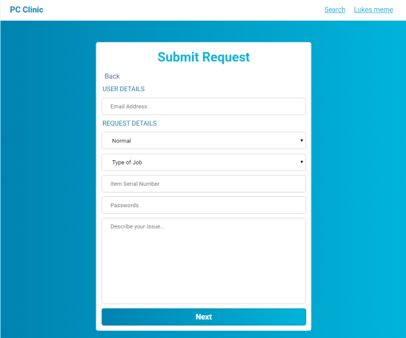

If you are already a user you can select **existing user** instead of the new user you get taken to a similar screen to the new user page, however the only user details it needs is your E-Mail. With your E-Mail it will retrieve the rest of your user details to save time. Then the request details are the same.

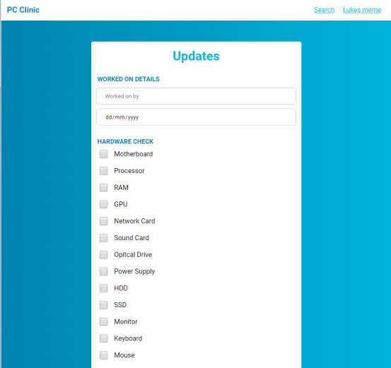

The updates is for the workers to use to track what work has been done by ticking off what things have been checked , when and who by. This is done by using the name space and the date selector.

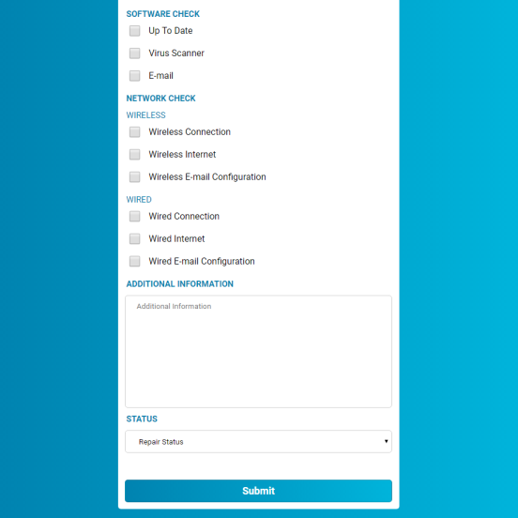Towards the bottom of the updates page is a few more tick boxes for some more tick boxes more the rest of the components to be checked.

Right at the bottom there is a space for any additional comments where the workers can track any information that cannot be tracked using the pre-existing tick boxes along with a repair status with a few options to see where the diagnosis is at along with the submit button to submit the form to the database.

