First bug I have encountered was when I have finished 1st page layout and tried to add items to my spinner elements. This is the code I used to accomplish this:

//SELECTING SPINNERS

Spinner spinnerWeight = FindViewById<Spinner>(Resource.Id.spinnerWeight);

Spinner spinnerDistance = FindViewById<Spinner>(Resource.Id.spinnerDistance);

//ADDING VALUES TO SPINNERS;

List<string> listWeight = new List<string>();

listWeight.Add("KG");

listWeight.Add("POUNDS");

List<string> listDistance = new List<string>();

listDistance.Add("KM");

listDistance.Add("MILES");

ArrayAdapter adapterWeight = new ArrayAdapter<string>(this, Resource.Id.spinnerWeight, listWeight);

ArrayAdapter adapterDistance = new ArrayAdapter<string>(this, Resource.Id.spinnerWeight, listDistance);

spinnerWeight.Adapter = adapterWeight;

spinnerDistance.Adapter = adapterDistance;

After running the app on my phone in debug mode I had this screen pop up:

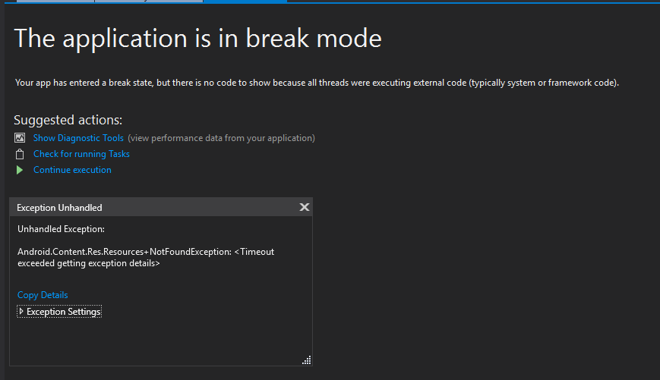

I did set a breakpoint at the start of the code, just in case the error would be visible in there. I then stepped over all lines of code, but they all executed successfully.

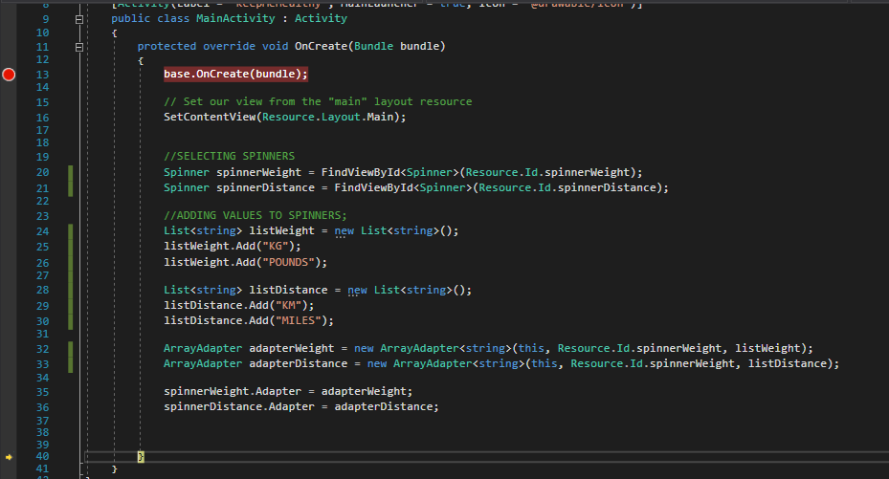

So, since debugging didn’t help, I went on the internet and after a few minutes of searching, I found an article that solved my problem (He, 2013). Turns out that the problem was indeed the code, and more specifically, I was missing a certain bit of code, and used the wrong value for the parameter. The new code looks like this:

//SELECTING SPINNERS

Spinner spinnerWeight = FindViewById<Spinner>(Resource.Id.spinnerWeight);

Spinner spinnerDistance = FindViewById<Spinner>(Resource.Id.spinnerDistance);

//ADDING VALUES TO SPINNERS;

List<string> listWeight = new List<string>();

listWeight.Add("KG");

listWeight.Add("POUNDS");

List<string> listDistance = new List<string>();

listDistance.Add("KM");

listDistance.Add("MILES");

ArrayAdapter adapterWeight = new ArrayAdapter<string>(this, Android.Resource.Layout.SimpleSpinnerItem, listWeight);

ArrayAdapter adapterDistance = new ArrayAdapter<string>(this, Android.Resource.Layout.SimpleSpinnerItem, listDistance);

spinnerWeight.Adapter = adapterWeight;

spinnerDistance.Adapter = adapterDistance;

Another problem I encountered was when I was attempting to convert the values from Pounds to kilograms and Miles to kilometres.

I had the following code:

if (spinnerWeight.GetItemAtPosition(0).ToString() == "POUNDS")

{

    weight = weight \* POUNDTOKG;

}

if (spinnerDistance.GetItemAtPosition(0).ToString() == "MILES")

{

    distanceTravelled = distanceTravelled \* MILESTOKM;

}

When I ran the code, entered all values and pressed calculate, the app did not convert the values. I placed a breakpoint at the start of the button’s event handler and stepped over the code until I reached those 2 If statements. When I pressed step over again to enter the if statement, the application did not enter any of those if statements. So, I knew the problem lied there.

Since I was used to arrays starting with 0 I assumed that GetItemAtPosition(0) would return the first item from the list. What it did was return the 0th number from the list which wasn’t what I intended. I changed the values from 0 to 1 and ran the code in debug mode again.

This time around the if blocks were entered and the code executed successfully. The values were converted and displayed properly to the user.