Patryk Petryszen

M00527445

Middlesex University

15th March 2017

**Dr Tuan Le**

**CCE2090**

**Project**

**1. Introduction**

Internet connection has become a standard in the contemporary houses. Nowadays most of the people have at least one computer in their place which is connected to the internet either via cable or Wi-fi. If we look a few years back, some companies such as Samsung, Sony, LG have released smart television’s. This kind of TV is connected to the internet in the same way as the computer and can be controlled over the internet using application on your phone. We can see on the market that everything these days strives to be smart. Haven’t you seen coffee maker controlled by your phone? Everything is made to make your life easier.

The idea of my project is to have control of your home in the cheapest possible way. For example, using motor sensors you can close the windows remotely when you have forgotten. You can control temperature, lights, or you can turn off devices to save on power using relays. It is possible to do it in a cheap way using sensors and my prototype will show you how it works in a micro scale. To control devices and taking the outputs from sensors I will be using android app programmed in MIT App Inventor which is a tool that allows you to programme using block of codes as in LabView.

Internet of things is a technology becoming future standard, in fact many houses has devices already connected to the internet. Some of examples are Thermostat (Nest) or lights (Hue Lights) which can be controlled from out of the house thanks to the Internet of Things technology. One of the biggest company in the world - Amazon has already expressed their interest in Internet of Things by releasing Amazon Echo. This device allows to control all the smart devices which are in your house using voice. Google also has released similar device which is called Google Home which was built with the same idea. Principle is the same, to automate your routines. That is why in every device like this you have options to create your own routines. For example, in Nest thermostat you can put the information such as what time do you normally come back to home. Let’s suppose it is 5pm. In this case Nest will turn on heating at 4pm to welcome you in a warm house. These devices have much more options than you think. For example, you can write your own code for Amazon Alexa. Programmers call them “skills”. Using them you can order pizza to your house or Uber. Using Google Home you can ask for the route and it will tell you estimated time and possible traffic. This kind of technologies make your life so much easier as you can see. And the ideas are indefinitely. You can programme what you want. You come back at this 5pm and hot coffee will be waiting for you in the kitchen if you have smart coffee maker. In this way, you can save a lot of time on daily basis.

The problem is these new technologies are very expensive and most of us can’t afford them. What about a possibility of doing it in a very cheap way using only one or two devices and make your whole house automated? Afterwards you will be able to control everything from your TV to lights, temperature or heating. What is better you will be able to control your house over the internet. That means you can turn off the lights/heating while on holidays. Internet of Things is an idea to connect everything to internet. In order to communicate between devices (things) and control them from remote locations

Arduino is an open source, computer hardware and software company, project, and user community that designs and manufactures [microcontroller](https://en.wikipedia.org/wiki/Microcontroller) kits for building digital devices and interactive objects that can sense and control objects in the physical world. Arduino board designs use a variety of microprocessors and controllers. The boards are equipped with sets of digital and analog [input/output](https://en.wikipedia.org/wiki/Input/output) (I/O) pins that may be interfaced to various expansion boards (shields) and other circuits. The boards feature serial communications interfaces, including [Universal Serial Bus](https://en.wikipedia.org/wiki/Universal_Serial_Bus) (USB) on some models, which are also used for loading programs from personal computers. The microcontrollers are typically programmed using a dialect of features from the programming languages [C](https://en.wikipedia.org/wiki/C_(programming_language)) and [C++](https://en.wikipedia.org/wiki/C%2B%2B).

The Arduino project started in 2003 as a program for students at the [Interaction Design Institute Ivrea](https://en.wikipedia.org/wiki/Interaction_Design_Institute_Ivrea) in [Ivrea](https://en.wikipedia.org/wiki/Ivrea), Italy,[[2]](https://en.wikipedia.org/wiki/Arduino#cite_note-kushner-2) aiming to provide a low-cost and easy way for novices and professionals to create devices that interact with their environment using [sensors](https://en.wikipedia.org/wiki/Sensor) and [actuators](https://en.wikipedia.org/wiki/Actuator).

We have a lot of different types of Arduino’s. They have been made to act different roles. In my project, I am going to use Arduino Uno which is the most common model and it is recommended for beginners in electronics.

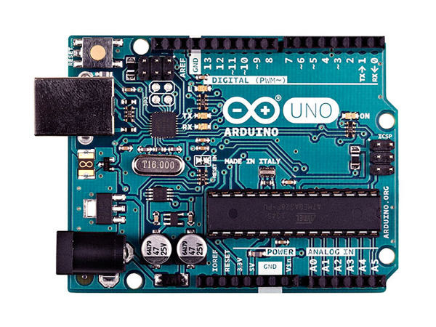

Figure 1: A layout of a Arduino Uno. Source: [http://static.arduino.org/media/k2/galleries/90/A000066-Arduino-Uno-TH-1front.jpg]

As we can see from the picture the device has USB port on the left side. Under it, there is a DC port. Arduino requires 9 to 12V DC, 250mA or more, 2.1mm plug. On the top and bottom of the board you have PINs which are digital and analog. As you already know digital is simply 1 (on) and 0 (off). The analog range is from 0 to 1024 and it depends on the Voltage. We can programme each pin to act as either as Output or Input. It depends on what sensor we will be using. In the middle, we can see Processor ATmega328P.

**2. Aims**

The aim of my project is to create a prototype to show you that my idea of smart home can be done in a cheap way. I am going to programme Arduino using C and C++ libraries. Instead of Wi-Fi connectivity I will use Bluetooth for presentation purposes. Doing it over the internet we will have to unblock ports in our router and that cannot be done at the university. I will write application in MIT App Inventor for Android where I will have outputs from individual sensors and buttons to control the light using relay. I will include also voice recognition software provided by Google so instead of clicking buttons you will have a possibility to press the “Voice” button and say to turn the light on or off.

**3. Objectives**

* Collect the information about Arduino, MIT App Inventor and C, C++ libraries.
* Write a code for Arduino to take the output values from the sensors connected to it.
* Write a code to take the outputs from the Arduino’s sensors.
* Write android application in MIT App Inventor.
* Connect Arduino to the App using Bluetooth
* Send readings over the Bluetooth to the application
* Do the sketch using Fritzing Programme.
* Present the data gathered with a report.

**4. Design & Development**

What I have used in the project:

* Arduino Uno - 1
* USB Cable
* Humidity Sensor - 4
* Photoresistor - 3
* IR Receiver - 6
* IR Remote Control
* Buzzer - 7
* Bluetooth Sensor HC-06 - 2
* Motion Detector – 5
* Relay Module - 11
* MIT App Inventor to programme the app for Android
* Tablet Asus Nexus 2013 to open the app
* Resistors: 220Ω (10) 120Ω (9) and 5kΩ (8)
* Bunch of wires

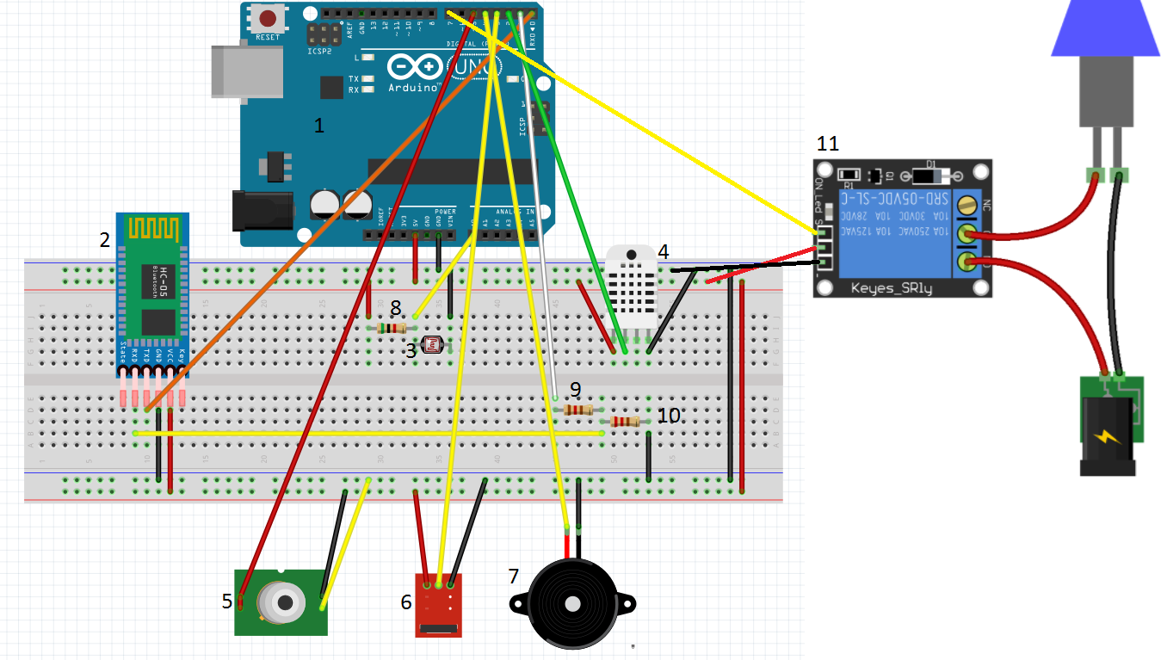

Figure 2: Design of my project.

Source: Fritzig Application for Windows.

Bluetooth Receiver HC-06 (2) is used to send and receive the data in binary using Bluetooth technology. The main advantage of using Bluetooth is that the possibility of interference with other devices is very low due to frequency hopping. Frequency hopping is a method of transmitting radio signals by rapidly switching a carrier among many frequencies channels. It uses serial connection on Rx and Tx Pins on Arduino. To connect Rx Pin (on receiver) to Arduino’s Tx Pin we need to create voltage divider to reduce the voltage because Rx Pin on HC-06 requires 3.3V not 5V. IF we connect it directly to Arduino our sensor will burn down. A **voltage divider** is a simple circuit which turns a large voltage into a smaller one. Using just two series resistors and an input voltage, we can create an output voltage that is a fraction of the input. The formula is as follows:

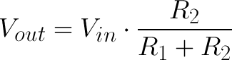

**Photoresistor**

Whenever using and Photoresistor, make sure to always have a resistor! The resistor limits the current, which will keep the photoresistor from burning out!

A photoresistor or photocell is a light-controlled variable resistor. The resistance of a photoresistor decreases with increasing incident light intensity. A photoresistor can be applied in light-sensitive detector circuits, and light- and dark-activated switching circuits. It's also called light-dependent resistor (LDR). It uses also voltage divider to vary the resistance and taking out the analog output from the sensor.

The resistance value becomes smaller when there is much light in the room.

I have written the code which converts the value 0-1023 to the percentage of the brightness. I adjust the resistors to my room so it might be not accurate during the presentation in different environment. You will see the value on my device Nexus 7 2013.

**Humidity Sensor**

This is the Humidity Sensor DHT11 which takes the measurement of temperature and humidity. It uses analog signals. The outputs will be shown on the android App on my tablet Nexus 7 2013.

**IR Receiver**

The Infrared signals are encoded in hexadecimal. To code the appropriate button, I had to first look for its hexadecimal value using the Arduino IDE and serial monitor.

**Relay Module**

Relay has 3 connections to deal with AC current:

* C – Common Connection
* NC – Normally Closed Connection
* NO – Normally Open Connection

We have also 3 connections to connect them to the Arduino:

* GND – ground
* 5V – 5 Volts
* And 1 pin that we have to connect to one of arduino’s pins to control it

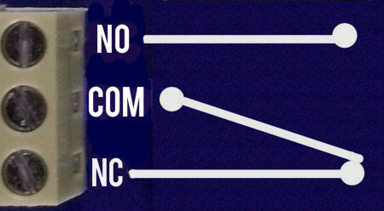

Figure:3 Ports on a relay module.

Source: [https://cdn.instructables.com/FYI/PJ47/HU0GLUZR/FYIPJ47HU0GLUZR.MEDIUM.jpg]

COM - it is the center terminal, It is hot as power to the load is connected at this terminal.

NO - It acts like a switch, since it is open - there will be no contact between COM and NO. When we trigger the relay module, it connects to COM by the electromagnet inside the relay and supply to the load is provided, which powers up the light, thus the circuit is closed until we trigger the state to low in relay.

NC - It is always in contact with COM, even when relay is not powered, when we trigger the relay it opens the circuit, so the connection is lost. it behaves just opposite to NO.  
  
I will be using NO connection, so in the code “HIGH” state means to turn off the relay (open the circuit – turn off the light). Opposing “LOW” will turn on the light (close the circuit).

**5. Android Application**

MIT App Inventor is an open-source web application originally provided by [Google](https://en.wikipedia.org/wiki/Google), and now maintained by the [Massachusetts Institute of Technology](https://en.wikipedia.org/wiki/Massachusetts_Institute_of_Technology) (MIT).

It allows newcomers to [computer programming](https://en.wikipedia.org/wiki/Computer_programming) to create [software applications](https://en.wikipedia.org/wiki/Application_software) for the [Android](https://en.wikipedia.org/wiki/Android_(operating_system)) operating system (OS). It uses a graphical interface, very similar to [Scratch](https://en.wikipedia.org/wiki/Scratch_(programming_language)) and the [StarLogo TNG](https://en.wikipedia.org/wiki/StarLogo_TNG" \o "StarLogo TNG) [user interface](https://en.wikipedia.org/wiki/User_interface), which allows users to [drag-and-drop](https://en.wikipedia.org/wiki/Drag-and-drop) visual objects to create an application that can run on Android devices.

To create the new android application, you need to first sign up on the website:

[http://appinventor.mit.edu/explore/#](http://appinventor.mit.edu/explore/)

Once you have done it press “Create app” on the right top corner on the website. You will have to link your account to your gmail.

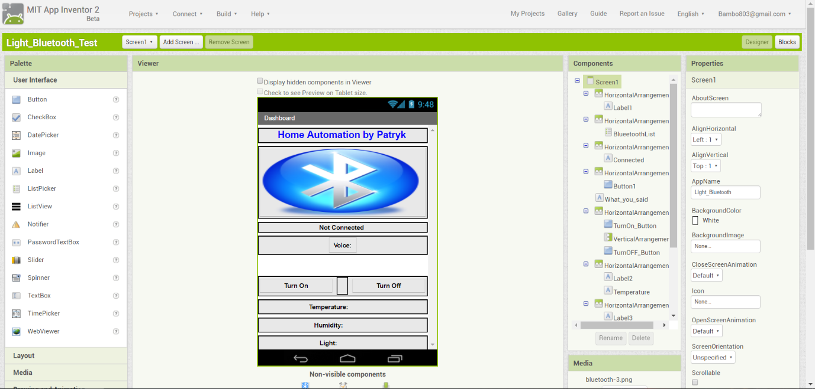

The screenshot above shows the main window where we can edit graphical user interface.

On the right side of the green panel you can see button called “Blocks” which will take you to the actual code of your programme. That is how it looks:

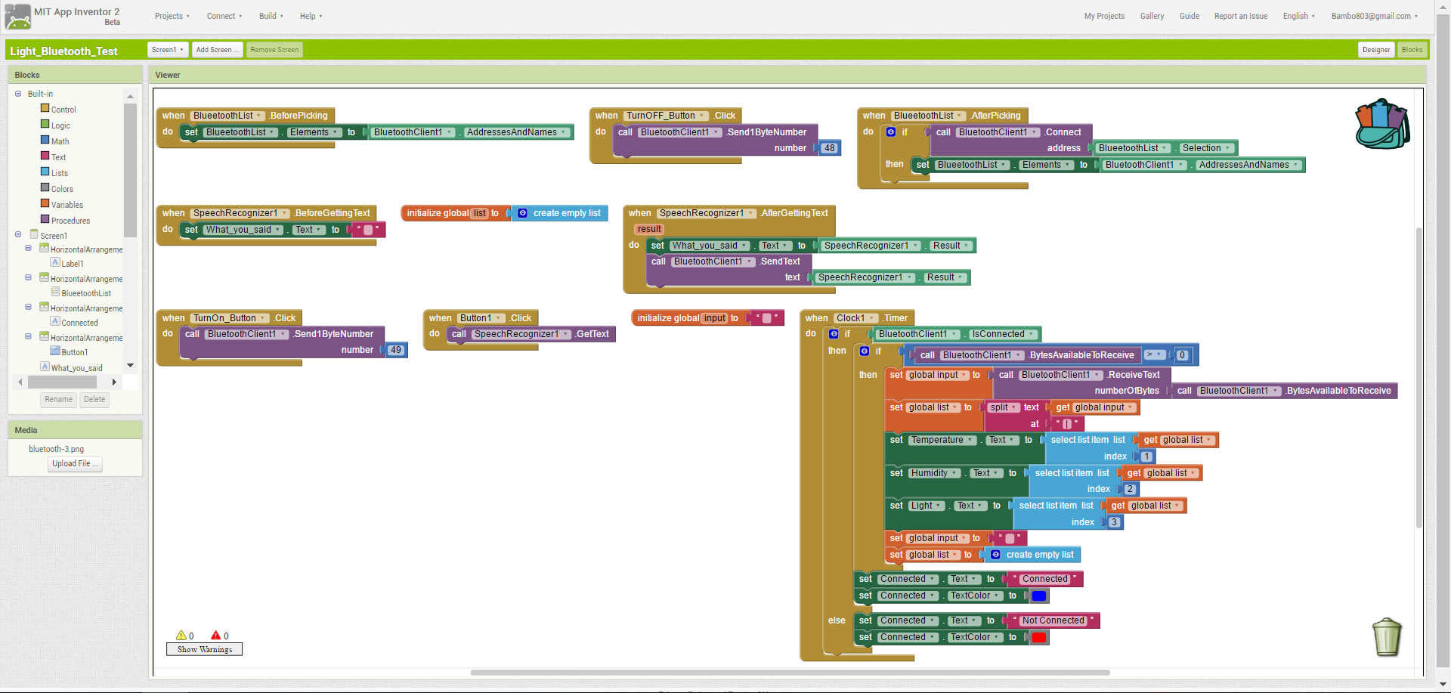

To download your programme as .apk file (the file supported by android) you need to press build at the top and take App (save .apk to my computer). Now the application is ready to be installed on your Android device which in my case is Nexus 7 2013.

**6. References:**

[1] https://en.wikipedia.org/wiki/Arduino

[2] <http://www.instructables.com/id/How-to-use-a-photoresistor-or-photocell-Arduino-Tu/>

[3] <http://www.instructables.com/id/Controlling-AC-light-using-Arduino-with-relay-modu/>

7. Appendix: Code for Arduino Uno.