1. **Technology.**

Application was writing using Microsoft Visual Studio 2019. Microsoft Visual is an integrated development environment created by Microsoft, available to any user working on the Windows operating system. The decision to use this technology was dictated by the fact that you can find the most useful materials on the web for a novice programmer.

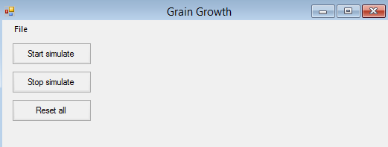   
 Project was creating using Windows Forms technology and standard editor integrated with Visual Studio. This technology is popular for Windows desktop application. Microsoft has many libraries integrated with Windows Forms, so it's easy to create an application.

1. **Interface.**

The GUI is typical for this type of application. It consists of basic buttons and windows for entering or changing values located around the bitmap where the simulation will be displayed. Bitmap will be in one size in the app, because application rescale generated map.

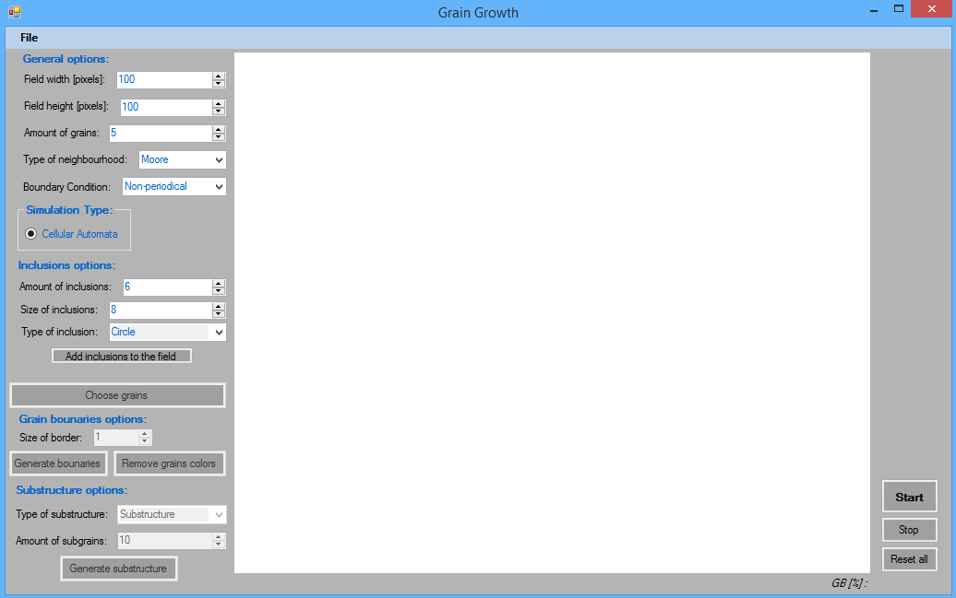

Picture : GUI.

1. **Parameters.**

Before we start we can set parameters of simulate.

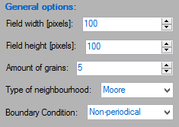

* 1. **General options.**

*Field width [pixels]* – width of simulation map.

*Field height [pixels]* – height of simulation map.

*Amount of grains* – amount of grains on simulation map.

*Type of neighbourhood* – neighborhood type:



* *Von Neumann*

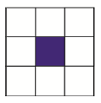

* *Moore*

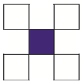

* *Further Moore*

*Boundary Condition* – boundary condition of simulation map.

* 1. **Simulation type.**

*Cellular Automata* – is a kind of model and simulation, consisting of a grid of cells.

* 1. **Inclusions options.**

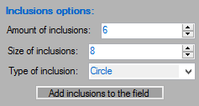*Amount of inclusions* – amount of inclusions on simulation map.

*Size of inclusions* – size of inclusions on simulation map.

*Type of inclusion* – type:

* *Circle*
* *Square* 
  1. 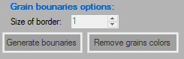**Grain bounaries options.**

*Size of border* – size of border on simulation map.

We can also mark single grown grain with the buton *Choose grains*.

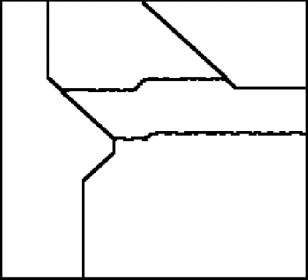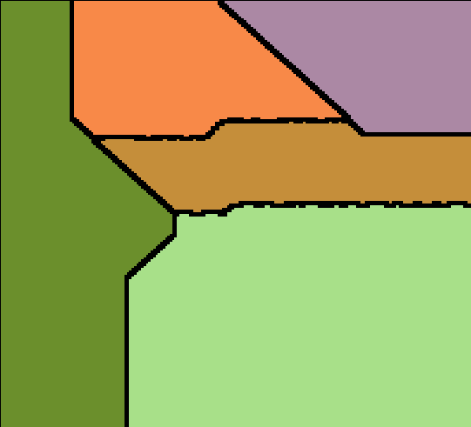

Picture Bounaries.

* 1. 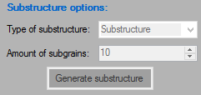**Substructure options.**

After generate grains structure, will be possible to generate substructure or dual phase. User need to select remaining grains, write amount of grains to generate and select type of new structure.

 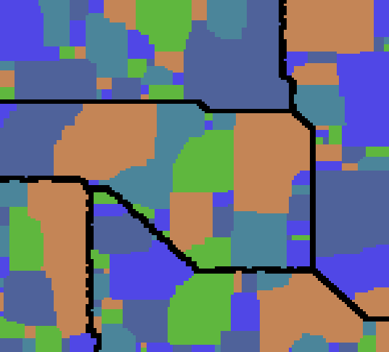

Picture Substructure.

1. 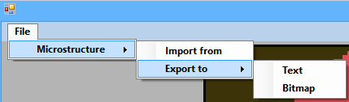**Toolbar.**

Save options as *.bmp or *.txt .

