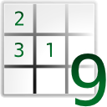

**SudokuSolver**

Created by: Patryk Gorol

**Overview**

Application was created as self-training programming project. The main purpose of program was to solve every possible Sudoku, from easiest to hardest. In order to fulfill that goal several solving methods were implemented. Program was written in Python with use of frameworks:

* **Numpy** – for managing two dimensional Sudoku array and referring to its internal elements and
* **Tkinter** – for graphical user interface.

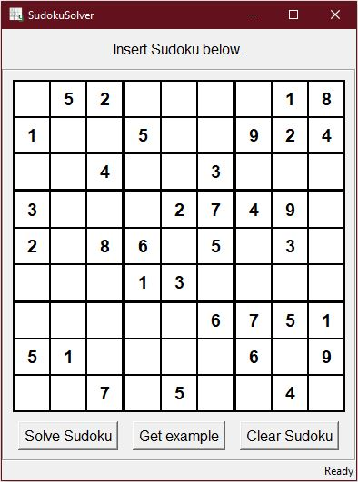

**Process Map**

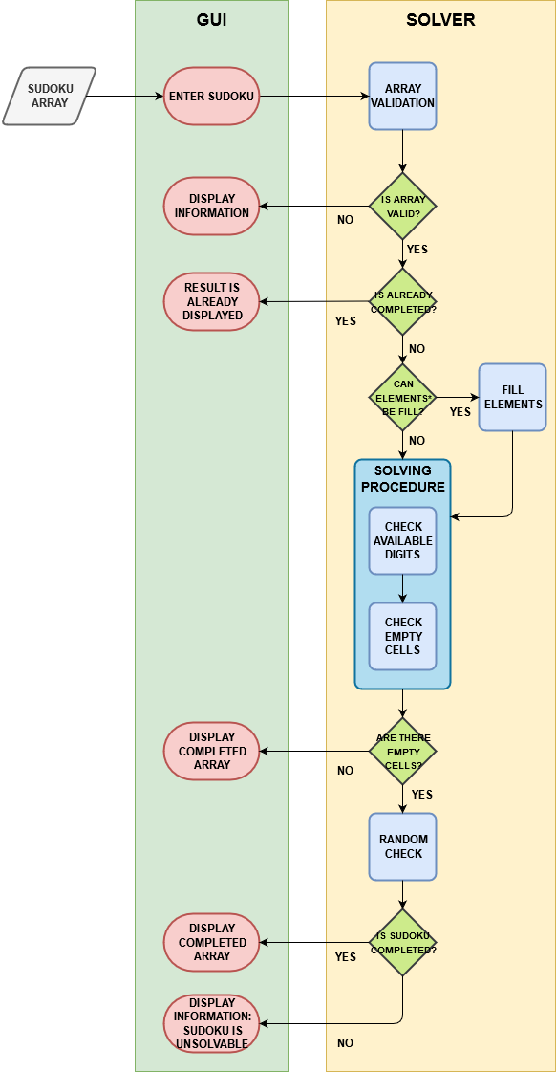

Program contains two modules: graphical interface and solver itself. After inserting digits to an empty array and clicking ‘Solve sudoku’ button, program reads array and sends it to solver.

At first Sudoku is verified as valid and not completed. In next step program determines whether some of array elements* contains 8 digits and can be already filled.

Main solving procedure consists of two methods:

* ‘Check available digits’ – for each digit program determines all possible cells and searches for clear

Solving procedures

CHECK AVAILABLE DIGITS

CHECK EMPTY CELLS

RANDOM CHECK

Postscript