**Priority queue**

While priority queues are often implemented with heaps, they are conceptually distinct from heaps. A priority queue is an abstract concept like "a list" or "a map" - just as a list can be implemented with a linked list or an array, a priority queue can be implemented with a heap or a variety of other methods such as an unordered array.

Because most priority queue implementations use heap, we will focus on this data structure.

**Heap**

In a heap, for every node *i*other than the root, the value of a node is greater \ smaller than or equal (at most) to the value of its parent.  
Thus, the largest \ smallest element in a heap is stored at the root. This is the most important property of a heap and priority queue.

Heaps are more efficient than binary trees if you only need the extreme element. Heaps only do the comparisons (lazily) necessary to determine the extreme element.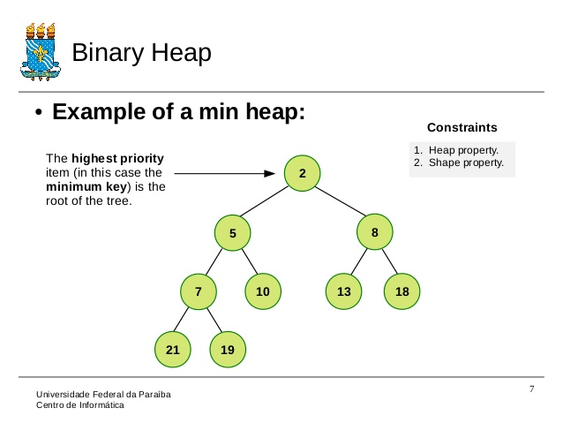**8.**

Heaps can be implemented in an array (fixed size or dynamic array): 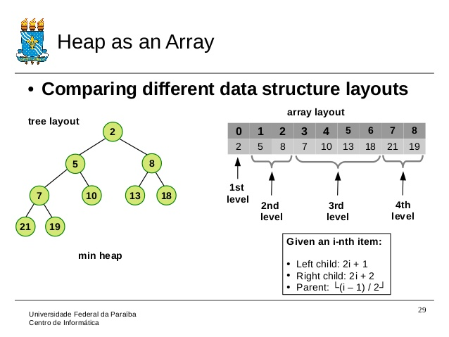

**9.**

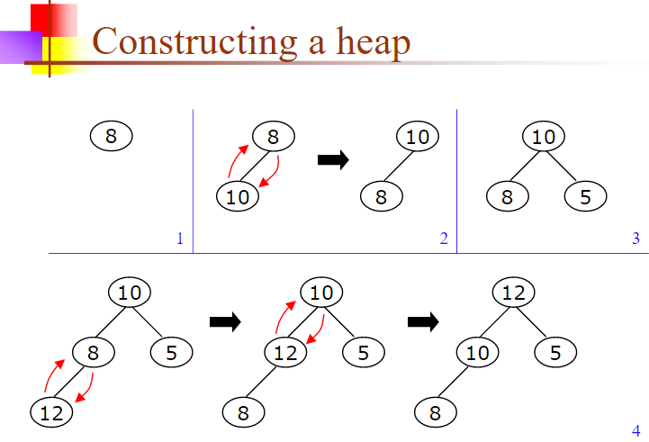

**10.**

Difference of priority_queue vs queue:

priority queues are based on priority instead of a pure FirstIn-FirstOut behavior.

In C++ a std::priority queue is a container adaptor that provides constant time lookup of the

largest (by default) element, at the expense of logarithmic insertion and extraction.

Working with a std::priority_queue is similar to managing a heap in some random access

Container (like std::vector), with the benefits of not being able to accidentally invalidate the heap, improved readability and clearer intent.

Alternative of using std::priority_queue would be to use std::vector \ std::deque and manage heap manually by functions:

std::make_heap, std::push_heap, std::pop_heap, std::sort_heap.

**Advanced**: example implementation of std::priority_queue:

template <class T, class Container = std::vector<T>,

class Compare = std::less<T> >

class priority_queue

{

protected:

Container c;

Compare comp;

public:

explicit priority_queue(const Container& c_ = Container(),

const Compare& comp_ = Compare())

: c(c_), comp(comp_)

{

std::make_heap(c.begin(), c.end(), comp);

}

bool empty() const { return c.empty(); }

std::size_t size() const { return c.size(); }

const T& top() const { return c.front(); }

void push(const T& x)

{

c.push_back(x);

std::push_heap(c.begin(), c.end(), comp);

}

void pop()

{

std::pop_heap(c.begin(), c.end(), comp);

c.pop_back();

}

};

**11.**