

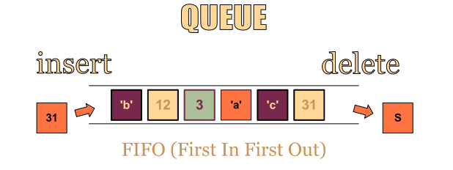

**12.**

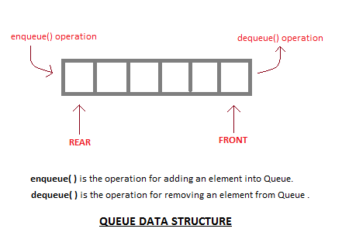

The std::queue class is a container adapter that gives the programmer the functionality of a queue - specifically, a FIFO (first-in, first-out) data structure.

The class template acts as a wrapper to the underlying container - only a specific set of functions is provided. The queue pushes the elements on the back of the underlying container and pops them from the front.

**13.**