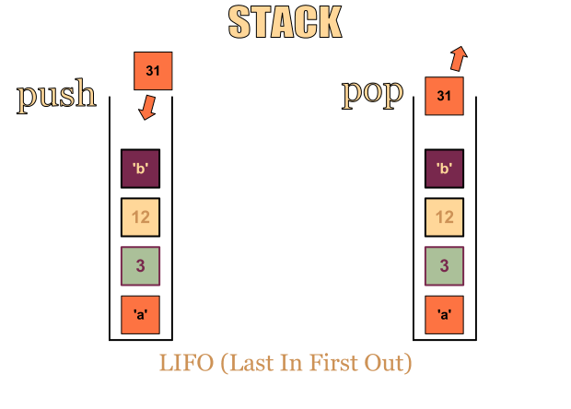

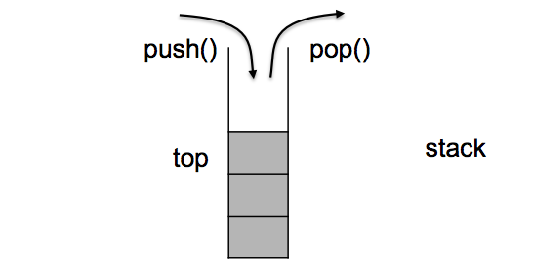

The std::stack class is a container adapter that gives the programmer the

functionality of a stack - specifically, a FILO (first-in, last-out) data structure.

The class template acts as a wrapper to the underlying container - only a specific set of functions is provided.

The stack pushes and pops the element from the back of the underlying container, known as the top of the stack.

**14.**