**Double ended queue:**

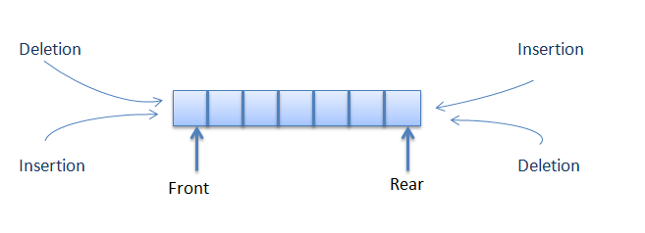

1. A nice application of the deque is storing a web browser's history. Recently visited URLs are added to the front of the deque, and the URL at the back of the deque is removed after some specified number of insertions at the front.
2. The steal-job scheduling algorithm, which schedules tasks for several processors uses deque to save / retrieve threads. It is used by Intel's Threading Building Blocks (TBB) library for parallel programming.

Insertion and deletion in front and back is O(1).