std::weak_ptr

std::unique_ptr models the concept of exclusive ownership
std::shared_ptr the concept of shared ownership.
std::weak_ptr models the concept of temporary ownership.

It borrows the resource from a std::shared_ptr. There are two dominant reasons for having a std::weak_ptr in C++:
- breaking of cyclic references of std::shared_ptr's.
- solving the dangling pointer problem

Weak_ptr uses weak reference counter for his ability to break references.
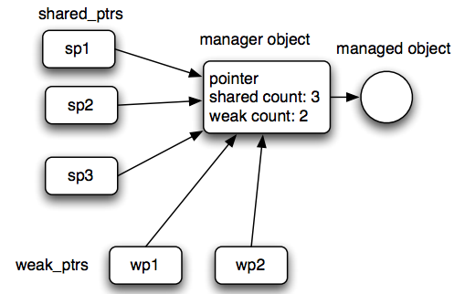

Cyclic references
You will get cyclic references of std::shared_ptr if the std::shared_ptr reference each other.

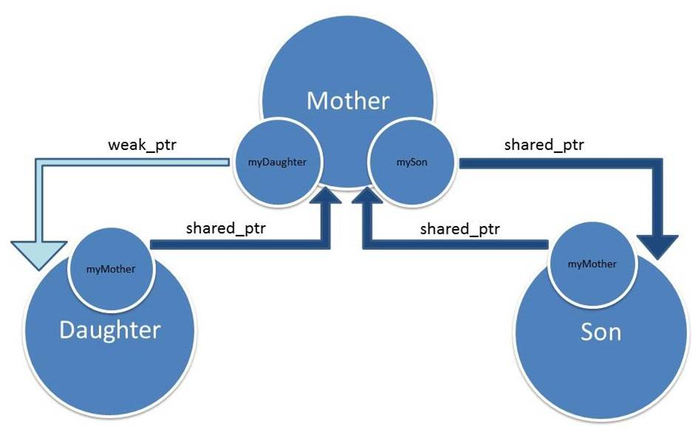

Example code:
class B;
class A
{
public:
A( ) : m_sptrB(nullptr) { };
~A( ) { cout<<" A is destroyed"<<endl; }
shared_ptr<B> m_sptrB;
};

class B
{
public:
B( ) : m_sptrA(nullptr) { };
~B( ){ cout<<" B is destroyed"<<endl; }
shared_ptr<A> m_sptrA;
};
//***********************************************************
void main( )
{
shared_ptr<B> sptrB( new B );
shared_ptr<A> sptrA( new A );
sptrB->m_sptrA = sptrA;
sptrA->m_sptrB = sptrB;
}

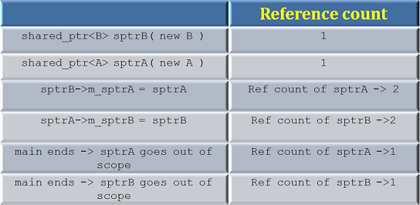

Reference counts for both sptrA and sptrB go down to 1 when they go out of scope and hence the resources are not released!

Corrected example:
class B;
class A
{
public:
A( ) : m_a(5) { };
~A( ) { cout<<" A is destroyed"<<endl; }
void PrintSpB( );
weak_ptr<B> m_sptrB;
int m_a;
};

class B
{
public:
B( ) : m_b(10) { };
~B( ) { cout<<" B is destroyed"<<endl; }
weak_ptr<A> m_sptrA;
int m_b;
};

void A::PrintSpB( )
{
if( !m_sptrB.expired() )
cout<< m_sptrB.lock( )->m_b<<endl;
}

void main( )
{
shared_ptr<B> sptrB( new B );
shared_ptr<A> sptrA( new A );
sptrB->m_sptrA = sptrA;
sptrA->m_sptrB = sptrB;
sptrA->PrintSpB( );
}

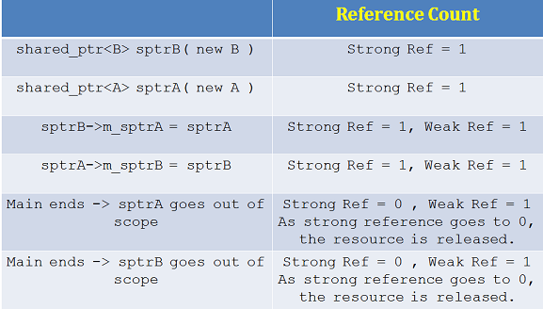

Dangling pointer problem:

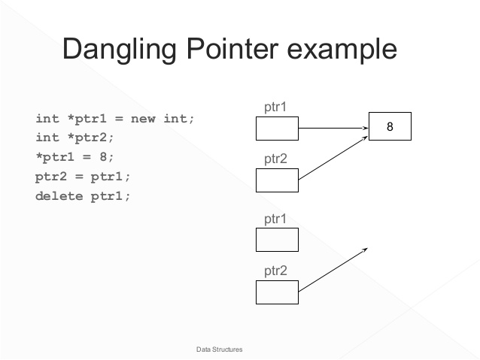

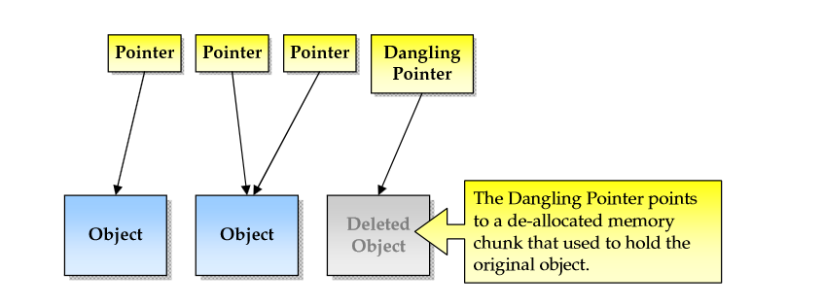

std::weak_ptr is a very good way to solve the dangling pointer problem.
By just using raw pointers it is impossible to know if the referenced data has been deallocated or not. Instead, by letting a std::shared_ptr manage the data, and supplying std::weak_ptr to users of the data, the users can check validity of the data by calling expired() or lock().

int main()
{
// OLD, problem with dangling pointer
// PROBLEM: ref will point to undefined data!

int* ptr = new int(10);
int* ref = ptr;
delete ptr;

// NEW SOLUTION: check expired() or lock() to determine if pointer is valid

// empty definition
std::shared_ptr<int> sptr;

// takes ownership of pointer
sptr.reset(new int);
*sptr = 10;

// get pointer to data without taking ownership
std::weak_ptr<int> weak1 = sptr;

// deletes managed object, acquires new pointer
sptr.reset(new int);
*sptr = 5;

// get pointer to new data without taking ownership
std::weak_ptr<int> weak2 = sptr;

// weak1 is expired!
if(auto tmp = weak1.lock())
std::cout << *tmp << '\n';
else
std::cout << "weak1 is expired\n";

// weak2 points to new data (5)
if(auto tmp = weak2.lock())
std::cout << *tmp << '\n';
else
std::cout << "weak2 is expired\n";
}

