std::shared_ptr layout in memory:

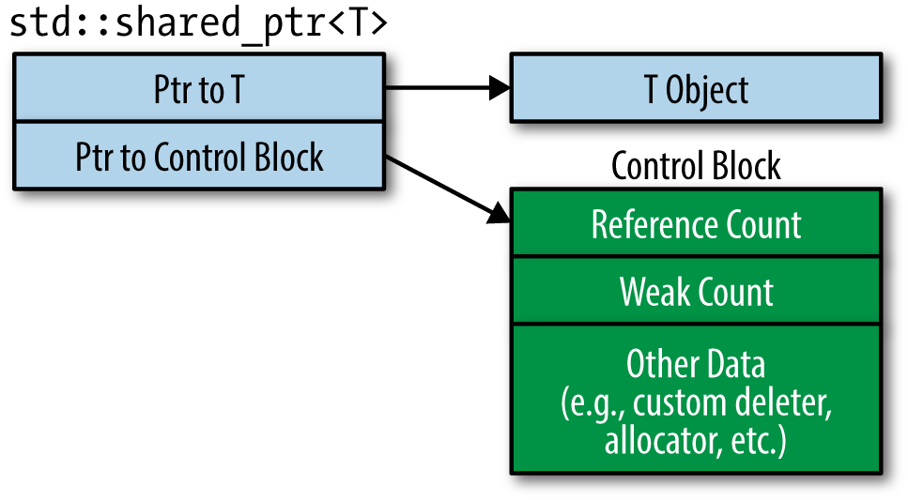

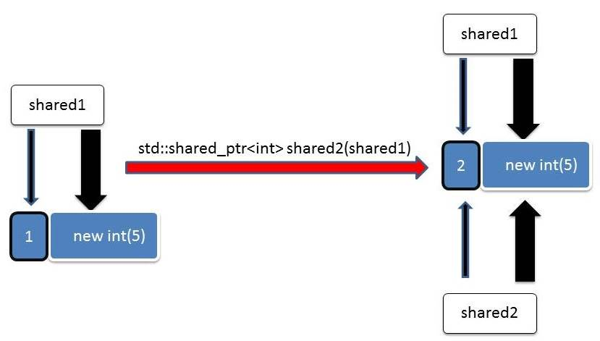

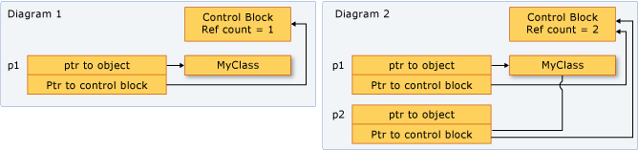

3.
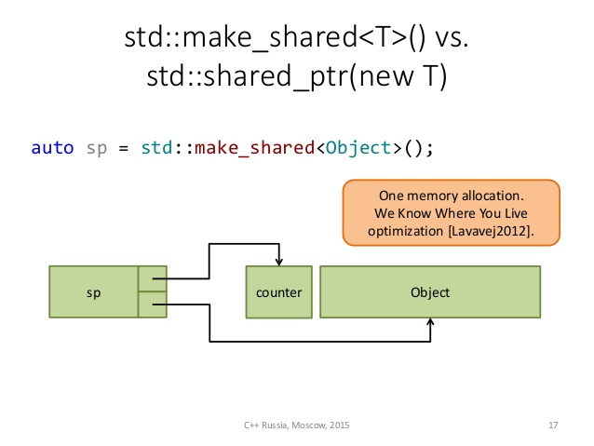
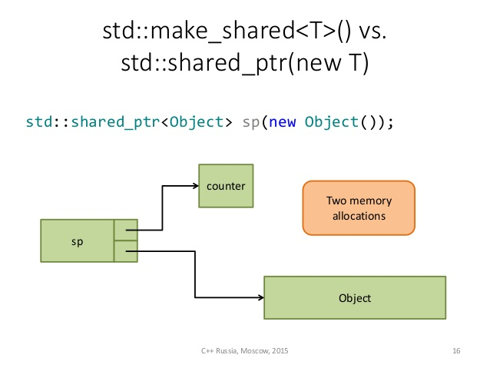
4.
std::make_shared vs new

std::shared_ptr<Object> p1 = std::make_shared<Object>("foo");
std::shared_ptr<Object> p2(new Object("foo"));

The difference is that std::make_shared performs one heap-allocation, whereas calling the std::shared_ptr constructor performs two.
Where do the heap-allocations happen?
std::shared_ptr manages two entities:
- the control block (stores meta data such as ref-counts, type-erased deleter, etc)
- the object being managed
std::make_shared performs a single heap-allocation accounting for the space necessary for both the control block and the data.
In the other case, new Obj("foo") invokes a heap-allocation for the managed data and the std::shared_ptr constructor performs another one for the control block.

make_shared is more efficient than calling new, because it allocates the reference control block together with the actual object in one single dynamic allocation. By contrast, the constructor for shared_ptr that takes a naked object pointer must allocate another dynamic variable for the reference count. The trade-off is that make_shared (or its cousin allocate_shared) does not allow you to specify a custom deleter, since the allocation is performed by the allocator.

5.

Exception-Safety
Consider this example,
void F(const std::shared_ptr<Lhs> &lhs, const std::shared_ptr<Rhs> &rhs)
{ /* ... */ }

F(std::shared_ptr<Lhs>(new Lhs("foo")),
std::shared_ptr<Rhs>(new Rhs("bar")));
Because C++ allows arbitrary order of evaluation of subexpressions, one possible ordering is:
- new Lhs("foo"))
- new Rhs("bar"))
- std::shared_ptr<Lhs>
- std::shared_ptr<Rhs>

Now, suppose we get an exception thrown at step 2 (e.g., out of memory exception, Rhs constructor threw some exception). We then lose memory allocated at step 1, since nothing will have had a chance to clean it up. The core of the problem here is that the raw pointer didn't get passed to the std::shared_ptr constructor immediately.

One way to fix this is to do them on separate lines so that this arbitary ordering cannot occur:
auto lhs = std::shared_ptr<Lhs>(new Lhs("foo"));
auto rhs = std::shared_ptr<Rhs>(new Rhs("bar"));
F(lhs, rhs);

The preferred way to solve this of course is to use std::make_shared instead:

F(std::make_shared<Lhs>("foo"), std::make_shared<Rhs>("bar"));

6.
Performance
std::shared_ptr always has memory overhead for reference counter, though it is very small.
std::shared_ptr has time overhead in constructor (to create the reference counter), in destructor (to decrement the reference counter) and in assignment operator (to increment the reference counter).
Due to thread-safety guarantees of std::shared_ptr, these increments/decrements are atomic, thus adding more overhead.

7.

