std::unique_ptr
std::unique_ptr is a smart pointer that owns and manages exclusively another object through a pointer and deletes that object when the unique_ptr goes out of scope.

std::unique_ptr is commonly used to manage the lifetime of objects, including:
- providing exception safety to classes and functions that handle objects with dynamic lifetime, by guaranteeing deletion on both normal exit and exit through exception.
- passing ownership of uniquely-owned objects with dynamic lifetime into functions.
- acquiring ownership of uniquely-owned objects with dynamic lifetime from functions.

Unique_ptr cannot be copied. Copying unique_ptr would break it’s exclusivity, hence copy constructor of unique_ptr is private.
If we want to create second unique_ptr to point to the same resource, the we need to move it from the first unique_ptr (explained in code).

1.

How moving unique_ptr works.

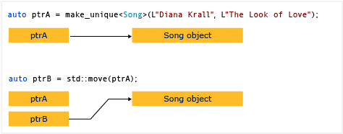
After moving ptrA to ptrB, you can’t access ptrA! It is NULL now.

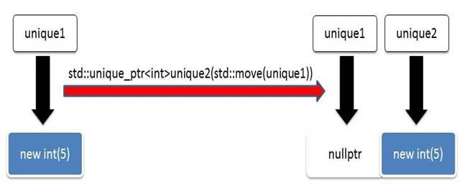

2.

