Chess game application:

Description:
Game between first player → white figures and second player → black figures.

All basic movements are performed:
1. White Player clicks on any of his figures.
2. Then he clicks where he has to change his location -> the condition must be the correct move for the figure.

View of the chessboard:

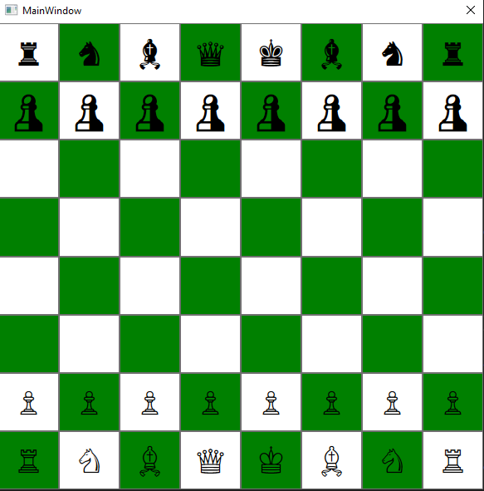
The player with white figures starts.

Figures movements:

- start of the game

- pawn movements:

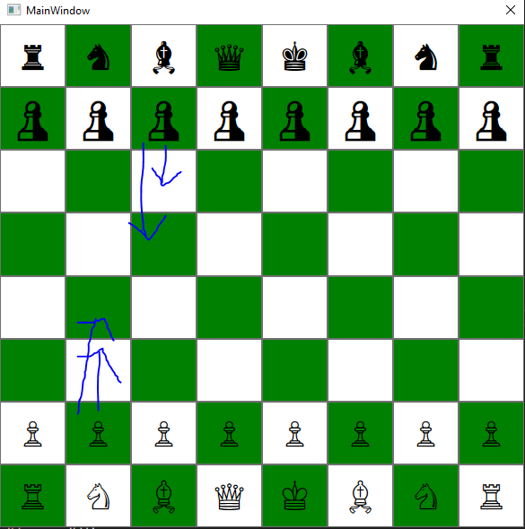
first pawn move
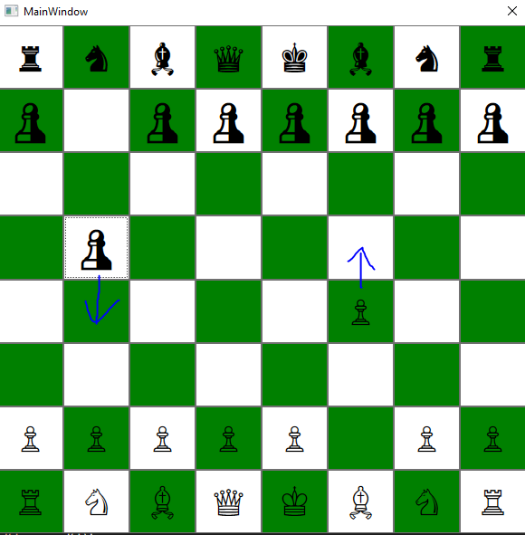
next pawn move

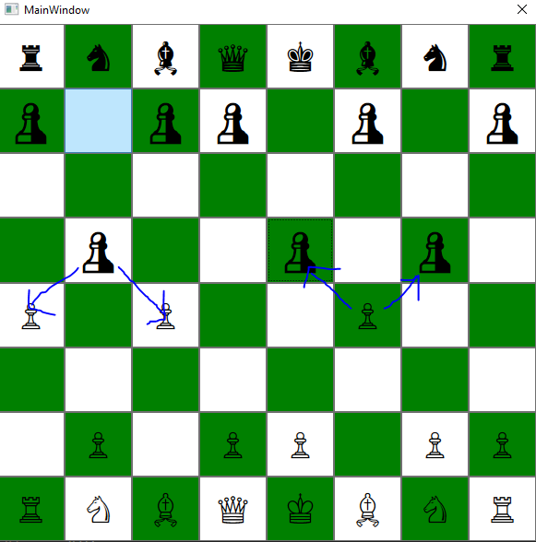

beats a figure

- rook movements:

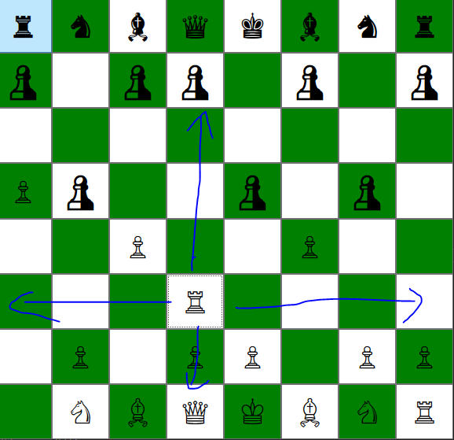
rook move

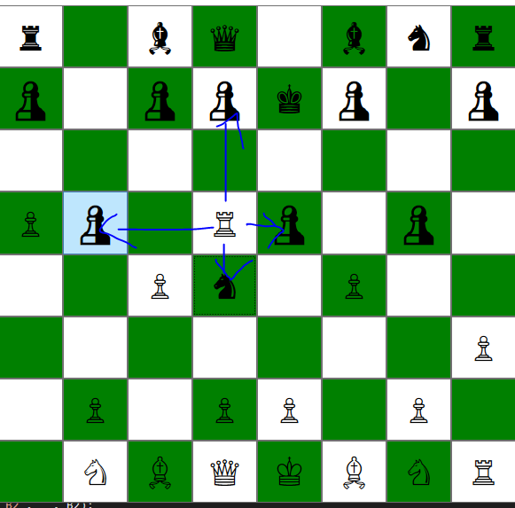
beats a figure

- bishop movements:

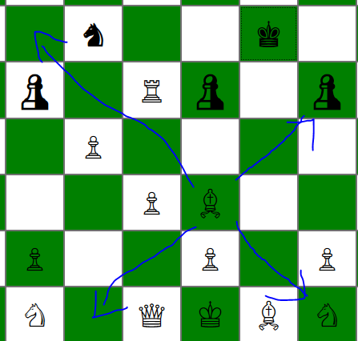

bishop move

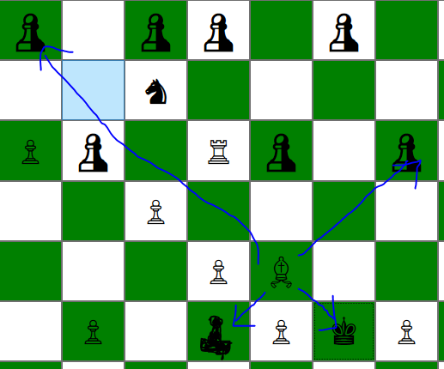
beats a figure

knight movements:

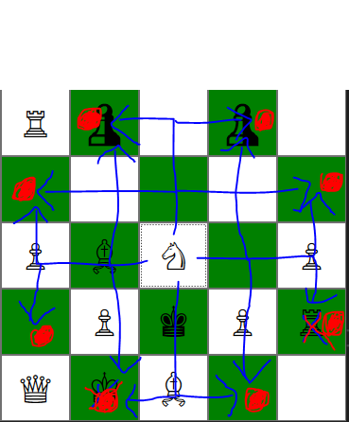

knight -> the same moves, the same beat a figure

king movements:

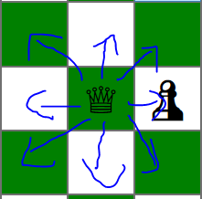

king → the same moves, the same beat a figure

- queen movements:

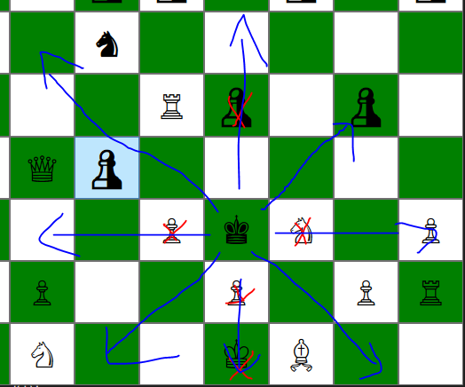
queen move

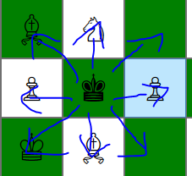

beats a figure

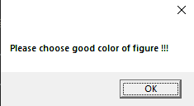

A given message pops up along with a short sound that there has been an illegal movement.
Types of abnormal movements:
- when the correct order of movements is not followed -> white figure, black figure, white figure, black figure.
- when one of the players clicks on the empty field.

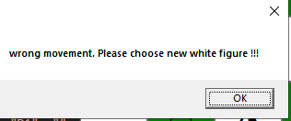

A given message pops up along with a short sound that there has been an illegal movement.
Types of abnormal movements:
- when any player clicks in the wrong place while moving

Game end when you beat the king.

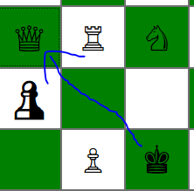

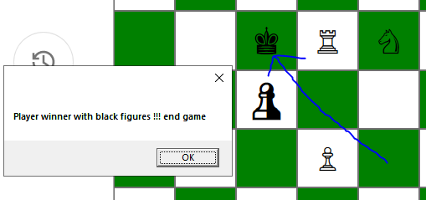

The message that the player won and a short song for the winner are shown. You have to click "OK" and the application is finished.

