Report on learning practice # 1
Analysis of univariate random variables

Performed by:
Patrik Stronski
Ivan Pavelev
J4133C

Saint-Petersburg
2021

0. Dataset description:
The dataset we used collects the data about fires in the USA. It is a subset of the bigger dataset. The dataset is contained within one CSV file, easy to read and process. The main variable in the dataset is fire_size which presents how big (in acres) the fire was. The fires are divided into several categories based on their size – fire_size_class. The classes possible here are from A to G, however in the dataset we used no small fires (A-class) are contained.
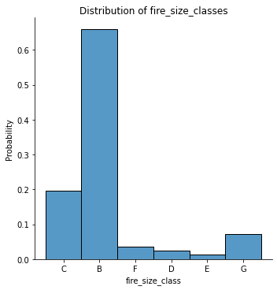

The dataset we used: https://www.kaggle.com/capcloudcoder/us-wildfire-data-plus-other-attributes?select=FW_Veg_Rem_Combined.csv
The base dataset: https://www.kaggle.com/rtatman/188-million-us-wildfires
1. Substantiation of chosen subsample;
We have chosen to assess two variables from our dataset:
- fire_size — size of fire (in acres)
- Temp_cont — temperature after the fire was contained (up to a day) (in degress Celsius)
Nevertheless, there are many classes of fires. The fire classes can be from B to G. Under this condition for each class the density is plotted. The aim of this assessment is to assess how big are the fires for each class and how high is the temperature after the fire was contained.

There are also notebooks representing the assessment of fire_size and Temp_cont regardless of fire class.

For this assignment we
2. Plotting a non-parametric estimation of PDF in form of a histogram and using kernel density function (or probability law in case of discrete RV)
Fire size is really varied, but in around 90% of cases it is not bigger than 50000m. Nevertheless, the values are really spread what we can see on the diagram. The range is well depicted by looking at the X axis, which is automatically fitting the possible values.
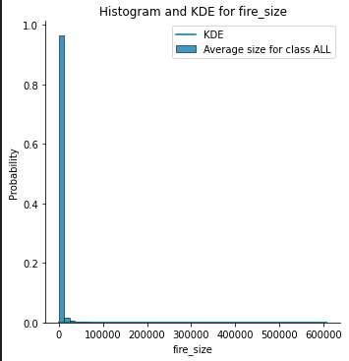
Therefore better depiction can be achieved by dividing the plot into fire_size_classes. Based on that we can learn what is the size and how it is modelled depending on each severity class.

For class B or D (examples) the KDE and Histograms can be easily read from these diagrams:
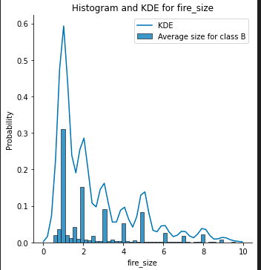
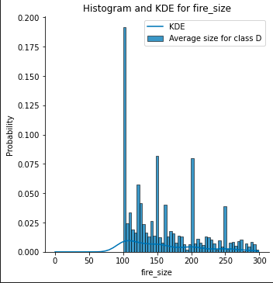
As it can be seen, the models look pretty different depending on the fire class. After changing the bins parameter to 10 in the histogram we get:
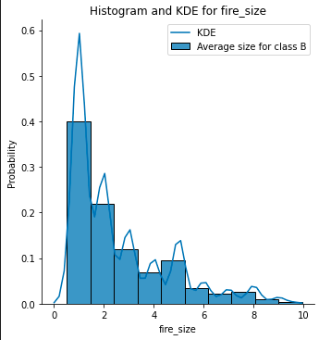
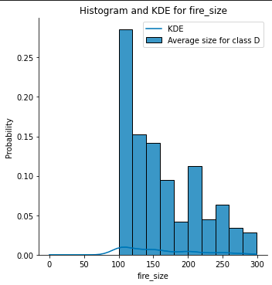
This way it looks far more similar to the KDE function.
On the other hand for Temp_cont the diagrams look rather similar. What is also good is that the scale is similar and smaller. Minimal value is -22.75, whereas max value is 55.0 for Temp_cont. It looks differently for fire_size where the values are from the range 0.51 and 606945.0.

The examples of the diagrams are:
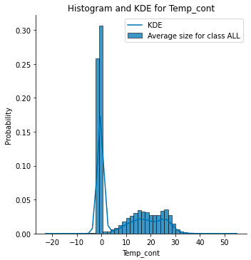
Similar diagrams are created for fire classes B and D
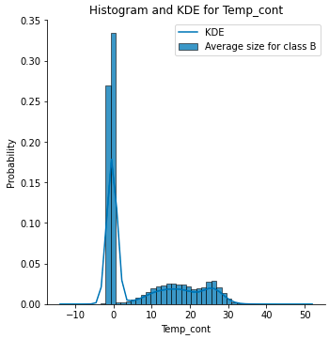
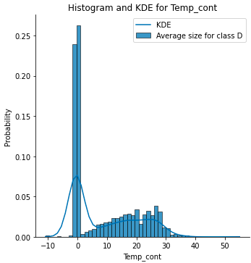

3. Order statistics estimation and its representation as “box with whiskers” plot.
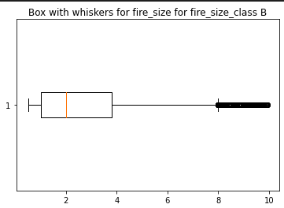
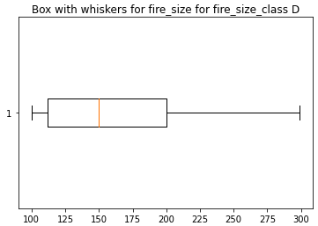
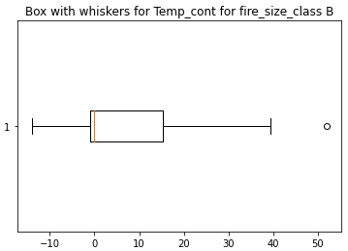
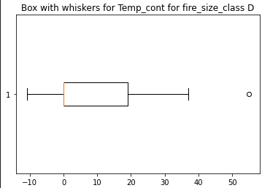

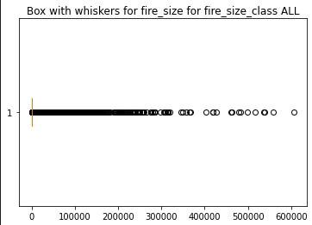
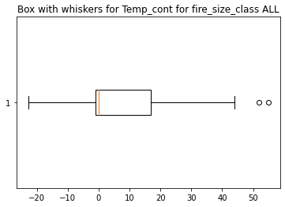
4. Selection of theoretical distributions that best reflect empirical data;
For fire_size, in general lognorm and exponnorm distribution should fit best. However, we have also tested exponential and gamma for this purpose. Those are the outcomes for the Method of Moments.
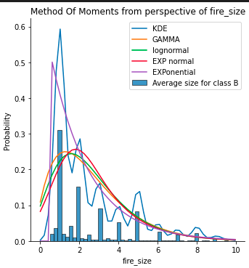
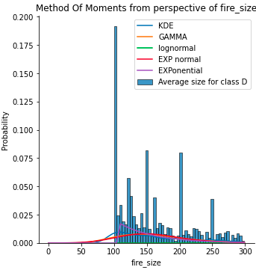
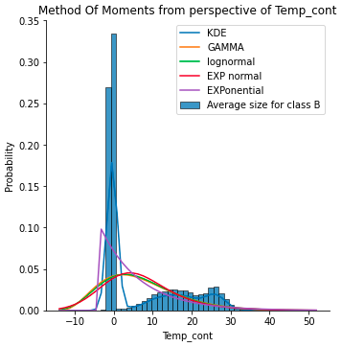
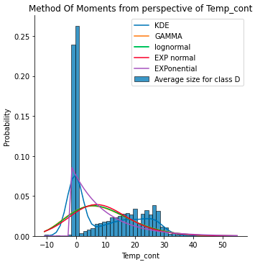
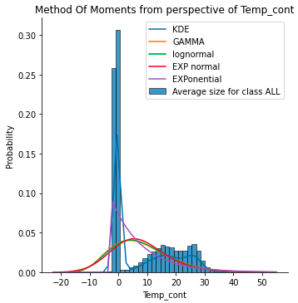
As we can see the distributions seem to quite well, but not perfectly, fit the histogram. Based on that it is better to use some statistical tests (point 6), to choose the best one.
5. Estimation of random variable distribution parameters using maximum likelihood technique and LS methods.
5.1. The first estimation techique we used was maximum likelihood method (MLE). Within the framework of MLE we managed to get the following diagrams
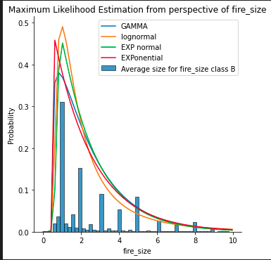
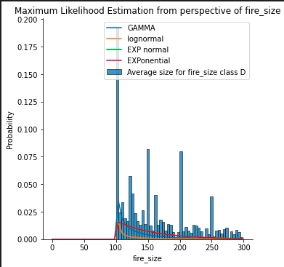
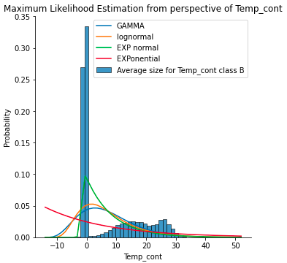
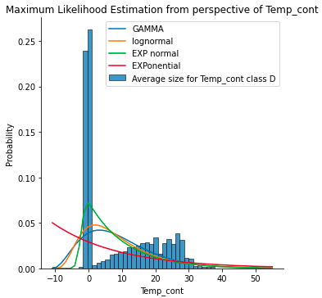
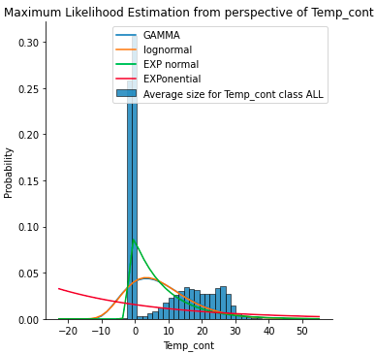
Here the results are slightly different than for the method of moments. We will asses their fitness using the statistical tests in point 6.

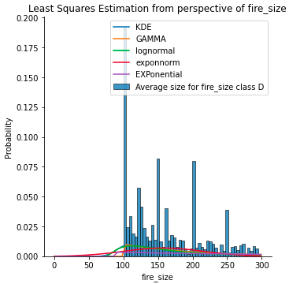
5.2 Least squares method
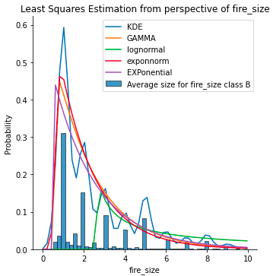

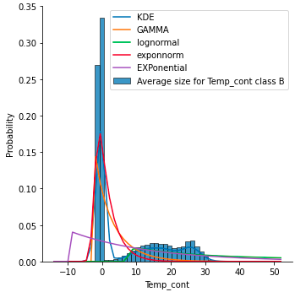
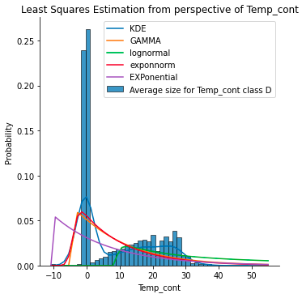
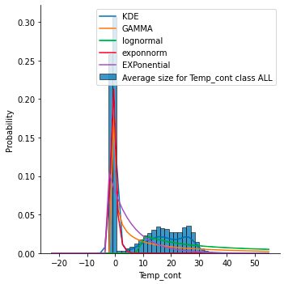
There are a few differences between the received diagrams and estimations. For MLE, the probability of a diagram maximizing the fitness quality is calculated, whereas for least squares – the difference (residual) bewteen the estimated value and the KDE. MLE is evaluated using the fit function which is provided for each of the distributions, whereas least squares is solved using SciPy’s optimize.least_squares. The residual is calculated with regatrds to the KDE.
6. Validation of empirical and theoretical distributions using quantile biplots.
Quantile biplots let us see how well does the data model fit the real data. We can see it visually then. I have made the QQ-plots only for estimations where the tests (Kolmogorov-Smirnov and Cramer Von Mises) where best (p-value highest)

For least_squares method and fire_size. On the left for size (B) and on the right –D
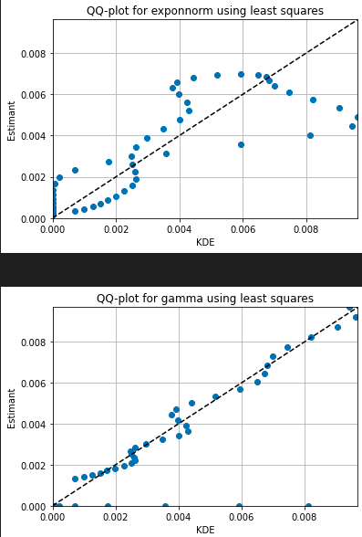
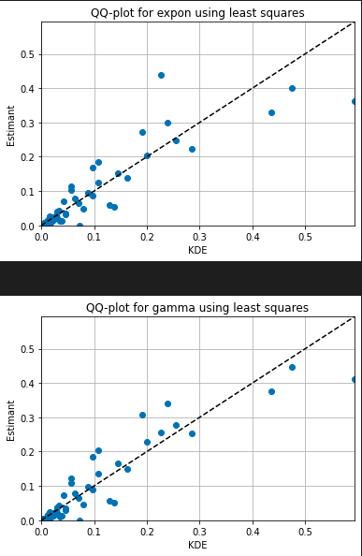

Similarly for least_squares but for Temp_cont. B on the left, D on the right
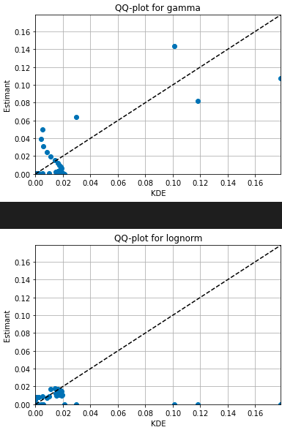
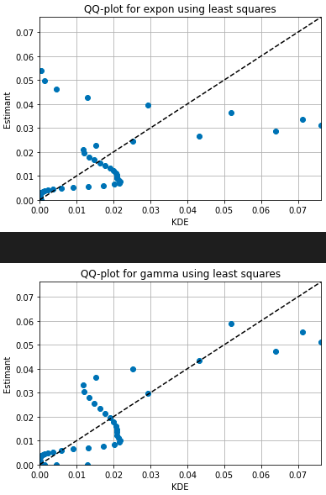
7. Statistical tests (2 at least).
As we can see, estimating distribution fitness by just looking at the diagrams is often not enough. Mathematics can provide far better answer for that question and this is why the statistical tests have been designed. We are using two of them:
- Kolmogorov-Smirnov test
- Cramer-von-Mises
Both tests are comparing the observed sample`s distribution function to the estimated one. They return an important measure called p-value. It is responsible for answering the question: what is the probability that the distributions match. The higher the p-value, the better.

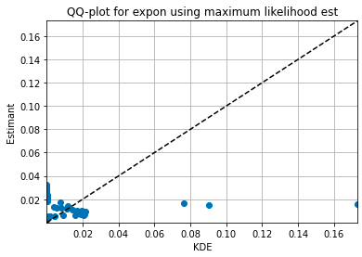
Best value for Temp_cont assessment without grouping by fire_size_classes.
statistic=0.5246722253607693, pvalue=2.3906571005960975e-13
It is Maximum Likelihood Estimator`s result for exponential function.

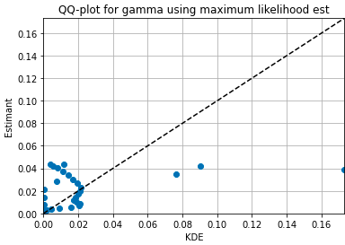
Best value for Temp_cont using Cramer-von Mises test: statistic=7.860493933136938, pvalue=1.6461424445779471e-09

It is Maximum Likelihood Estimator`s result for Gamma function.

Sourcecode
https://github.com/PatrykStronski/MultivariateAnalysis_Task1

