Patryk Stroński 242564
Lab 3 Artificial Intelligence

Gomoku game – duel between player and computer
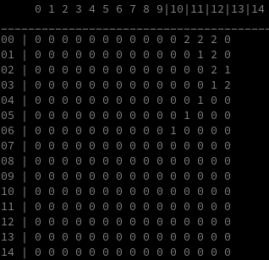
Introduction
The gomoku is a simple 0-sum game between two players. The game is taking place on a 15x15 board. I utilized Rust programming language to implement minimax algorithm with alpha-beta pruning. The interface is very simple – it is a command-line one. The 1’s denote player’s moves whereas 2’s – computer’s. The user inputs the numbers like this:
4,5
Where 4 denotes position on Y axis, whereas 5 – on X axis (it’s reversed comparing to cartesian coordinates).
After first of the rivals (computer or player) scores 5 points in a row, the game is finalized and result, who won is displayed.

Decision tree implementation
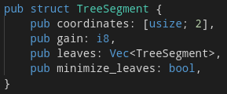
The decision tree is implemented using simple Structure TreeSegment – which takes the coordinates, gain, leaves and minimize_leaves fields.

