Patryk Stroński 242564
Lab 6 – extension of Lab5

Introduction
Lab 6 is an extension of lab 5, therefore the instruction from lab 5 is more or less valid (which is also in this zip). Even though there are several changes. First of all there are now three modules, where two of them need to run on server and one on RFID card reader RaspBerry PI. The reader.py file is the pne that needs to run directly on Raspi, whereas server_broker.py and index.py – on server. Index.py manages the flask-based REST interface and server_borker.py is responsible for message subscription.
The logs of cards are transferred from Reader parts to Server using messages via MQTT protocol.
The server needs therefore to have MQTT broker Mosquitto running. It can be easily downloaded either from repositories (like in case of Arch Linux – AUR), or installed as a package via snap. Please refer to the site https://mosquitto.org/download/. Then it needs to be run using command mosquitto -c /etc/mosquitto/mosquitto.conf. Where etc/mosquitto/mosquitt.conf is the filepath of the config file.
Each module is run from terminal using python <filename.py> command.
Also, as previously, remember to have these conditions satisified:
- postgresql database up and running with database rfid_logs
- port 5000 free and open
- credentials in db_management set up correctly.
- correct Mosquitto url in both server_broker.py and reader.py defined using QUEUE_ADDRESS variable
- the modules from dependencies.txt file installed using pip.
- the table card_logs needs to be dropped and the one from previous version of the exercise cannot persist. It changes in this exercise so it’s better for it to self load using the creation statements in db_management.py file.

Message structure
The messages include json formatted (but stringified) message. The following Fields are there for log reading: {"status": log, "time": <time of reading card>, "uid": <employee card uid>, "instance_id": <uid of the worker (reader)>}
and for healthcheck:
{"status": "health", "on": 0/1, "instance_id": <uid of the worker (reader)>}
They are decoded by the broker module and processed.

Healthchecks
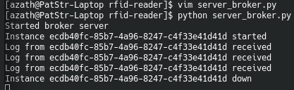
Healthchecks are special logs informing that an instance connected or disconnected to the broker. When the broker is working and reader is initialized, the log is printed by broker, informing that some reader is up and running. The uuid of this reader (instance id, not hardware reader id, because each running reader.py can for now use only one HW RFID reader) is provided. When the instance is connecting and is disconnecting, the message is sent. Healthchecks are implemented for logging purposes. Based on healthcheks from logs administrator can now that the reader got connected or not.

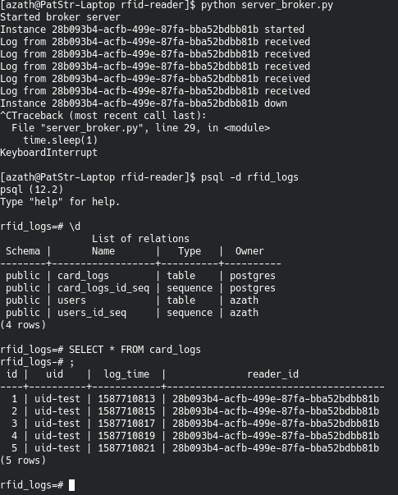
RFID reading
The main part is the RFID reading. The reads of the external card are sent using the MQTT protocol. The messages are saved immediately to the database and are browsable from table card_logs in postgresql. I ran a 2-second-gap to show that the logs are read and written to the database with correct data received from broker.

RESTful UI
The RESTful api that was introduced in the previous exercise remains unchanged. Please refer to the report from there.
Important note: you need to assign user yourself via API call to the UID, because in the beginning the UIDs can be read, but the user needs to have them assigned in order to work correctly.

