SmartCare v0.4 - Domain Implementation Workbook
Week 7 student resource

1. UML-to-Code Trace
UML element | Python element | Implemented? | Notes
Patient.patientId, name | Patient.__init__,patient_id and name attributes | Yes | Required nonblank strings:name is checked by Patient
Patient.dateOfBirth, contactDetails | Date_of_birth, contact_details attributes | Yes | Birth date and nonblank details validated
Patient 0..* appointments | _appointments, add_appointment(), get_appointments() | Yes | Returns a tuple, only links own appointments
Practitioner ID,name,speciality,contact | Practitioner.__init__ and validated attributes | Yes | No db logic, validates the required text
Practitioner 0..* appointments | _appointments, add_appointment(), get_appointments() | Yes | Returns a tuple, only links own appointments
Appointment ID and dateTime | Appointment_id, date_time, Appointment.__init__ | Yes | Parses the date string
Appointment patient 1, practitioner 1 | patient and practitioner references | Yes | Checks types and links objects
Appointment status, updateStatus() | status property, update_status() | Yes | Appointment status enum: only Scheduled to cancelled
Appointment cancel() | cancel() | Yes
No double booking at the same time | Appointment.__init__ conflict scan | Yes | Checks the active appointments of the parties before linking them

2. Domain Invariants
Class | Invariant / rule | How protected
Patient | ID, name, contact required: valid DOB | required in constructor; no SQL.
Practitioner | ID, name, specialty, and contact | required in constructor; no SQL.
Appointment | Exactly one Patient/One Practitioner | Type checks, required references and reciprocal links.
Appointment | No active booking conflicts | Scan both appointment collections before creating the link
Appointment | Only scheduled may transition to cancelled | Read Only status property, enum and update guard
Patient/ Practitioner | Cancellation preserves in history | Cancel changes status only

3. Composition / Inheritance Decisions
Relationship | Decision | Rationale
Appointment -> Patient | Association 1 to 1 per appointment | An appointment has a patient, a patient is not an Appointment
Appointment -> Practitioner | Association 1 to 1 per appointment | A practitioner can have many independent appointments
Patient -> appointments | One to 0..* association | Appointments can be retained even after a cancellation
Practitioner -> appointments | One to 0..* association | Returning a tuple prevents callers from editing the collection
Doctor -> Practitioner | No inheritance in v4 | A subclass is justified only if the later rules give it a distinct behavior

4. AI Pair-Programming Record
AI contribution | Conforms? | Decision | Reason | Verification
AppoitmentStatus and private status | Yes | Accept | Enum expresses the two states, read only property stops the direct assignment | Assigning appoiontment.status raises AttributeError
Appointment cancellation guard | Yes | Accept | Cancelled object stays linked: repeat transition raises a ValueError | Call cancel twice, inspect both histories
Booking validation and both party conflict | Yes | Refine | Replaced the global collision rule, two different GP’s can share a time | Same time booking pass: either part clash fails it

5. Updated UML
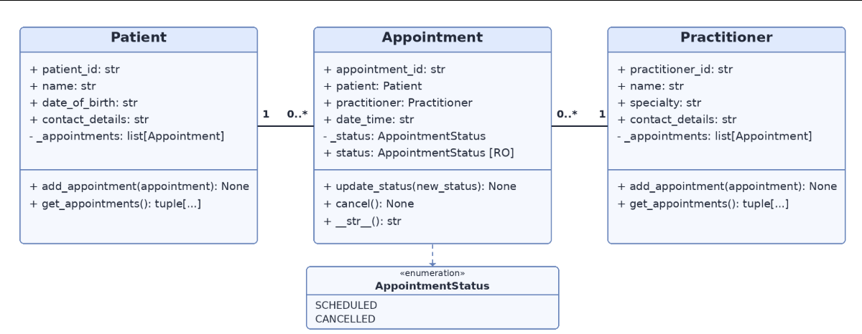
Insert updated UML only if implementation revealed a justified design change. Explain every change.
- Appointment status now gives status its two permitted values
- Status property is read only
- Date of birth and appointment time are validated
- RO means read only
- The diagram follows the current Python names and doesn’t introduce persistence

AI Log
I uploaded the picture of my updated UML along with the recommended prompt and this was the response
“Act as a Python pair programmer. Implement only the Appointment class from the approved SmartCare UML. Use type hints and an AppointmentStatus enum. Cancelled appointments remain as objects. Do not add database, UI, notification or service classes. Protect status transitions and explain any decision not directly visible in the UML.”
from enum import Enum
from typing import TYPE_CHECKING

if TYPE_CHECKING:
from patient import Patient
from practitioner import Practitioner

class AppointmentStatus(Enum):
SCHEDULED = "Scheduled"
CANCELLED = "Cancelled"

class Appointment:
def __init__(
self,
appointment_id: str,
patient: "Patient",
practitioner: "Practitioner",
date_time: str
) -> None:
self.appointment_id: str = appointment_id
self.patient: "Patient" = patient
self.practitioner: "Practitioner" = practitioner
self.date_time: str = date_time
self._status: AppointmentStatus = AppointmentStatus.SCHEDULED

@property
def status(self) -> AppointmentStatus:
return self._status

def update_status(self, new_status: AppointmentStatus) -> None:
if not isinstance(new_status, AppointmentStatus):
raise TypeError("new_status must be an AppointmentStatus.")

if (
self._status == AppointmentStatus.SCHEDULED
and new_status == AppointmentStatus.CANCELLED
):
self._status = AppointmentStatus.CANCELLED
return

raise ValueError(
f"Invalid appointment status transition: "
f"{self._status.value} -> {new_status.value}"
)

def cancel(self) -> None:
self.update_status(AppointmentStatus.CANCELLED)

def __str__(self) -> str:
return (
f"Appointment {self.appointment_id}: "
f"{self.patient.name} with {self.practitioner.name} "
f"at {self.date_time} "
f"[{self.status.value}]"
) Design decisions not directly visible in the UML
The UML shows _status: AppointmentStatus and a read-only status: AppointmentStatus [RO]. I implemented this using a protected _status attribute and a @property with no setter. This means other code can read the current status but cannot directly overwrite it.
For example:
print(appointment.status)
is allowed, but this is not:
appointment.status = AppointmentStatus.CANCELLED
Status changes must go through update_status() or cancel().
The UML only defines two appointment states:
SCHEDULED
CANCELLED
To protect status transitions, the implementation only allows:
SCHEDULED -> CANCELLED
Any other transition raises ValueError. This includes:
SCHEDULED -> SCHEDULED
CANCELLED -> CANCELLED
CANCELLED -> SCHEDULED
This means repeated cancellation is rejected rather than silently accepted.
The cancel() method does not delete the object. It only changes its status:
self.update_status(AppointmentStatus.CANCELLED)
This satisfies the requirement that cancelled appointments remain as objects and can still exist in the patient's or practitioner's appointment history.
The __str__() method uses:
self.patient.nameself.practitioner.name
rather than printing the objects directly. This makes the appointment display readable with the current Patient and Practitioner classes.
The updated v0.4 UML shows:
date_time: str
so this implementation uses str. The older Stage 3 design used dateTime: DateTime, so this choice is specifically based on the updated v0.4 UML.
I also used TYPE_CHECKING so the type hints can reference Patient and Practitioner without implementing those classes here or introducing extra classes outside the approved scope.
No database, UI, notification, service, persistence, or other architecture has been added.

Reflection
I reworked the Patient and Practitioner classes myself as they were a part of the AI-OFF area. The initial Appointment only AI response introduced AppointmentStatus enum, a read only status and a more guarded cancellation method. It did not validate the appointment details, check for booking clashes or link the appointments to practitioner histories however later changes added those features to the v4 and changed the global clash rule so different practitioners would be able to hold appointments during the same time. The updated UML kept the three domain classes and all their associations while the lab scope excluded any databases, graphical UI, notifications and service classes

Validations
