SmartCare v0.3 - Domain Model Workbook
Week 6 student resource

Requirement-to-Concept Trace
Requirement | Concept | State/behaviour | Decision
Store Patient information | Patient | Patient info | Create Patient class
Search and retrieve patient information | Patient | Searchable patient info | Keep Patient as a core domain class
Store practitioner information | Practitioner | Practitioner info | Create Practitioner class
Create appointments linking patients and practitioners | Appointment | Patient and Practitioner associations | Create Appointment class
Prevent duplicate or conflicting bookings | Appointment | Booking conflict business rule | Keep as appointment related rule
Store appointment status | Appointment | Status | Add status as Appointment state
Update appointment status | Appointment | Update_status() | Add behavior to Appointment
Cancel appointments | Appointment | Cancel() | Add behavior to Appointment
Retain cancelled appointments | Appointment | Appointment remains in history | Do not delete cancelled Appointment objects
View patient appointment history | Patient, Appointment | Patient-Appointment relation | Associate Patient with multiple appointments

CRC Cards

Patient
Responsibilities | Collaborators
Represent patient information | Appointment
Participate in appointments | Appointment
Provide access to associated appointment history | Appointment

Practitioner
Responsibilities | Collaborators
Represent practitioner information | Appointment
Participate in appointments | Appointment
Be associated with scheduled appointments | Appointment

Appointment
Responsibilities | Collaborators
Represent an appointment | Patient, Practitioner
Associate a Patient with a Practitioner | Patient, Practitioner
Maintain appointment status | Patient, Practitioner
Allow appointment status to be updated | Patient, Practitioner
Support cancellation | Patient, Practitioner
Remain available in appointment history after cancellation | Patient, Practitioner

Optional class
A separate class like AppoitmentStatus could be considered late if the status values are confirmed and require additional behaviour

UML Class Diagram
Insert/draw UML here. Include defensible relationships and multiplicities.
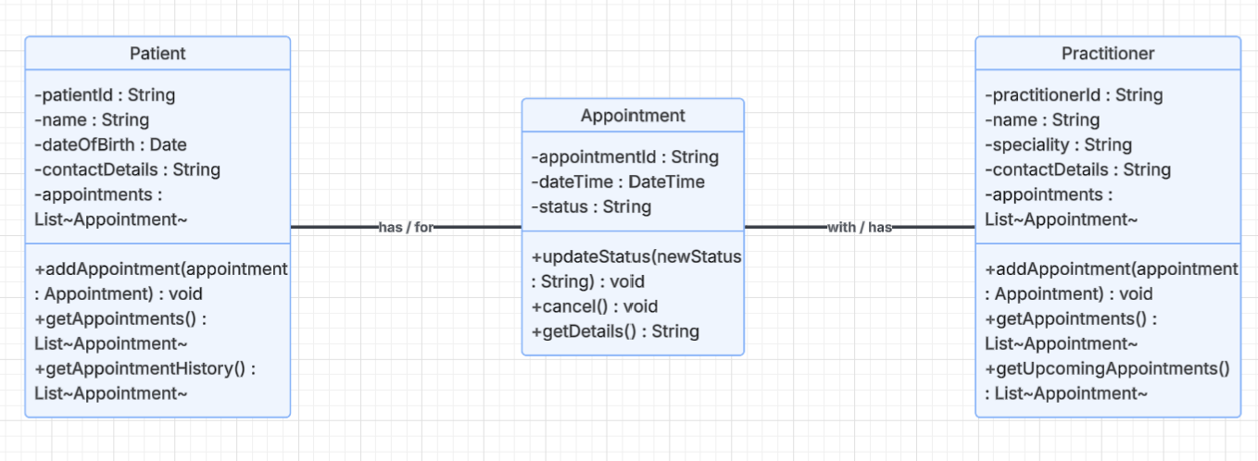
Relationships
Patient 1 – 0* Appointment
A patient may have zero or many Appointments. Each appointment is associated with one patient
Practitioner 1 –0*Appointment
A practitioner may have zero or many appointments. Each Appointment is associated with one practitioner
These are associations not inheritance relationships

Design Rationale
Explain class selection, responsibility allocation and key relationships.
The SmartCare domain model uses three main classes: Patient, Practitioner, and Appointment. These were chosen because they are clearly related to the confirmed purpose of the SmartCare system. Patient represents patient info, Practitioner represents practitioner info, and Appointment represents the appointment connecting patients and practitioners.
Appointment contains most of the systems business work as the requirements focus heavily on appointment creation, status management, cancellation and history. Appointment is associated with only one Patient and one practitioner. A patient may have zero or more appointments same as a practitioner.
Inheritance was not used as an appointment is not a type of Patient Practitioner. Instead, these have associations because an Appointment has a Patient and a Practitioner.
I didn’t model Status and cancellation as separate classes because the current requirements support treating status as Appointment state and cancellation as Appointment behavior. Classes like a Schedule were also excluded because there is not enough confirmed requirement evidence to justify them
The final model is simple and clear while still supporting the confirmed SmartCare requirements

AI Design Review Record
AI suggestion | Evidence | Decision | Reason | Model change
Create Patient Class | Patient information needs to be stored and retrieved | Accepted | Patient is a clear entity | Patient included
Create Practitioner class | Practitioner must be managed | Accepted | Practitioner is a clear individual entity | Practitioner included
Create Appointment class | Appointment creation, status, cancellation and history are all required | Accepted | Appointment has its own states and behaviors | Appointment included
Associate Patient with Appointment | Patient appointment history is required | Accepted | A patient can be linked to multiple appointments | 1 to 0* association inluded
Associate Practitioner with Appointment | Appointments need to involve practitioners | Accepted | A practitioner is linked to multiple appointments | 1 to 0* association inluded
Create ScheduleEngine | Confilct prevention is required | Modified | The business rule is supported, but a entirely separate class isn’t justified yet | Confilct is managed without needing to add another class
Create AppointmentManager | Appointment management is required | Modified | Management behaviour exists, but it does not yet require its own class | Is managed by the current model
Create NotificationManager | No notification requirement confirmed | Rejected | Unsupported by the current needs of the code | No class added
Create ClinicController | NO confirmed requirement for clinic or controller behavior | Rejected | Adds unnecessary complexities | No class added

