Momentum Scalp Signal Engine
Active trade window — UI mockups and interaction spec
Trade AI v12 · draft v0.1 · 27 July 2026 · design review, not a build authorization

1. Purpose
This document collects three UI mockups for the active trade window, the surface where a pending momentum-scalp signal is reviewed and, eventually, granted permission to route. It exists to settle layout and interaction questions before any of it reaches code.
The source material is a conventional DOM order-entry panel. That panel assumes the decision has already been made and only handles execution. The active trade window has to carry the decision itself, so the layout is reorganised around evidence first and execution last.

2. Operating posture — read before reviewing
Every mockup here depicts controls that would submit live orders. The system is not in a state where any of them can. At the time of writing:
- ALPACA_MODE = paper
- LLM_DISABLE_LIVE_EXECUTION = true
- autonomous_live_submit = False
- Momentum scalp engine feature flag OFF; M3-S0 through S5 shipped shadow/read-only
- Stage 2a Schwab canary has not run
Accordingly, every mockup carries a visible shadow badge and the permission rail is explicitly marked display-only. Two deliberate omissions are worth calling out, because they were present in the source panel and were removed rather than overlooked:
Auto-send is absent. The source panel places an auto-send checkbox inches from a one-click market order. On a surface that also renders untested signals, that combination is the single most dangerous control available. When live execution is eventually enabled, auto-send belongs behind the 2FA rail, not next to the quantity box.
Vetoed signals stay visible. The queue does not filter out rejected signals. A queue that shows only survivors cannot be audited — a mis-scaled veto would be invisible. Seeing why something was killed is the point.

3. Figure 1 — Active trade window
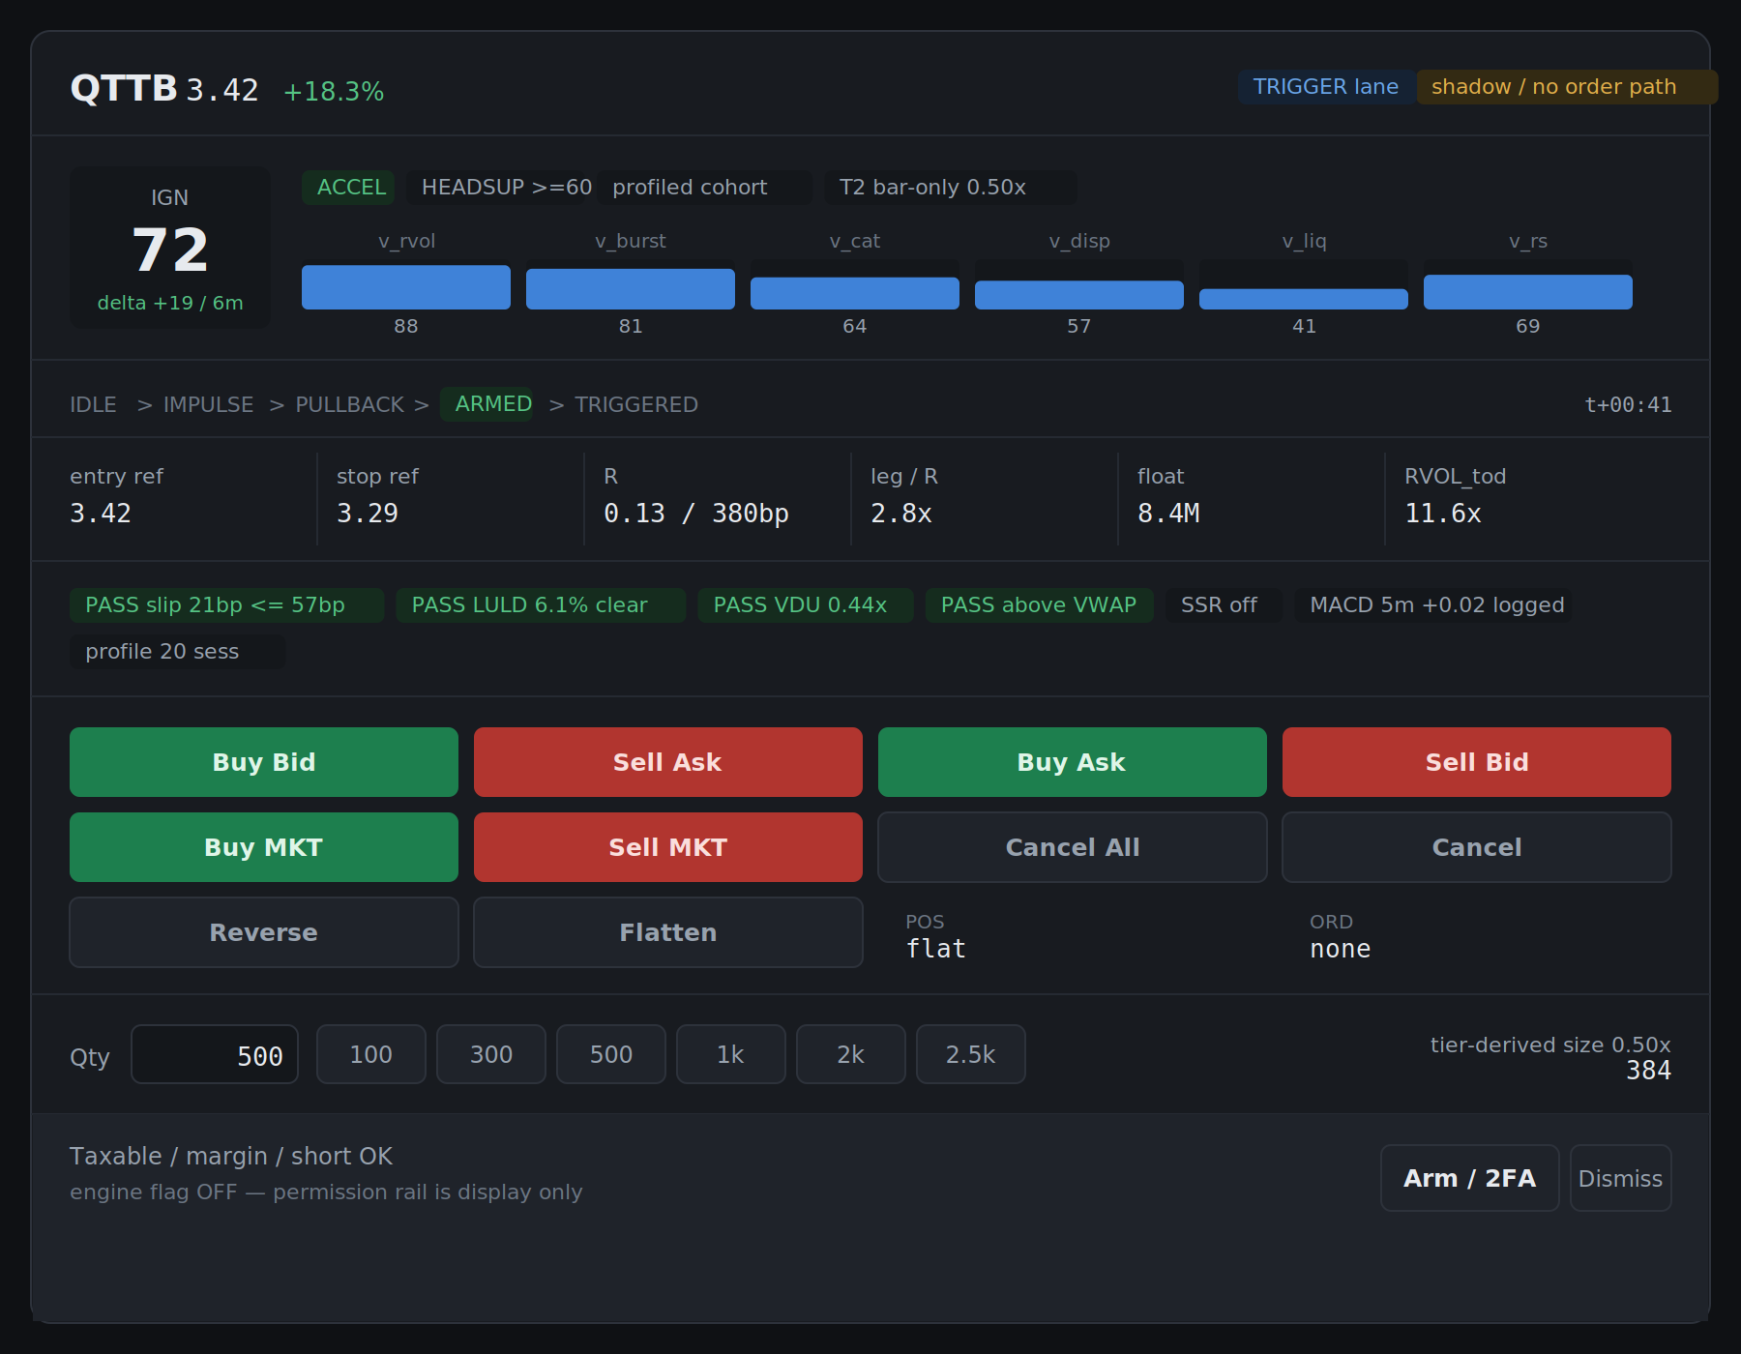
Figure 1. Single-symbol card: signal evidence, levels, gates, order entry, sizing, permission rail.

Reading order
The card runs top to bottom as evidence → levels → gates → action. The buttons are the last thing reached, not the first. This is the main structural departure from the source panel.

Design notes
Gate chips carry numbers, not ticks. Each chip is a veto that already ran, displayed with the actual measured value. "slip 21bp <= 57bp" tells you the stop is wide relative to crossing cost. A bare green checkmark would not have caught the six whipsawed fires observed in M3-S5, where R was as low as $0.004 — a stop inside the spread, which resolves to −1R on quote noise before price does anything.
Quantity appears twice, deliberately. Manual presets sit on the left; the engine's tier-derived size (0.50× → 384) sits on the right. These must not be the same control. If tier sizing silently overwrote the operator preset, the fallback-ladder rule would be enforcing itself invisibly and disagreements between operator and engine would become unobservable.
MACD is shown as logged, not gating. Per §6.1 the 5-minute MACD is a regime filter that is recorded but never gates a fire. The chip styling matches the other non-gating context chips (SSR state, profile session count) rather than the pass/fail chips, so the distinction is visible at a glance.
Cohort and data tier are always on the card. Profiled versus proxy, and the T-tier with its size multiplier, are shown as first-class badges. Precision@1R is never pooled across cohorts, so the cohort has to be visible at decision time and not just in the rollup.

4. Figure 2 — Permission queue
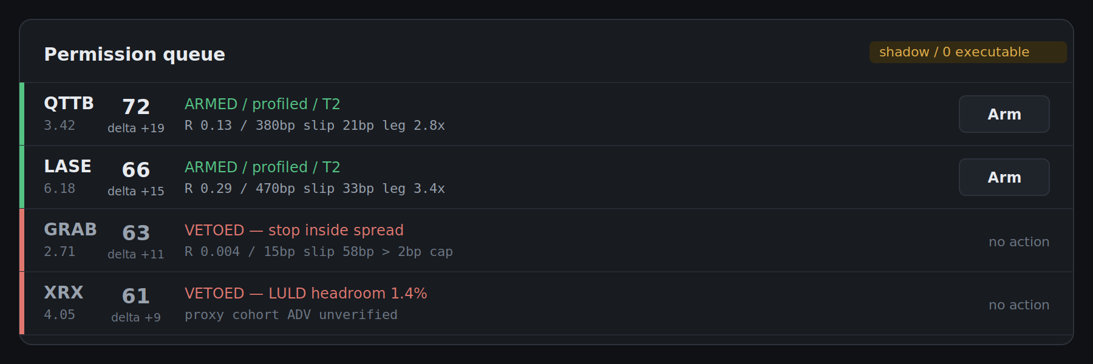
Figure 2. Compact multi-signal rail. Two armed, two vetoed with the reason stated.
In practice several signals are pending at once and most need rejecting quickly rather than reading in full. The queue exists for triage; Figure 1 is what opens when a row is expanded.
The two vetoed rows are the cases observed in shadow. GRAB shows a 15bp stop against a 58bp crossing cost — the M3-S5 finding, rendered as a veto rather than a loss. XRX shows a signal from the proxy cohort where the ADV input is still circular and therefore not yet trustworthy.

5. Figure 3 — Account routing dialog
This is the step that follows Arm. It was not in the source panel and is new to this revision.
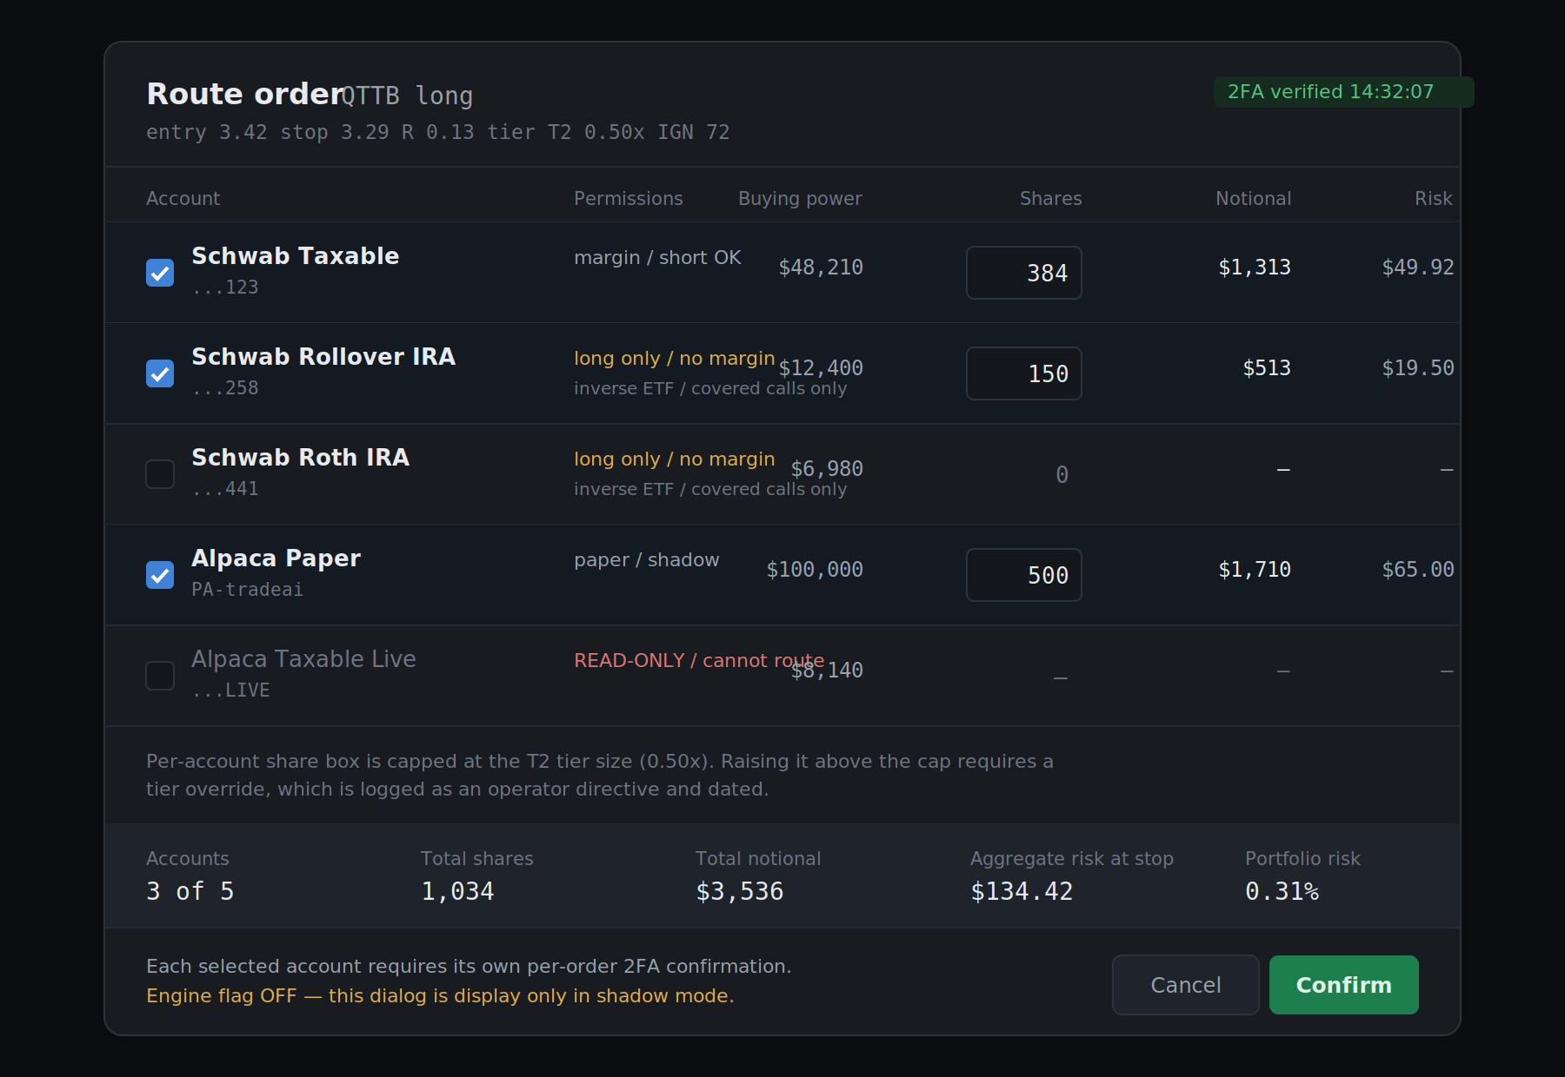
Figure 3. Multi-account selection with per-account share entry, permission constraints, and aggregate risk.

Behaviour
- Multiple accounts may be selected in a single routing action.
- Share count is entered per account, not split automatically from a single total. Automatic splitting would hide the per-account constraint that actually binds.
- Each per-account share box is capped at the tier-derived size. Exceeding the cap requires a tier override, which is logged as a dated operator directive.
- Accounts that cannot legally take the trade are shown disabled with the reason, not hidden. A read-only broker connection is a routing constraint the operator should see.
- Each selected account requires its own per-order 2FA confirmation. One confirmation does not authorise the basket.
- Aggregate risk at stop is computed across the selection and shown before confirmation, alongside portfolio-level risk percentage.

Account permission matrix
The dialog enforces the standing account rules rather than restating them in prose:
Account | Short | Margin | Hedging instruments
Schwab Taxable | Yes | Yes | Direct short, inverse ETF, options
Schwab Rollover IRA | No | No | Inverse ETF, covered calls only
Schwab Roth IRA | No | No | Inverse ETF, covered calls only
Alpaca Paper | Yes | Yes | Shadow only — no capital at risk
Alpaca Live (taxable / IRA) | n/a | n/a | Read-only integration — cannot route
A short signal therefore renders the two IRA rows disabled automatically, with the reason shown inline. The dialog is where this rule becomes visible rather than an assumption living in code.

6. Field reference
Where each element on the card comes from, so the eventual implementation has no ambiguity about its source.
Element | Source | Notes
IGN score | scalp_ignition_events.ign_score | Six weighted sub-scores per §3.2
Delta IGN | Derived, rolling 10-minute window | ACCEL tier fires on Δ ≥ 15 regardless of level
Sub-score bars | v_rvol, v_burst, v_cat, v_disp, v_liq, v_rs | EvR is logged as diagnostic and excluded
FSM state | scalp_trigger_engine | IDLE → IMPULSE → PULLBACK → ARMED → TRIGGERED / VOID
Entry / stop / R | Trigger engine compute_levels() | Stop = entry − 1×ATR₁ₘ per §6, noise floor applied
leg / R | Measured-move feasibility check | Replaces the tautological R:R against target_1
RVOL_tod | symbol_volume_profile denominator | Null below the denominator floor, never a raw ratio
Slippage chip | spread_estimate_gate, T2 degraded form | max(CS, AR) for gating; median for scoring
LULD chip | Free deterministic band calculation | No entitlement required; best halt predictor
VDU chip | Pullback volume / impulse volume | Highest-value gate, commonly omitted elsewhere
Data tier badge | scalp_ignition_events.data_tier | Drives the size multiplier shown at right
Cohort badge | profiled or proxy | Precision@1R reported per cohort, never pooled
Buying power | broker_accounts, live read | Per-account, refreshed at dialog open

7. Open items

Unresolved from the source request
Three phrases in the request did not survive voice transcription and were not guessed at:
- "a Prisma morph of this" — visual direction unclear. Interpreted provisionally as "restyle into the dashboard idiom."
- "monkeys, the public gloves" — unresolved. Possibly a feature intended for the card.
- "twenty five hundred brick" — interpreted as a 2,500-share quantity preset, added as the 2.5k button.
- One further phrase in the follow-up request was unintelligible and is not reflected anywhere in this document.

Design questions raised by the mockups
- Paper account in aggregate risk. Figure 3 currently sums the paper account into total notional and aggregate risk. Arguably paper should be excluded from portfolio-risk arithmetic and shown separately, since it represents no capital at risk. Unresolved.
- Queue ordering. Figure 2 is ordered by IGN descending. Time-to-expiry may be the more useful sort during an active session.
- Expiry behaviour. A pending permission should lapse rather than persist indefinitely. The countdown is shown on the card; the timeout value is not yet specified.
- Tier override path. The mechanism exists in the design as a logged operator directive, but the UI affordance for invoking it is not drawn.

8. Status
These are mockups for review. They are not a build authorization, and nothing here should be read as approval to wire an execution surface. The outstanding M3-S2.5 gate items — profile curve verification, cron off-by-one, the tier monotonicity invariant, and the max/median aggregation split — remain open and are prerequisites to further stages regardless of UI work.
If a page is built from this, it belongs alongside scalp-shadow.html under /v3-next/ and under the same read-only posture.

