Fraud Detection Methods Analysis

Jayden Pickin
University of Colorado Boulder
japi4073@colorado.edu

ABSTRACT
Fraud exists within any system that handles currency. This project uses multiple data analysis techniques on historical banking transaction data, evaluating different methods confusion matrix, F1 score, K-Fold, ROC-AUC, Anomaly Score Distribution and Silhouette Score. Two supervised (Decision Tree, Random Forest) and an unsupervised (KMeans, Isolation forest) methods have been implemented and tested. Testing indicates most methods struggle to detect fraud within the dataset, highlighting a class imbalance between fraud and normal transactions. Despite this, the Random Forest model reliably detected fraud within this dataset. Supervised methods overall performed better than unsupervised methods as well.
KEYWORDS
Fraud, Supervised Learning, Unsupervised Learning
1 Introduction
Banks handle millions of transactions every day and hidden within these transactions exist fraudulent transactions. These attempts are done with the intent of taking money from account holders. If caught after the transaction, the bank still loses funds in order to refund the client.
There was $12.5 billion in reported losses due to fraud in 2024 according to the FTC. This is despite existing systems and solutions used by banks to detect these transactions. However, these systems may be trained on old data, or may not use all possible methods. This project uses historical data, and data mining methods in order to develop a new model for fraud detection and determine which models need further research.
The objective is to find if a model or learning method is significantly more reliable in detection that would support further research into or ideally could be used in a practical application.
2 Related Work
Due to the large scale of losses involved, there exist research using machine learning, and behavioral analysis to detect fraud. All work exists around trying to identify patterns within fraud and client transactions. A common problem within existing research is twofold. There is an assumption of completion, the research assumes the dataset is perfectly labeled between fraud and normal transactions. However, the research field exists because there is no reliable method into labeling transactions perfectly. Therefore, models trained on real data will be trained using fraudulent transactions labeled as normal.
3 Proposed Work
Existing research focuses on trying to understand client behavior and spotting when a transaction exists outside those boundaries. This project will focus on trying too accurately predict which transactions are fraud based on historical fraud attempts.
3.1 Data source
The Data Source used contains 50,000 simulated banking transactions from the Financial Transaction Fraud Dataset. The dataset contains 25 attributes, including Transaction_ID, Transaction_Amount, Distance_From_Home, IP_Address, and the Fraud_Label. Initial analysis shows a class imbalance, with fraudulent transactions comprising 4.846% of the dataset.
3.2 Preprocessing
The preprocessing required was the conversion of the Fraud_Label into a binary fraud indicator for calculation purposes. There exist attributes that contained text labels that were converted into integers. Some attributes were converted into buckets of data where the values were assigned to an integer that represented a particular range.
3.3 Supervised Machine Learning Methods
3.3.1 Single-Decision Tree DT Decision Tree Models create a tree that splits the data based on features in order to come to a decision. It benefits from creating a process that is being easy to understand and follow at the end. It does so by making a clear set of rules from input to output. A DT was implemented, and preliminary results show that it overfit without pruning, resulting in inconsistent generalization performance.
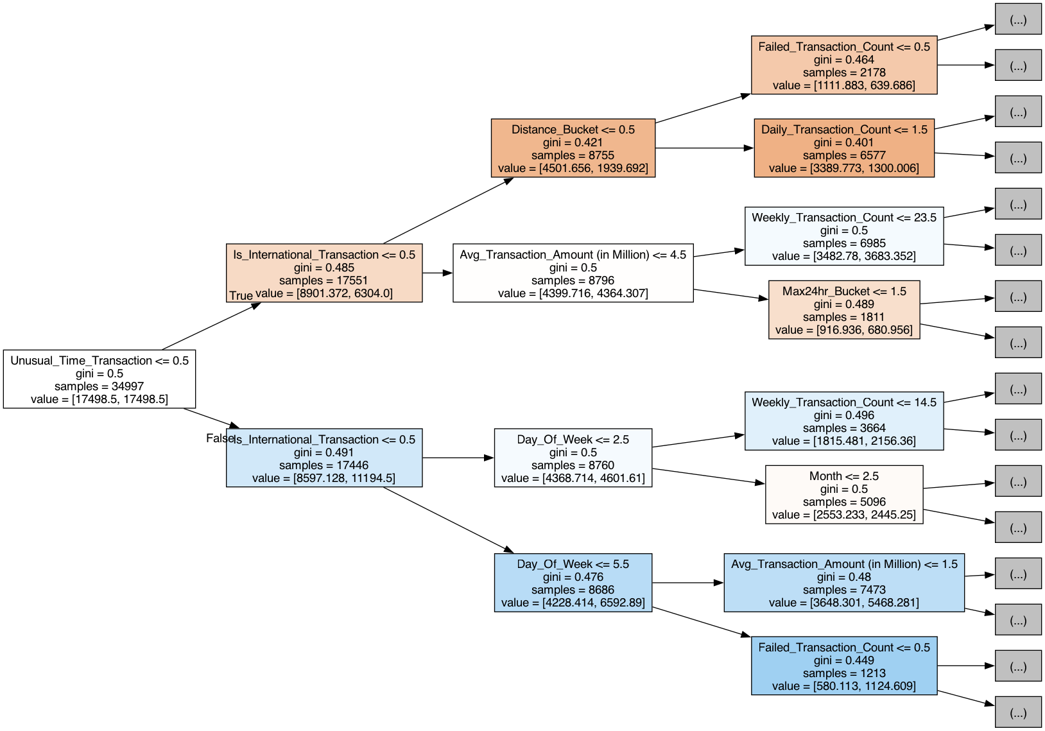
Figure 1: Decision Tree visualized

The Decision Tree Model achieved an accuracy of .4534. However due to the class imbalance in the dataset, accuracy is not a reliable evaluation metric. The model had an F1-score of .11 for the fraud class, indicating a struggle correctly identifying fraudulent transactions despite moderate recall (0.68).
The confusion matrix (fig. 2) shows a high number of false positives (7,968) and false negatives (230), suggesting a struggle to balance precision and recall across both classes.
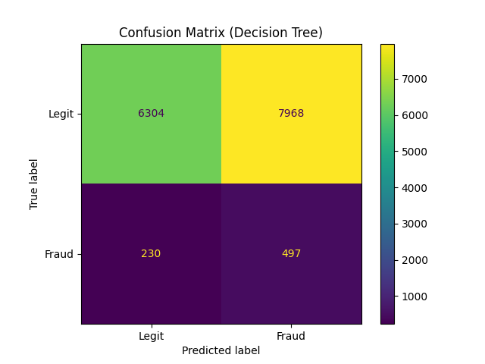
Figure 2: Decision Tree Confusion Matrix

The k-fold (k=5) cross validation produced an average F1-score of .1081 with a standard deviation of .005. Therefore, the Decision Tree produced consistently poor results.
Feature importance analysis indicates that Unusual_Time_Transaction and Is_Internation_Transaction is the most influential in the decision, suggesting behavioral and temporal patterns being key indicators within the dataset. This can be seen in figure 3 below.

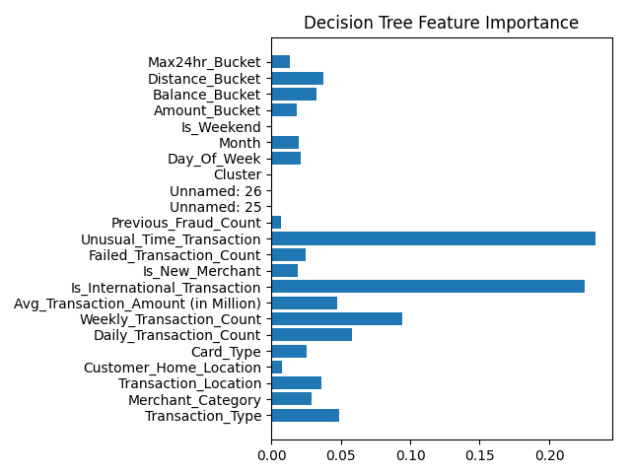
Figure 3: Decision Tree Feature Importance

The DT struggled to assign higher probability of fraud to fraudulent data points. It near perfectly split the data on the optimal threshold with no significant difference in fraud distribution between the 2 sets. The distribution of fraudulent data points amongst the probabilities was fairly even, signifying a struggle with predicting fraud.
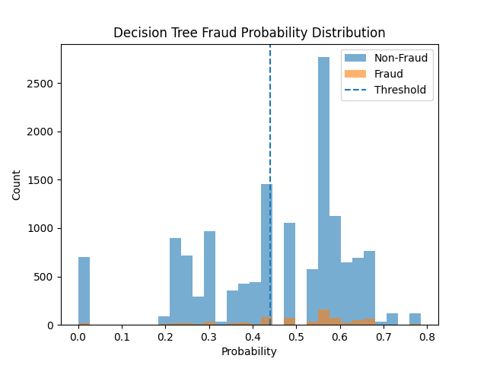
Figure 4: Decision Tree Probability Distribution

3.3.2 Group-Random Forest RF. Random Forest models expand upon the concept Decision Trees do, but on a larger scale. They create multiple DTs that are each trained on random data, allowing them to average decisions. This is harder for a user to follow the input to output directly, but still fairly clear. However, it is more computationally heavy and struggles to identify new patterns not seen in training data.
Within the fraud class the RF model achieved a higher F1 score of .34 displaying a low performance in detecting fraudulent transactions. However, it did achieve a high recall of .93 covering 93% of cases cover 21% of predicted fraud.
The confusion matrix (fig. 5) displays this information in the 2379 legit transactions labeled to be fraud and only 454 of fraudulent labeled transactions actually being fraud. However, only missing 31 fraudulent transactions is a quality performance.
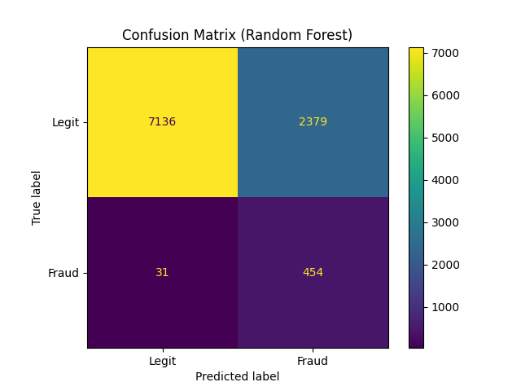
Figure 5: Random Forest Confusion Matrix

This performance did require threshold training in order to get any actual fraudulent labels on the data. This is shown in the predicated probability distribution (fig. 6). The Random Forest correctly assigned the highest value probabilities to majority of the fraud data. As shown by the threshold line on Figure 6, the calculated threshold line does lie within a portion of the normal transaction probability range. This displays the tradeoff in detecting more hidden fraud in exchange for also falsely flagging some normal transactions that a detection model must deal with.
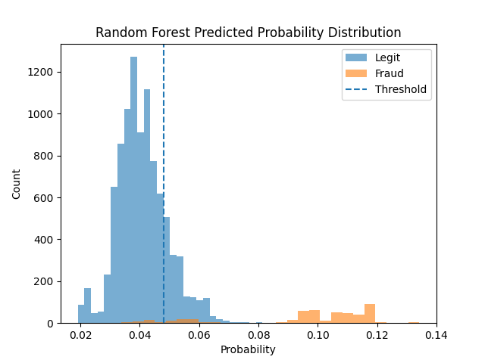
Figure 6: Random Forest Probability Distribution

3.4 Unsupervised Machine Learning Methods
3.4.1 Single-KMeans KM. KMeans models create clusters of data that exhibit similar features. However, it does assume that there exists spherical clustering of datasets. Attempting to determine an optimal value of clusters is computationally expensive, particularly for high dimensional datasets. In this case, no clearly optimal cluster count was identified using standard evaluation methods(elbow method/silhouette score), so a k value of 4 was selected for interpretability and observed separation.
After implementation, results showed significant imbalance across clusters. Approximately 98.956% of data were assigned to cluster 0, which exhibited a fraud rate similar to the overall dataset distribution. This suggests that the clustering process did not meaningfully split the fraudulent and normal transactions. Clusters 2 and 3 showed deviation from the global rate of fraud, however they contained 33 and 34 data points respectively, limiting their statistical significance.
Using a subset sample for computational efficiency, the k-means testing produced a silhouette score of -0.0004. A score close to zero like the one produced demonstrates a weak cluster structure. Combined with a negative value this represents a potential misassignment, KMeans failed to find a meaningful structure.
PCA projection (figure 7) further confirms weak separability between clusters in a reduced feature space.
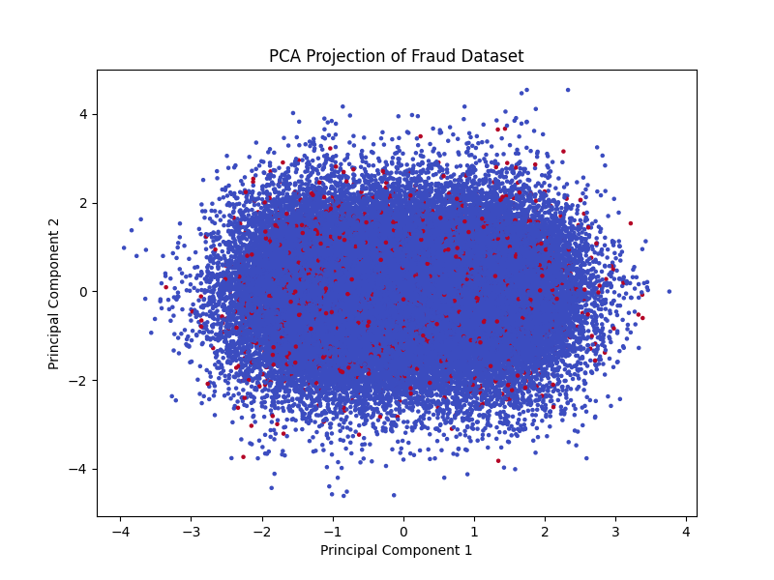
Figure 7: KMeans clustering results visualized using PCA projection

3.4.2 Group-Isolation Forest IF. Isolation Forest methods creates randomly built decision trees that isolate individual data points. It does this without labels, thus allows it to spot anomalies, however not all anomalies are fraud. It creates a higher false positive rate or misses fraud that mimics real behavior.
The IF method produced an F1 score of .05 for the fraud class. This is evidenced by the confusion matrix (fig. 8) with almost a perfect miss with fraud labels.
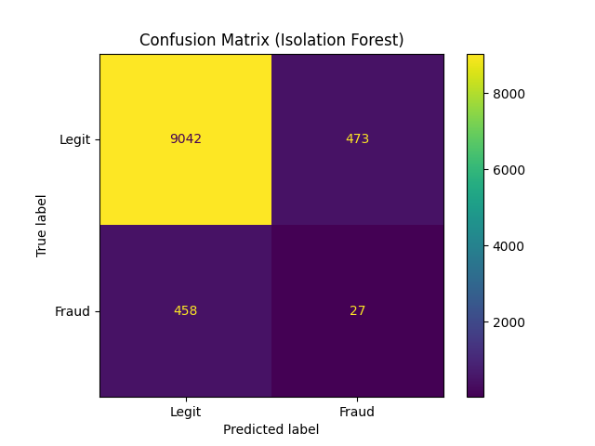
Figure 8: Isolation Forest Confusion Matrix

When looking at the score separation, it becomes clear the IF could not distinguish between the fraudulent and normal data points. It assigned all data a score within .15 of 0 meaning they are normal. The IF assigned the highest path lengths to normal transactions. This indicates the struggle in isolating fraud within the dataset. A chart visualizing the score separation is shown in Figure 9.
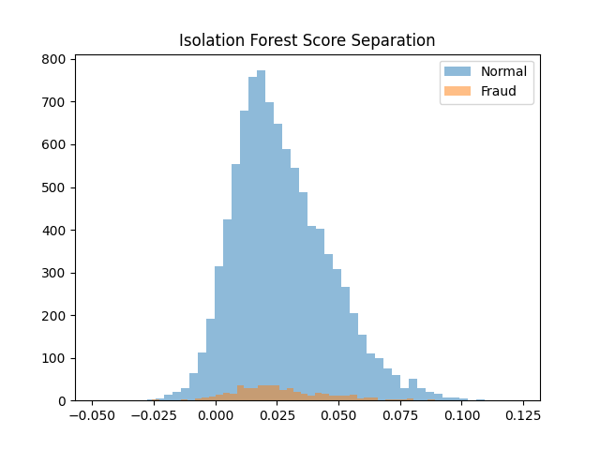
Figure 9: Random Forest Score Separation
3.4 Implementation Details
This project used the Pandas library to perform data preprocessing. The Sklearn python library performed the analysis and method implementation. The python libraries Matplotlib.pyplot and Graphviz were used to generate the charts and graphs. All analysis was performed with the assumption that the dataset did accurately label fraud and normal data points correctly. There was also the assumption that the sample dataset reflected the population dataset.

3.5 Process & Reasoning
The four methods that were used were selected because they provided insight into supervised vs unsupervised data mining methods performance. Multiple methods were selected for each class of methods to cover any weakness present in a single method.
4 Evaluation Plan
The supervised models are predicting using labeled data whereas unsupervised models are finding anomalies, not fraud so will need to split evaluation methods. Note that accuracy is not used as a metric because an imbalance in fraud count in datasets makes it unreliable.

4.1 Overall Evaluation
4.1.1 Confusion Matrix
True Positives (TP) | False Negatives (FN)
False Positives (FP) | True Negatives (TN)
Figure 10: Table displaying layout of a Confusion Matrix

4.1.2 F1 Score.
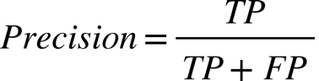
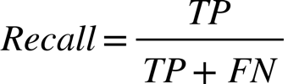
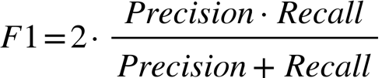
4.1.3 ROC & AUC
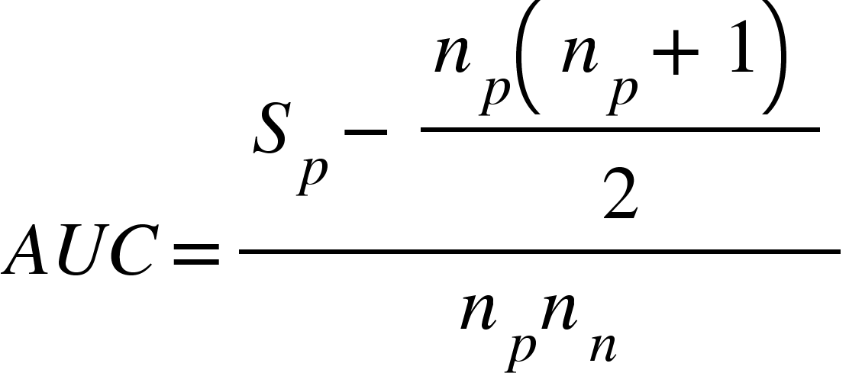
4.2 Supervised Evaluation
4.2.1 K-fold.

4.2 Unsupervised Evaluation
4.2.1 Silhouette Score.

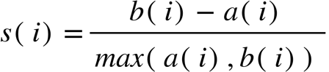

4.2.2 Anomaly Score Separation
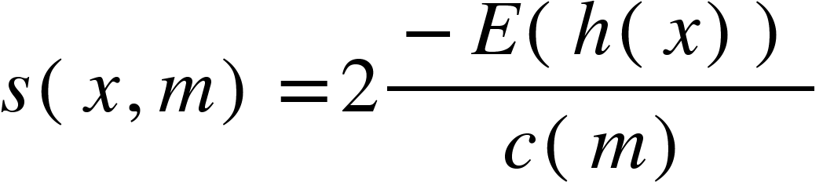
4.3 Results
The ROC curve (fig. 11) highlights the difference in performance between the 4 models tested. The Random Forest model’s score of .957 far outperforms the other models. The KMeans and Isolation Forest scores of .501 and .508 respectively are representative of a random result. Decision Forest received a .581 AUC value which is better than random, but not useful in detection.
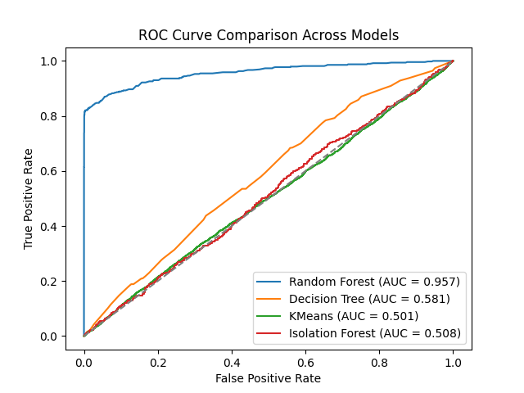
Figure 11: ROC Curve Comparison
4.4 Interpretation
The results indicate that unsupervised learning models (ULM) performed similar to random selection in detecting between fraudulent and normal financial transactions. The supervised learning models (SLM) performed better in detection. The primary difference is the ULMs used didn’t use labeled data and instead try to find anomalies using the attributes and then add labels to evaluate if the anomalies detected are fraud.
All the models did highlight the tradeoff between precision and recall that is a necessary consideration. Random Forest best highlighted this trade off, as seen in Figure 6, where it reduced the precision in order to increase the recall score. In Fraud detection, the highest recall is desired because missing fraud cases is worse than falsely flagging normal transactions.
Due to this trade off, none of these models should be used as a final verdict for if a transaction is fraud. When they reliably catch fraud, they also flag a disproportionately higher number of normal transactions.
Of the SLM’s, the Decision Tree Model only performed moderately better than random selection which does not provide practical value in detection. However, Random Forest did achieve an AUC score >.9 which indicates an excellent performance. Therefore, Random Forest could be used as a tool to detect fraudulent transactions within this dataset. Further research is required on more datasets in order to conclude if it is useful to implement into real world application cases.
5 Discussion
5.1 Progress
The dataset is relatively clean. It required the creation of a binary fraud indicator for calculation purposes. Some attributes were converted to buckets to aggregate data points into more practical indicators. All models were successfully implemented with the sklearn python library handling model creation and evaluation.
5.2 Changes
The initial plan did require modification to add in new evaluation methods that better evaluate performance for each model. ROC and AUC evaluation metrics were added to better compare the model’s performance.
5.3 Challenges
The dataset exhibits a class imbalance between fraudulent and normal transactions. While this does reflect the actual imbalance in a bank’s transactions, it has introduced challenges for the model’s performance.
When performing evaluation, there was a challenge in comparing performance between models. The original plan of F1-score and confusion matrix as the primary comparative evaluation metrics was modified as F1-score was an imperfect metric for some models and comparing confusion matrixes was not an objective method. Therefore, the AUC evaluation was used to compare performance.
6 Timeline
The project was executed in iterative one-day stages repeating for each model. The first day was spent preprocessing the dataset. For each model: built codebase, executed models, analyzed results, modified codebase, repeat. Implemented the KMeans and Decision Tree models before writing a progress check. Then added in Isolation Forest and Random Forest models. Once all models were added and evaluated, implemented the AUC calculation and graph generation.
7 Conclusion
This project applied 4 data mining methods to existing banking transaction data searching for fraudulent transactions in order to determine if any methods reliably can detect fraud. The models covered both supervised and unsupervised learning methods.
Multiple metrics evaluated each model to determine performance.
The results reflected the challenge in detecting fraud. The low frequency it occurs in a dataset means a model that predicts every transaction as normal achieves high accuracy, causing alternative metrics being needed to evaluate performance. Fraud attempts also are performed with the intention of matching normal transactions in order to not be detected.
These challenges resulted in the unsupervised methods being unreliable in detecting fraud with the worse of the 2, KMeans, performing similar to a random guess. While the supervised methods performed better, only one achieved results that indicate practical use. The Random Forest model achieved an AUC value of .957 which is indicative of a high ability to distinguish between normal and fraudulent data points.
7.1 Future Work
The research performed focused on 4 methods using a singular dataset. There was little research applied into the dataset and the attributes contained. Finding if there are attributes that are indicators of fraud would provide value in optimizing the dataset used by the models.
Furthermore, more research into supervised learning models to determine if there are others that provide practical value in fraud detection. There could be improvements made by incorporating multiple models to create a multi-layered model made of more than 1 model.
The success of the Random Forest model indicates a value in deeper research into the model for fraud detection. Further research should focus on other datasets to establish if the results are consistent across data. If it is proven to be reliable across datasets, then research should continue into real world integration of Random Forest models into existing fraud detection software.
REFERENCES
[1] Federal Trade Commision, 2025. New FTC Data Show a Big Jump in Reported Losses to Fraud to $12.5 Billion in 2024 retrieved April 3, 2026 from https://www.ftc.gov/news-events/news/press-releases/2025/03/new-ftc-data-show-big-jump-reported-losses-fraud-125-billion-2024
[2] TransUnion, 2026. Banking Fraud Detection. Retrieved April 3, 2026 from https://www.transunion.com/business-needs/fraud-prevention/banking-fraud-detection
[3] Muhammad Shahzad, 2026. Financial Transaction Fraud Dataset. Kaggle. Retrieved April 3, 2026 from https://www.kaggle.com/datasets/algozee/financial-transaction-fraud-dataset

[4] Richard J. Bolton and David J. Hand., 2002. Statistical Fraud Detection: A Review. Project Euclid. 10.1214/ss/1042727940
[5] Yufeng Kou and Chang-Tien Lu and S. Sirwongwattana and Yo-Ping Huang 2004. Survey of fraud detection techniques. IEEE International Conference on Networking, Sensing and Control. 10.1109/ICNSC.2004.1297040

