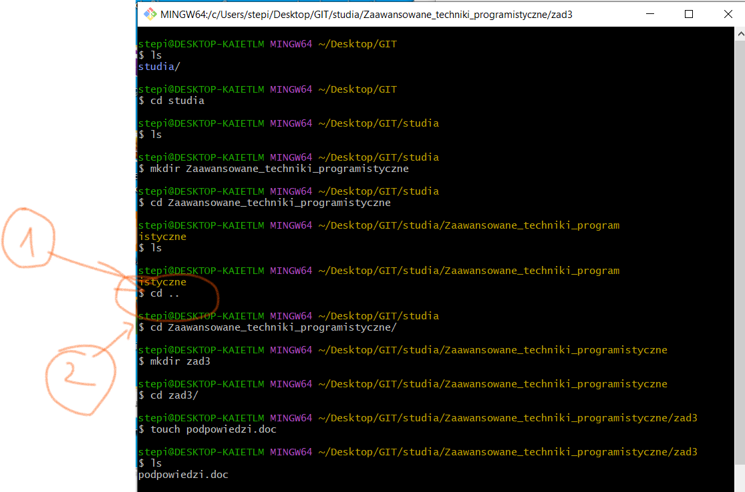

1 – came back to the previous folder

2 – start writing a first leter of the folder and then click ‘Tab’ and the next sentence would be full

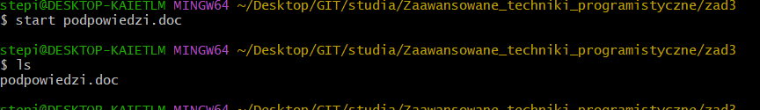

open a nex document

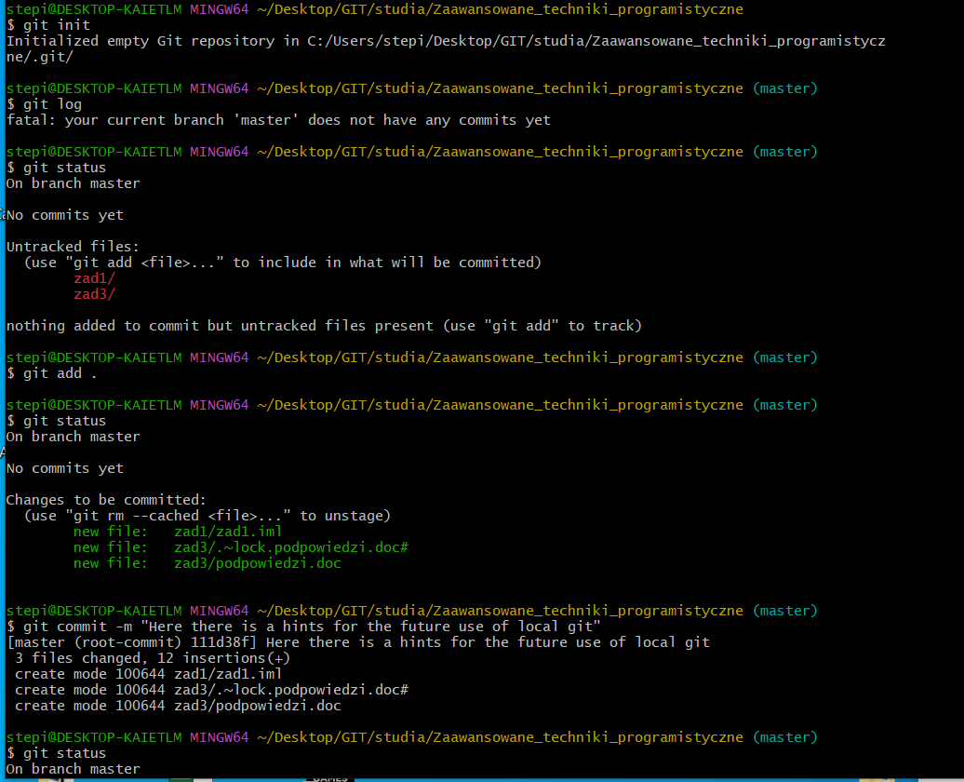

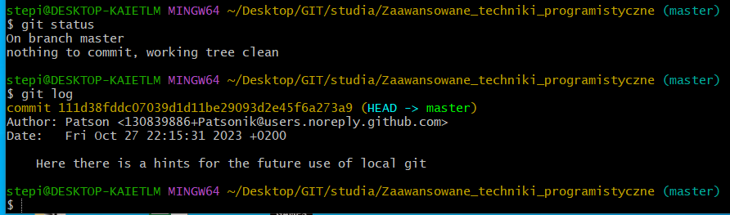

and here I click ctrl+s in the document (so I changed all the files)

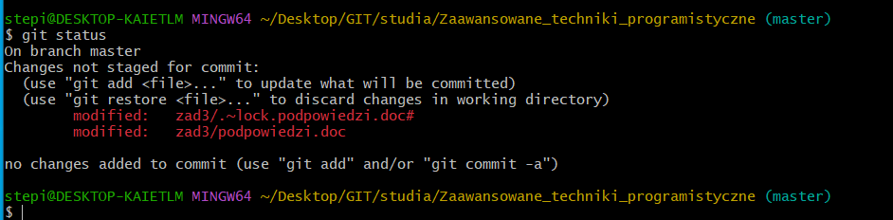

and now I see that changes are showed but without a commit
so first of all I should write “git add . “ and that would be smth like ‘I want to add this to the commit’

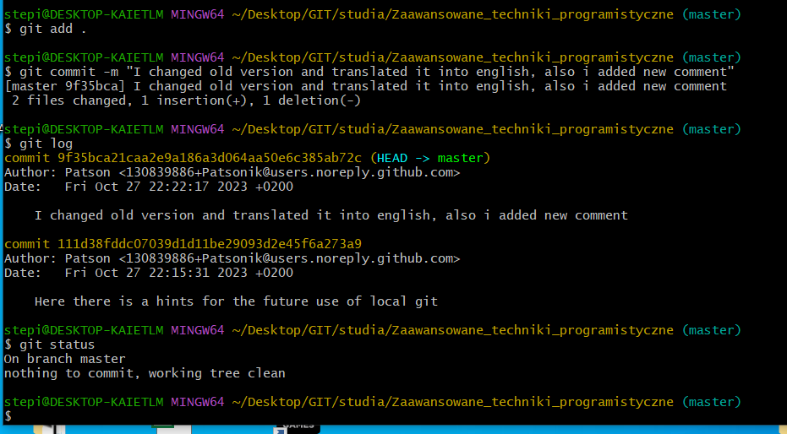

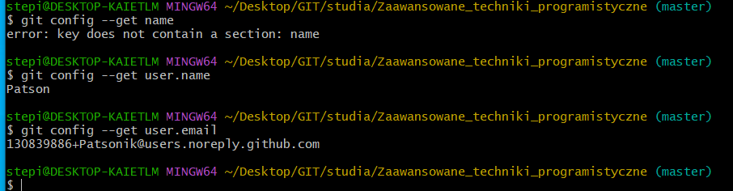

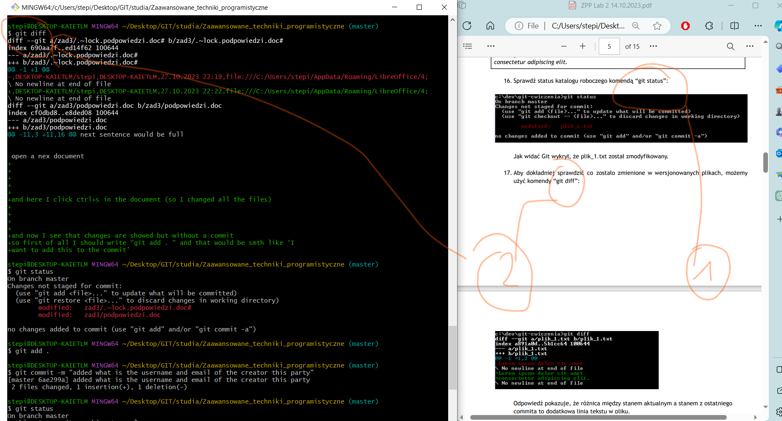

1 – I changed the file “podpowiedzi.doc” and then I use a git diff commend and see that smth is not rifgt so I added commit and vłala perfecto I badoom tss

whe everythinf is PERFECTO the git diff command is empty . Cause everything is good :)

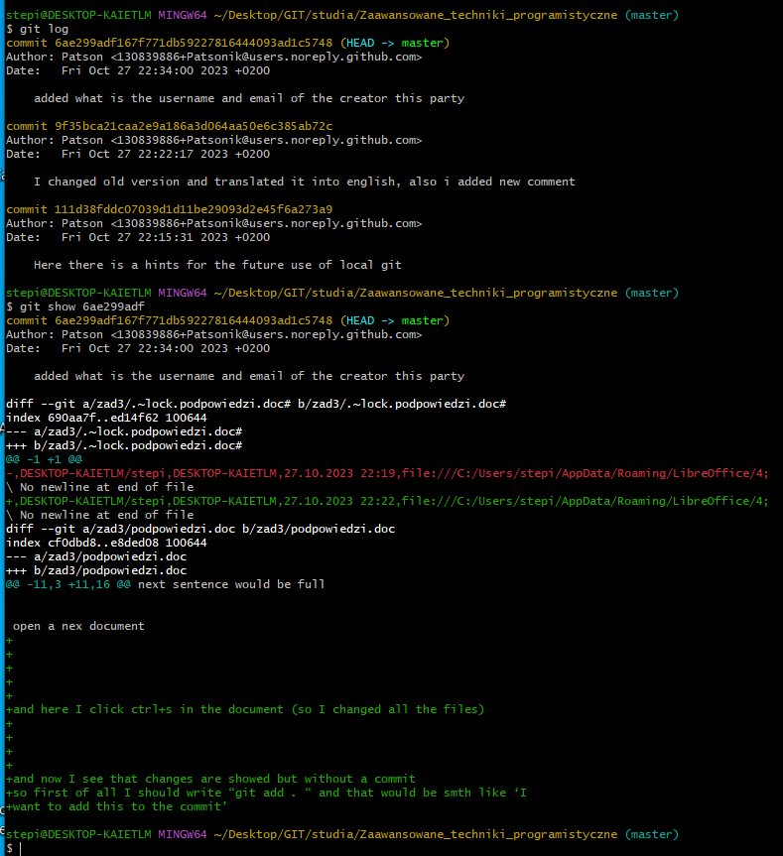

whan I wan to use “git show” first of all I should use a git log and see number of commits and then I need to write first e.g. 6 number :D

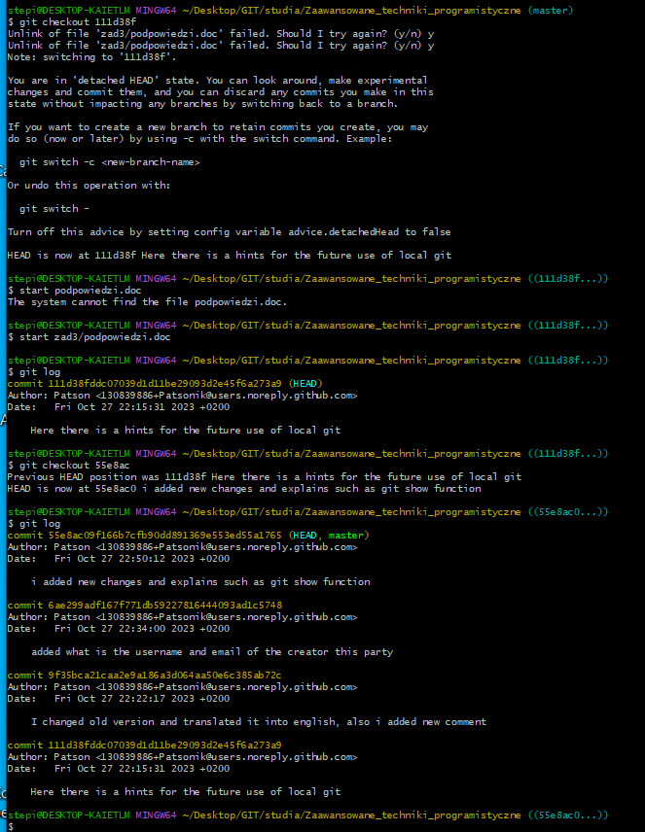

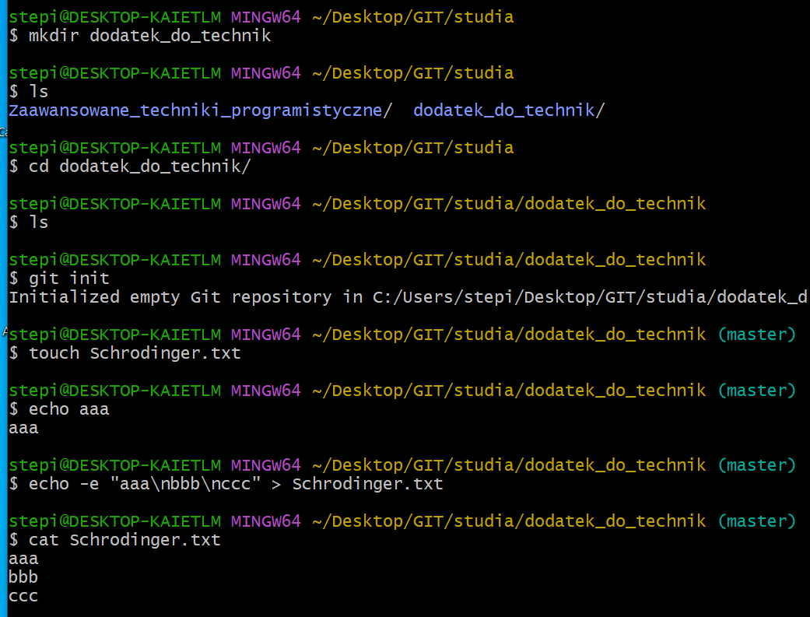

when I want added a new text and I don’t want to open a file I could make a ‘echo – e ‘ command :)

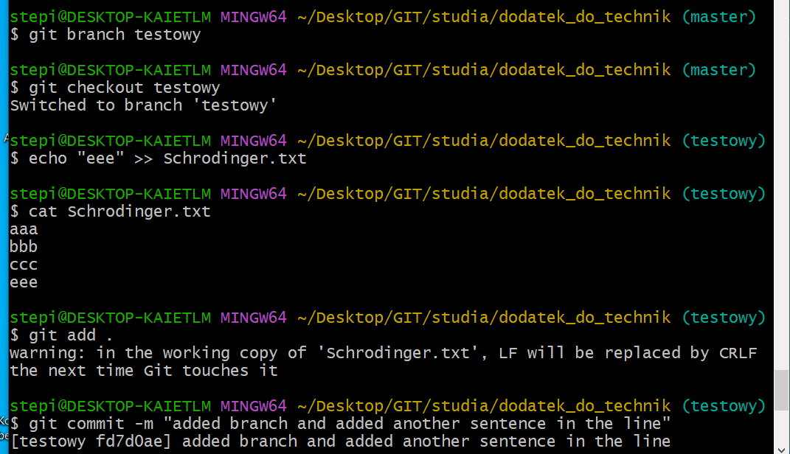

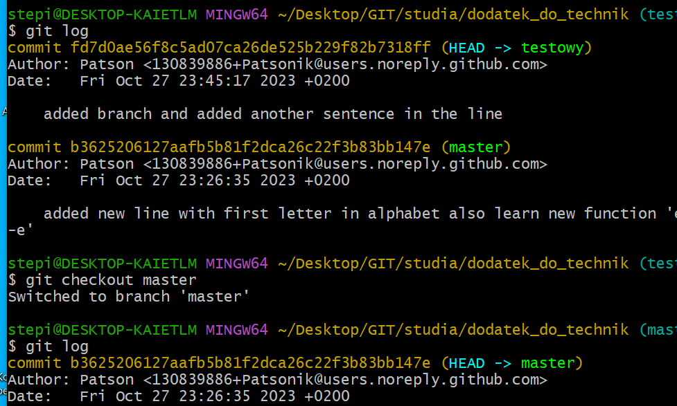

and also I changed a brench to the master by using the line “git checkout”

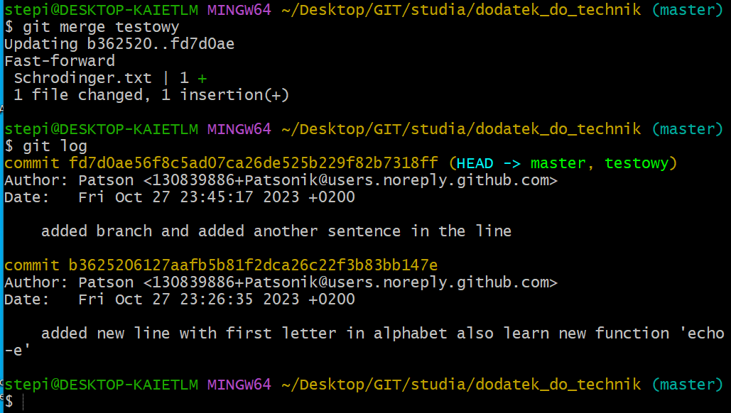

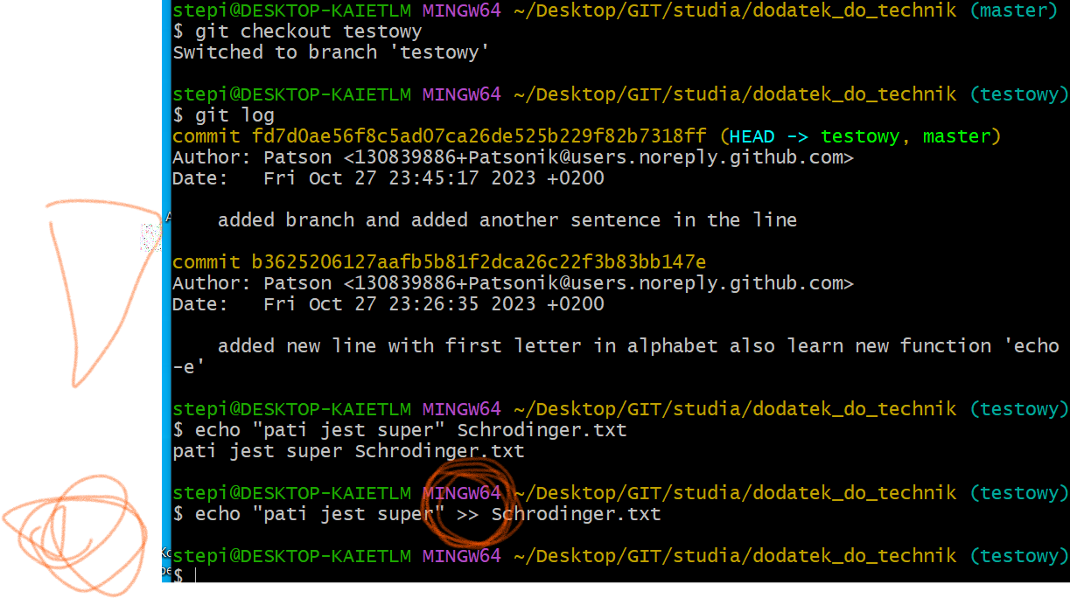

if I use only one “>” all the lines with text disapear

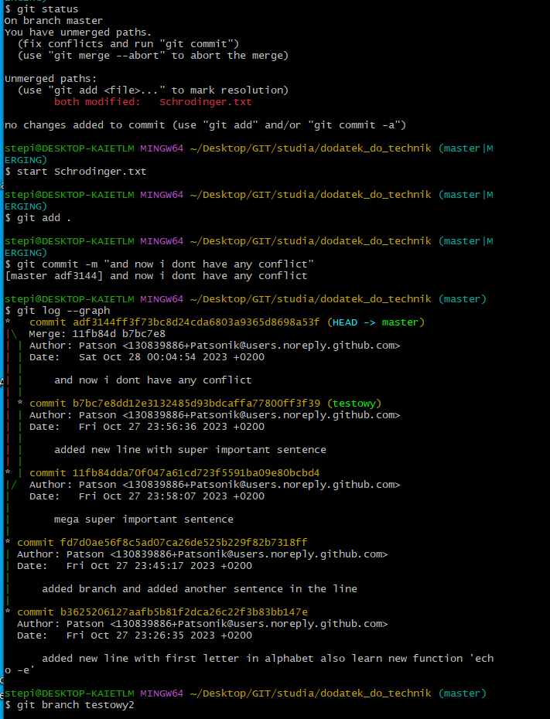

I changed file in both of the branch so I should open the txt and changed everything by myself

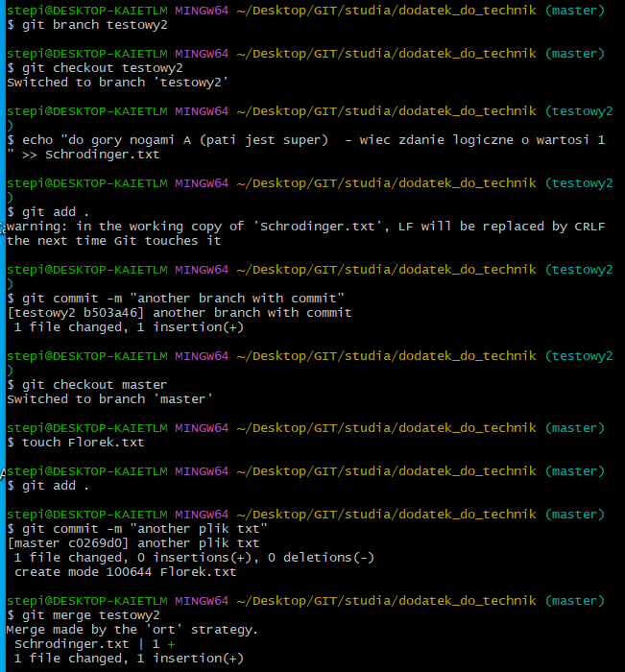

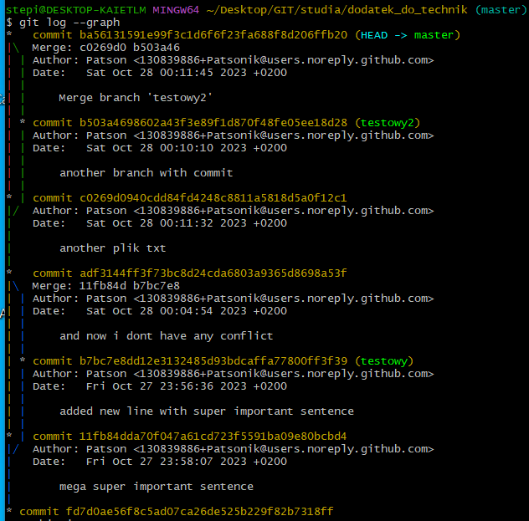

:q

is the function that I should click when I don’t kno wwhat I have to do

ctrl + c

