**Grade Calculator Test Document**

**Test 1 – Maximum Attributes:**

Description: This function tests the response of the grade calculator feature when the awareness and skill level attributes are at their highest (1.0 and 10, respectively). This represents a scenario where the character has completed lots of activities and studying and has therefore achieved maximum awareness and skill levels.

Code:

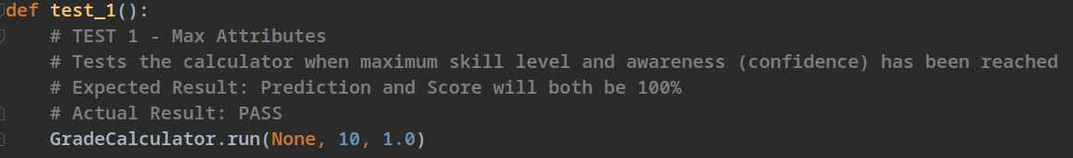

Result: **PASS**

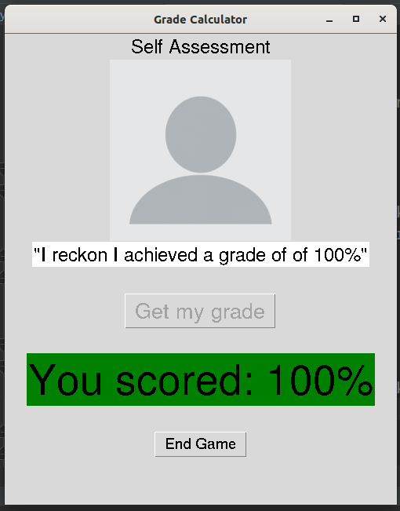

Conclusion: After running the test repeatedly, the grade calculator always produced a prediction and final score of 100%.

**Test 2 – Minimum Attributes:**

Description: This function tests the response of the grade calculator feature when the awareness and skill level attributes are at their lowest (0.5 and 1, respectively). This represents a scenario where a character has completed minimal activities and studying and therefore gets a low score and has a very inaccurate prediction.

Code:

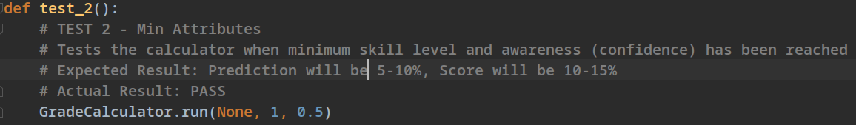

Result: **PASS**

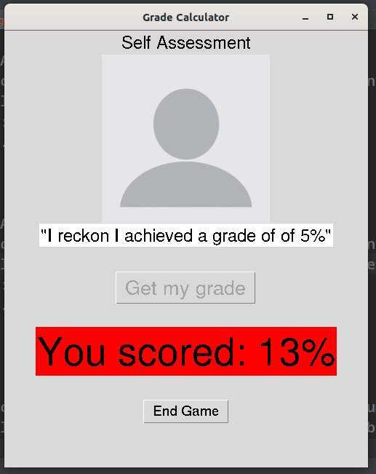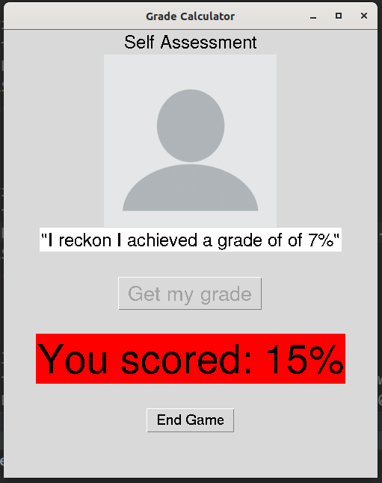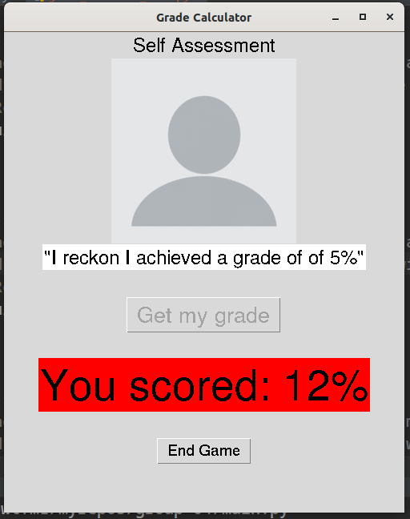

Conclusion: After running the test repeatedly, the grade calculator always produced a prediction of 5-10% and a final score of 10-15%.

**Test 3 – High Skill Level, Low Awareness**

Description: This function tests the response of the grade calculator feature when the awareness level is low and the skill level is high (0.5 and 10, respectively). This represents a scenario where the character has done lots of studying (increasing their skill level) but has not completed and received feedback for many activities (giving them low awareness), therefore resulting in them getting a high final score, but a very inaccurate prediction due to their lack of awareness.

Code:

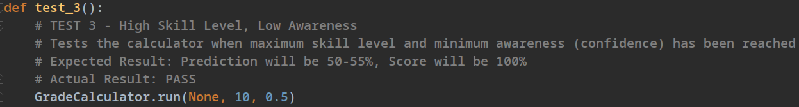

Result: **PASS**

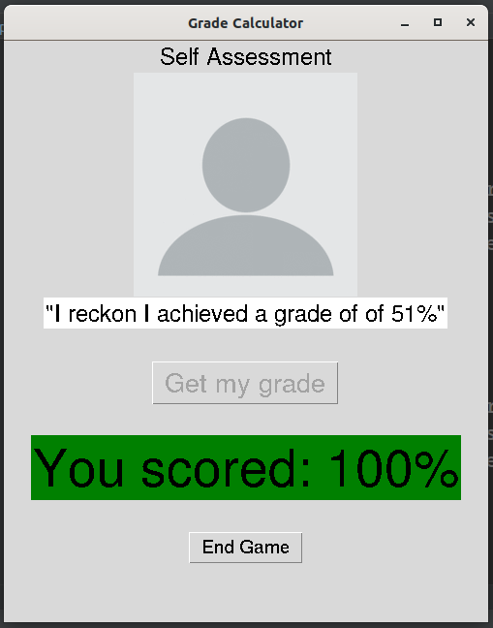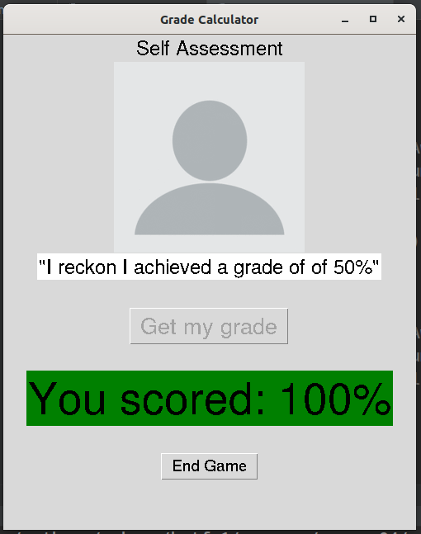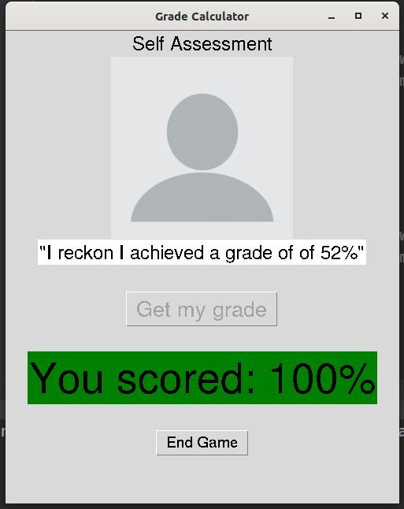

Conclusion: After running the test repeatedly, the grade calculator always produced a prediction between 50-55% and a final score of 100%.

**Test 4 – Low Skill Level, High Awareness**

Description: This function tests the response of the grade calculator feature when the awareness level is high and the skill level is low (1.0 and 1, respectively). This represents a scenario where the character has not studied enough but has attempted activities and read the feedback enough to make an accurate prediction of their grade.

Code:

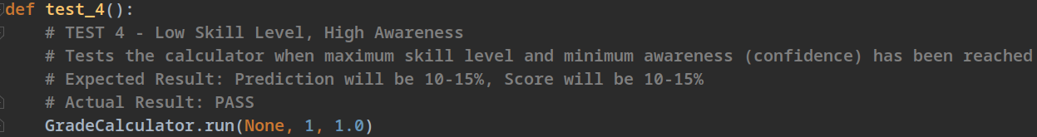

Result: **PASS**

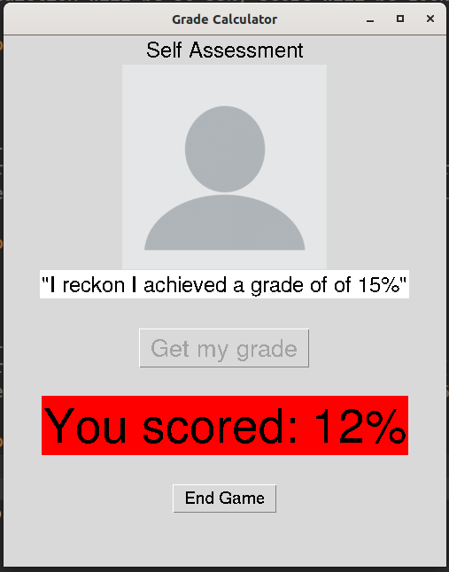

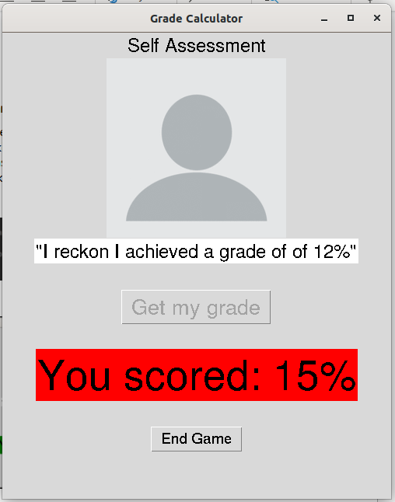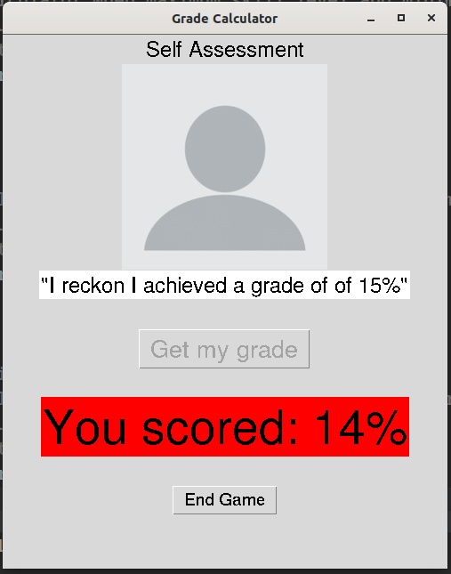

Conclusion: After running the test repeatedly, the grade calculator always produced a prediction between 10-15% and a final score of 10-15%.

**Test 5 – Medium Skill Level, Medium Awareness**

Description: This function tests the response of the grade calculator feature when the awareness and the skill level are medium (0.75 and 6, respectively). This represents a scenario where the character has done a decent amount of studying and some activities, so their prediction is quite off but their grade is alright.

Code:

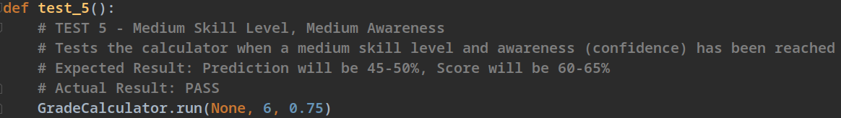

Result: **PASS**

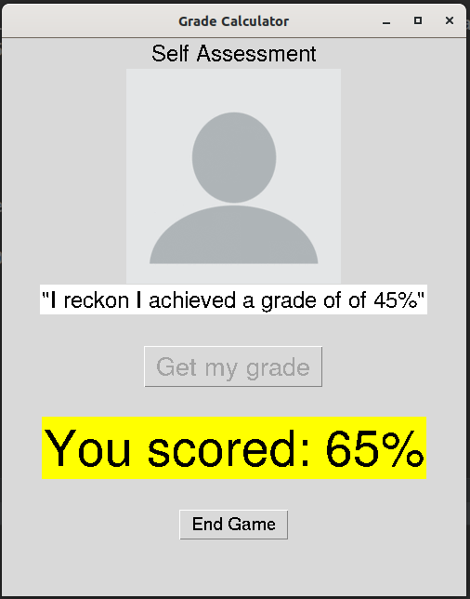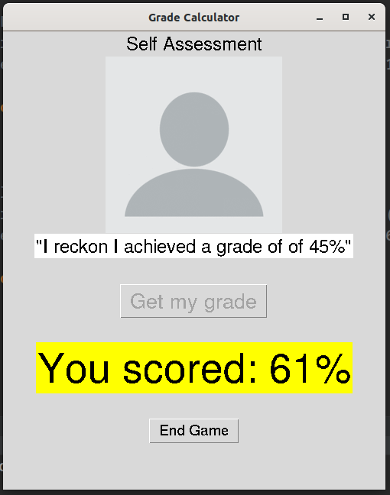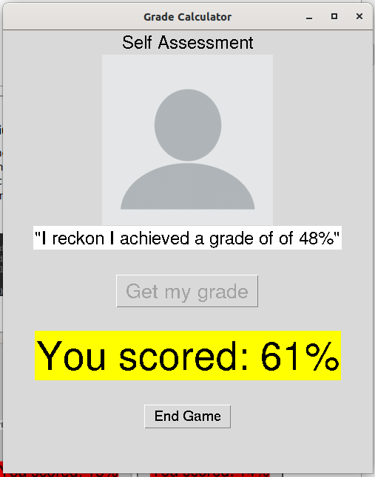

Conclusion: After running the test repeatedly, the grade calculator always produced a prediction between 45-50% and a final score of 60-65%.