Lab – Linux Servers
By: Sean Patterson
Part 1: Servers
Step 1: Access the command line
- Log on to the CyberOps Workstation VM as the analyst, using the password cyberops. The account analyst is used as the example user account throughout this lab.
- To access the command line, click the terminal icon located in the Dock, at the bottom of VM screen. The terminal emulator opens.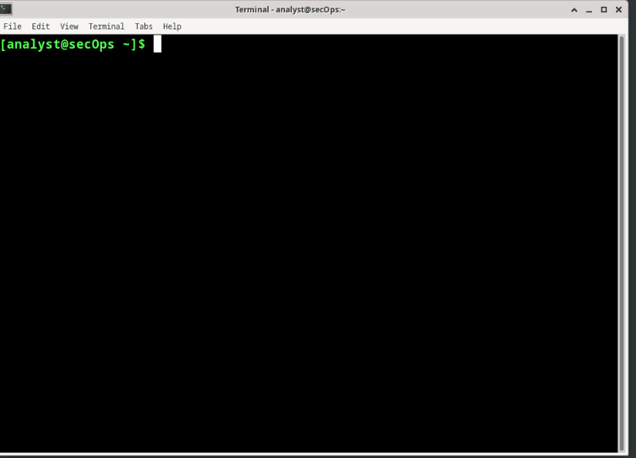
Step 2: Display the services currently running
- Use the ps command to display all the programs running in the background:
  - Sudo ps -elf
  - Why was it necessary to run ps as root (prefacing the command with sudo)?
    - You can view all the processes running on the computer
  - 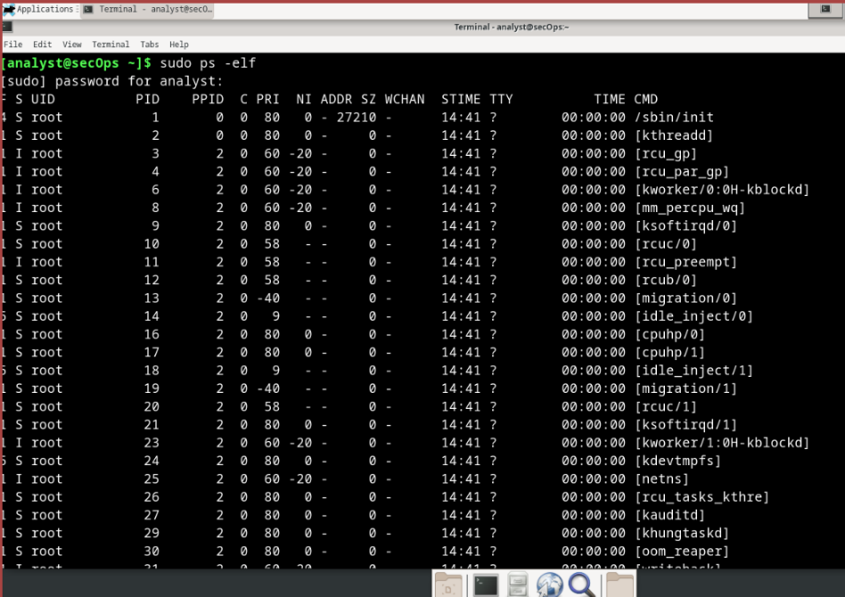
- In Linux, programs can also call other programs. The ps command can also be used to display such process hierarchy. Use –ejH options to display the currently running process tree after starting the nginx webserver with elevated privileges. Note: The process information for the nginx service is highlighted. Your PID values will be different.
  - Sudo /usr/sbin/nginx
  - Sudo ps -ejH
  - 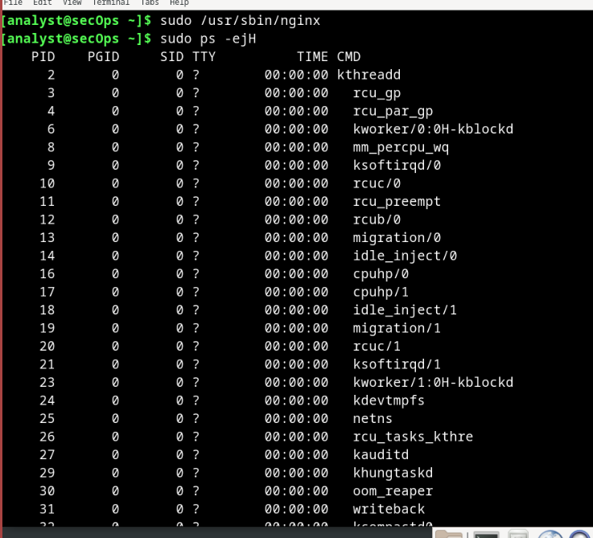
  - How is the process hierarchy represented by ps?
    - The hierarchy represented by ps is by the letter j .
- As mentioned before, servers are essentially programs, often started by the system itself at boot time. The task performed by a server is called a service. In such fashion, a web server provides web services. The netstat command is a great tool to help identify the network servers running on a computer. The power of netstat lies on its ability to display network connections. Note: Your output maybe different depending on the number of open network connections on your VM. In the terminal window, type netstat.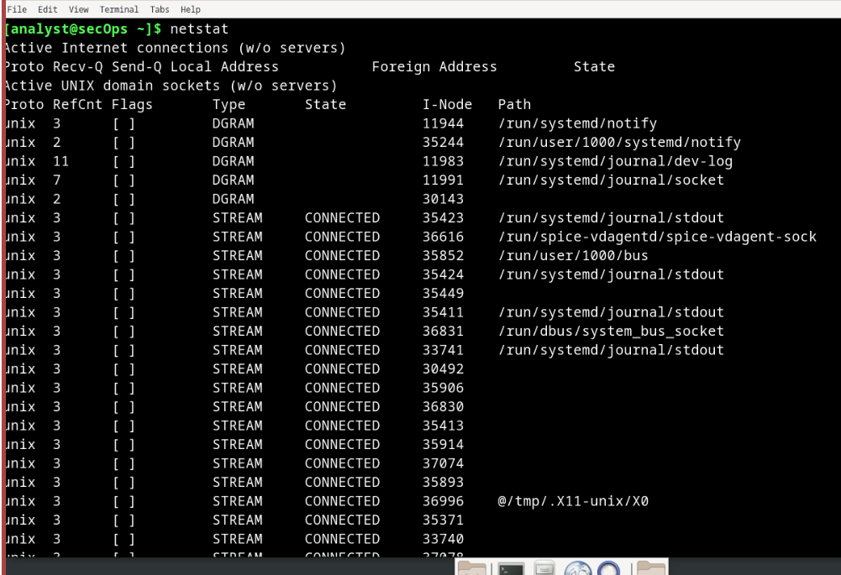
- Use netstat with the –tunap options to adjust the output of netstat. Notice that netstat allows multiple options to be grouped together under the same “-“ sign. The information for the nginx server is highlighted.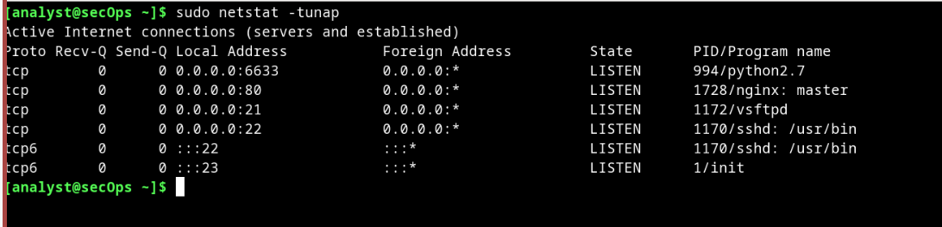
  - What is the meaning of the -t, -u, -n, -a and -p options in netstat? (use man netstat to answer)
    - -t (tcp), -u(udp), -n(numeric), -a(all), and -p(program)
  - Is the order of the options important to netstat?
    - No but -n put them in a numeric order
  - Clients will connect to a port and, using the correct protocol, request information from a server. The netstat output above displays a number of services that are currently listening on specific ports. Interesting columns are: o o o o o Question: The first column shows the Layer 4 protocol in use (UDP or TCP, in this case). The third column uses the format to display the local IP address and port on which a specific server is reachable. The IP address 0.0.0.0 signifies that the server is currently listening on all IP addresses configured in the computer. The fourth column uses the same socket format to display the address and port of the device on the remote end of the connection. 0.0.0.0:* means that no remote device is currently utilizing the connection. The fifth column displays the state of the connection. The sixth column displays the process ID (PID) of the process responsible for the connection. It also displays a short name associated to the process.
    - Based on the netstat output shown in item (d), what is the Layer 4 protocol, connection status, and PID of the process running on port 80?
      - TCP, Listening, 1728 PID
    - While port numbers are just a convention, can you guess what kind of service is running on port 80 TCP?
      - Nginx. HTTP
- Sometimes it is useful to cross the information provided by netstat with ps. Based on the output of item (d), it is known that a process with PID 395 is bound to TCP port 80. Port 395 is used in this example. Use ps and grep to list all lines of the ps output that contain PID 395. Replace 395 with the PID number for your particular running instance of nginx:
  - Sudo ps -elf | grep 395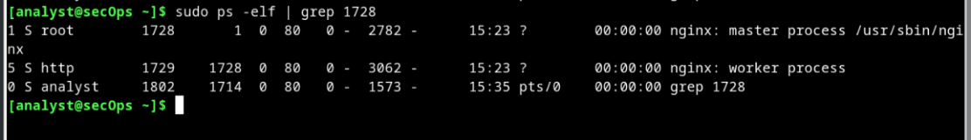
  - In the output above, the ps command is piped through the grep command to filter for only the lines containing the number 395. The result is three lines with text wrapping. The first line shows a process owned by the root user (third column), started by another process with PID 1 (fifth column), at 19:33 (twelfth column) The second line shows a process with PID 396, owned by the http user, started by process 395, at 19:33. The third line shows a process owned by the analyst user, with PID 3789, started by a process with PID 1872, as the grep 395 command. The process PID 395 is nginx. How could that be concluded from the output above?
    - You can tell because it says “nginx: master process”
  - What is nginx? What is its function? (Use google to learn about nginx)
    - Nginx is a high-performance, open-source web server that also functions as a reverse proxy, load balancer, HTTP cache, and TCP/UDP proxy server.
  - The second line shows that process 396 is owned by a user named http and has process number 395 as its parent process. What does that mean? Is this common behavior?
    - Yes, this is common behavior because the parent process should always be first followed by the child-processes.
  - Why is the last line showing grep 395?
    - The last line is showing grep 395 because that is what we (as the analyst user) is searching for based on all the find of 395
Part 2: Using Telnet to Test TCP Services
- In Part 1, nginx was found to be running and assigned to port 80 TCP. Although a quick internet search revealed that nginx is a lightweight web server, how would an analyst be sure of that? What if an attacker changed the name of a malware program to nginx, just to make it look like the popular webserver? Use telnet to connect to the local host on port 80 TCP:
  - telnet 127.0.0.1 80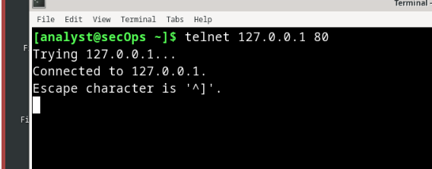
- Press a few letters on the keyboard. Any key will work. After a few keys are pressed, press ENTER. Below is the full output, including the Telnet connection establishment and the random keys pressed (fdsafsdaf, this case):
  - Thanks to the Telnet protocol, a clear text TCP connection was established, by the Telnet client, directly to the nginx server, listening on 127.0.0.1 port 80 TCP. This connection allows us to send data directly to the server. Because nginx is a web server, it does not understand the sequence of random letters sent to it and returns an error in the format of a web page. Why was the error sent as a web page?
    - It was sent as a web page because the port 80 is HTTP and that is a web service.
  - 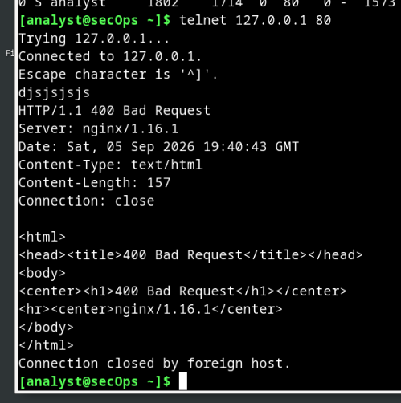
- Looking at the netstat output presented earlier, it is possible to see a process attached to port 22. Use Telnet to connect to it. Port 22 TCP is assigned to SSH service. SSH allows an administrator to connect to a remote computer securely. Below is the output:
  - telnet 127.0.0.1 22
  - Use Telnet to connect to port 68. What happens? Explain.
    - 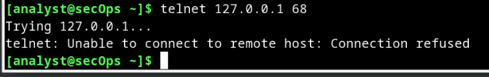
    - Port 68 is DHCP used to give out IP addresses. You can’t connect to this port.
Reflections Questions:
- What are the advantages of using netstat?
  - The advantages of using netstat is that it is versatile, cross-platform network utility. This means that you can use it on every machine and every CLI. It is used to troubleshoot, monitor, and analyze network activity.
- What are the advantages of using Telnet? Is it safe?
  - The advantages of using Telnet are for educational purposes, accessing legacy systems, and many other useful things. Although, it is not secure it is still used for some scenarios. It was replaced by SSH because SSH is more secure than Telnet.

