Lab- Create User Accounts
By: Sean Patterson
Part 1: Creating a New Local User Account
Step 1: Open the User Account Tool
- Log on to the Windows PC with an Administrator account. 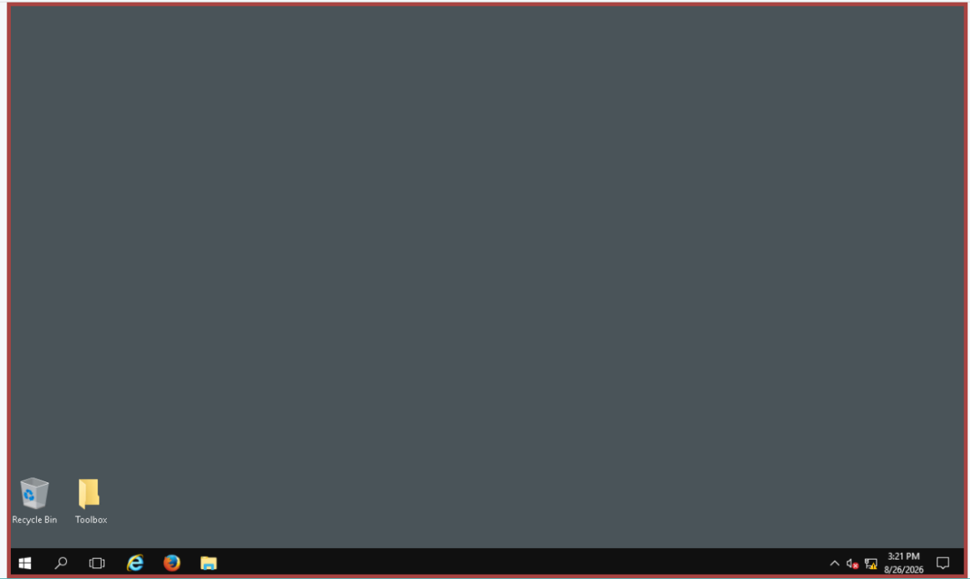
- Click Start > search Control Panel. Select User Accounts in the Small icons view. To change the view, select Small icons in the View by drop down list.
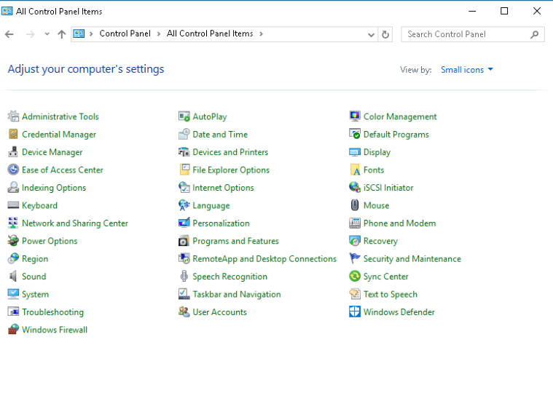
Step 2: Create a user account
- In the User Accounts window, click Manage another account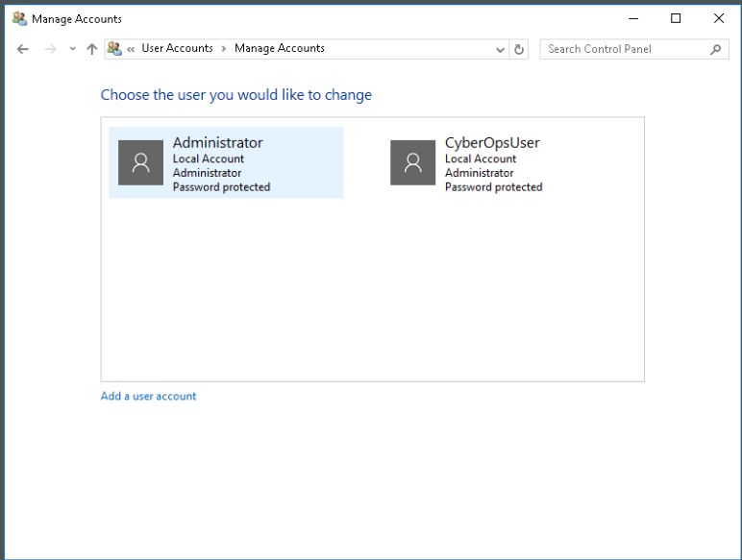
- In the Create an account for this PC window, provide the necessary information to create the new user account named User1. Click Next to create the new user account. What type of user account did you just create?
  - The type of user account I created was a local account
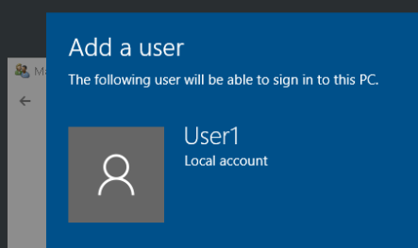

- Navigate to C:\Users folder. Right-click the User1 folder and select Properties, and then the Security tab. Which groups or users have full control of this folder?
  - The System, Administrator, and User1 have full control over this folder.
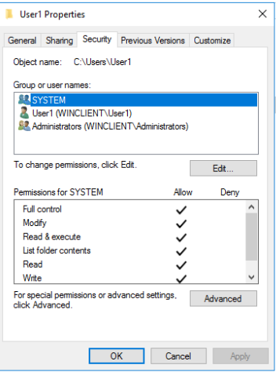
- Open the folder that belongs to CyberOpsUser. Right-click the folder and click the Properties tab. Were you able to access the folder? Explain.
  - I could not access this folder because I (as User1) do not have the permissions to access this folder.
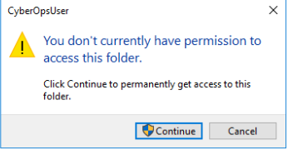
- Log out of User1 account. Log back in as CyberOpsUser.
- Navigate to C:\Users folder. Right-click the folder and select Properties. Click the Security tab. Which groups or users have full control of this folder?
  - The groups and users that have full control of this folder are SYSTEM, CyberOpsUser, and Administrators. 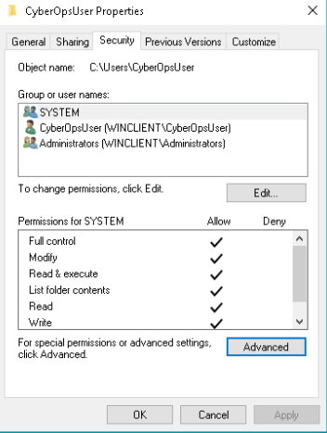
Part 2: Reviewing User Account Properties
- Click Start > Search for Control Panel > Select Administrative Tools > Select Computer Management.
- Select Local Users and Groups. Click the Users folder.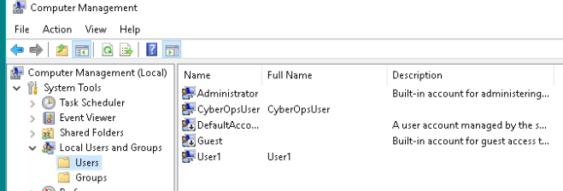
- Right-click User1 and select Properties.
- Click the Member Of tab. Which group is User1 a member of?
  - User1 is a member of the Users group.
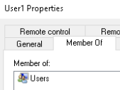
- Right-click the account CyberOpsUser and select Properties. Which group is this user a member of?
  - CyberOpsUser is a member of the Users and Administrators group.
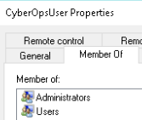

Part 3: Modifying Local User Accounts
Step 1: Change the account type
- Navigate to the Control Panel and select User Accounts. Click Manage another account. Select User1.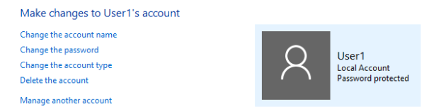
- In the Change an Account window, click the User1 account. Click Change the account type.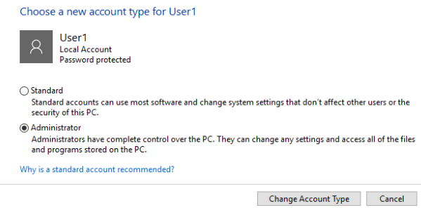
- Select the Administrator radio button. Click Change Account Type.
- Now the account User1 has administrator rights.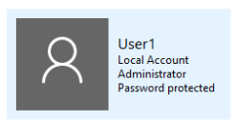
- Navigate to Control Panel > Administrative Tools > Computer Management. Click Local Users and Groups > Users.
- Right-click User1 and select Properties. Click Member Of tab. Which groups does User1 belong to?
  - User1 now belongs to both Users and Administrators groups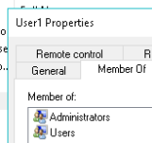
Step 2: Delete the account.
- To delete the account, right-click User1 and select Delete.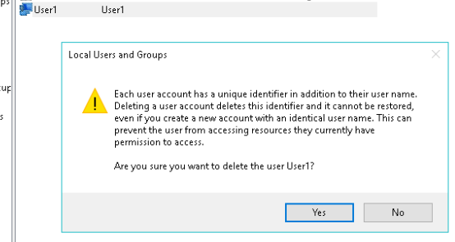
- Click Ok to confirm the deletion. What is another way to delete a user account?
  - Another way to delete a user account is in the Control Panel > User Accounts > Manage another account > User1 > Delete the account.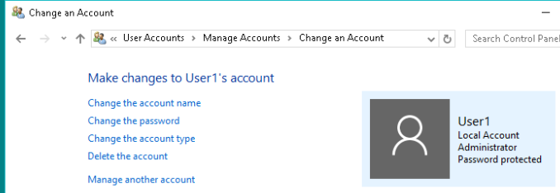

Reflection Questions:
- Why is it important to protect all accounts with strong passwords?
  - Strong passwords are the first line of defense against unauthorized access to your system. With strong passwords, attackers are less likely to break into your system with ease vs weak passwords. Protecting your accounts with strong passwords also helps protect your sensitive data from attackers.
- Why would you create a user with Standard privileges?
  - The reason to have a user with standard privileges is because of the Principle of Least Privilege (PoLP). This means that it limits the user’s permissions to only what is strictly necessary. If you gave a user administrative privileges, they could do anything that they wanted to.

