Lab – Windows Task Manager
By: Sean Patterson
Part 1: Working in the Processes tab
- Open a command prompt and a web browser.
- Right-click the Task bar to open Task Manager. Another way to open the Task Manager is to press Ctrl+Alt+Delete to access the Windows Security screen and select Task Manager.
- Click More Details to see all the processes that are listed in the Process tab.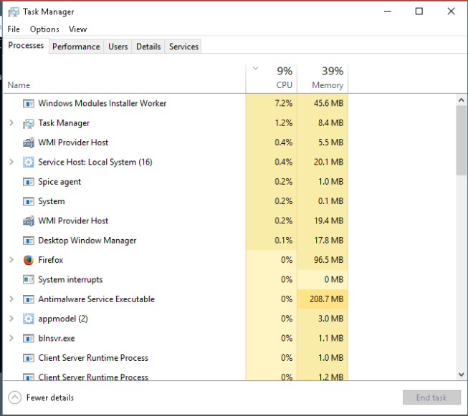
- Expand the Windows Command Processor heading. What is listed under this heading?
  - 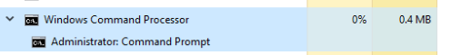
- There are three categories of processes listed in the Processes tab: Apps, Background processes, and Windows processes.
  - The apps are the applications that you have opened, such as Microsoft Edge, Task Manager, and Windows Command Processor, as shown in the figure above. Other applications that are opened by the users, such as web browsers and email clients, will also be listed here.
  - The Background processes are executed in the background by applications that are currently open.
  - The Windows processes are not shown in the figure. Scroll down to view them on your Windows PC. Windows processes are Microsoft Windows services that run in the background
  - Some of the background processes or Windows processes may be associated with foreground processes. For example, if you open command prompt window, the Console Window Host process will be started in the Windows process section, as shown below.
- Right-click Console Window Host and select Properties. What is the location of this filename and location of this process?
  - 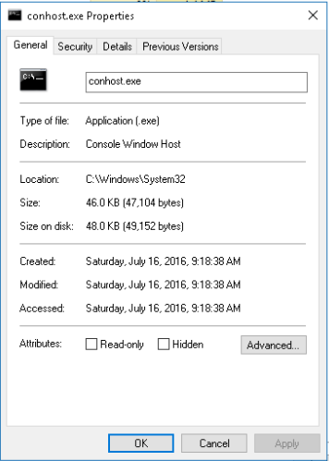
- Close the command prompt window. What happens to Windows Command Processor and Console Window Host when the command prompt window is closed?
  - When the command prompt window is closed the Windows Command Processor and Console Window Host are killed because the application is not in use.
- Click the Memory heading. Click the Memory heading a second time. What effect does this have on the columns?
  - The effect from clicking the Memory heading a second time will filter what process is currently using the most memory.
- Right-click on the Memory heading, and then select Resource values > Memory > Percents. What affect does this have on the Memory column? How could this be useful?
  - By changing the Memory column to percents, showing how much memory is being used at the time in percents. This could be useful for easier use of looking at what process is using the most memory instead of looking at MB.
- In the Task Manager, click the Name heading.
- Double-click the Microsoft Edge. What happens?
  - When you double-click on Microsoft Edge it expands the process to show Start Page. If you click Microsoft Edge again, it will open the web browser.
- Return to the Task Manager and right-click Microsoft Edge. Select End Task. What happens to the web browser windows?
  - When you right-click on Microsoft Edge and select End Task, you will kill Microsoft Edge process.
Part 2: Working in the Services tab
- In the Task Manager window, click the Services tab. Use the scroll bar on the right side of the Services window to view all the services listed. What statuses are listed?
  - In the Servies tab, it shows Running and Stopped statuses. Running services are actively operating in the background. Stopped services are currently inactive and not consuming CPU or memory resources.
Part 3: Working in the Performance tab
- In the Task Manager window, click the Performance tab. How many threads are running? How many processes are running?
  - There are 588 threads that are currently running. There are also 46 processes currently running. 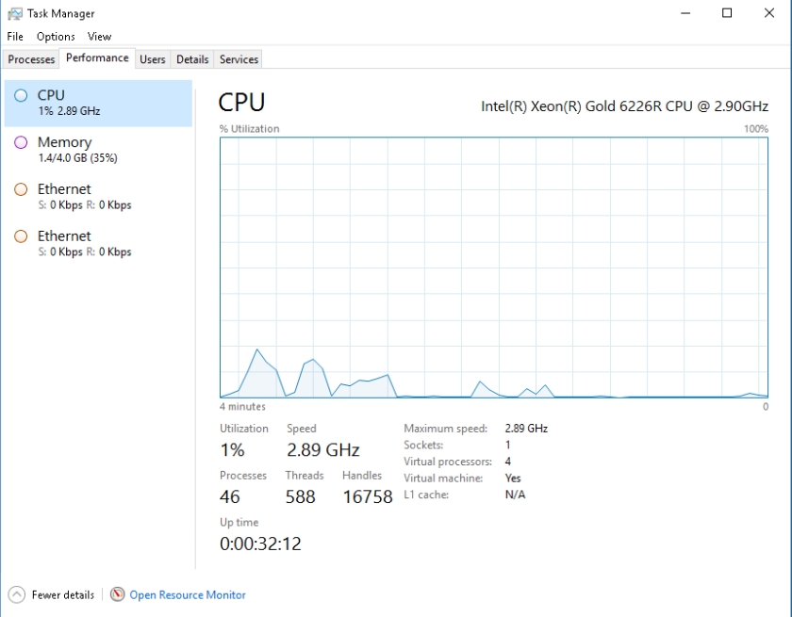
- Click the Memory in the left panel of the Performance tab. What is the total physical memory (MB)? What is the available physical memory (MB)? How much physical memory (MB) is being used by the computer?
  - The total physical memory is 4 GB. The available physical memory is 2.6GB. There is currently 1.3 GB of physical memory being used by the computer. 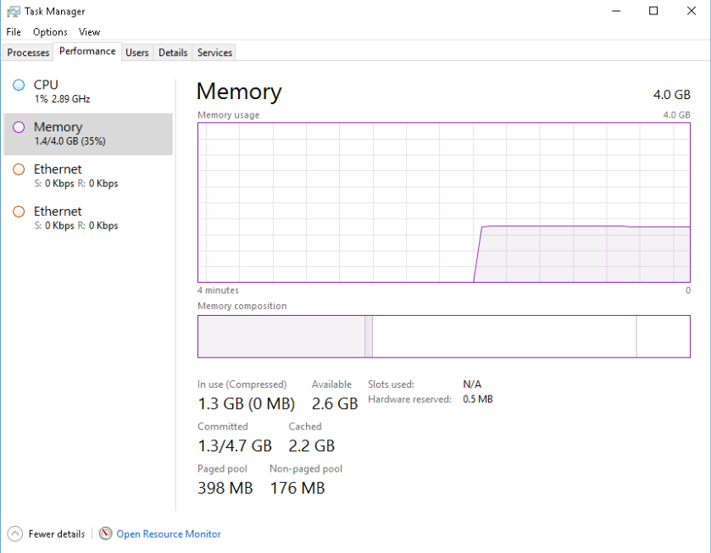
- Click the Ethernet Chart in the left panel of the Performance tab. What is the link speed? What is the IPv4 address of the PC?
  - The link speed is 100 kbps. The IPv4 address of this PC is 192.168.0.12.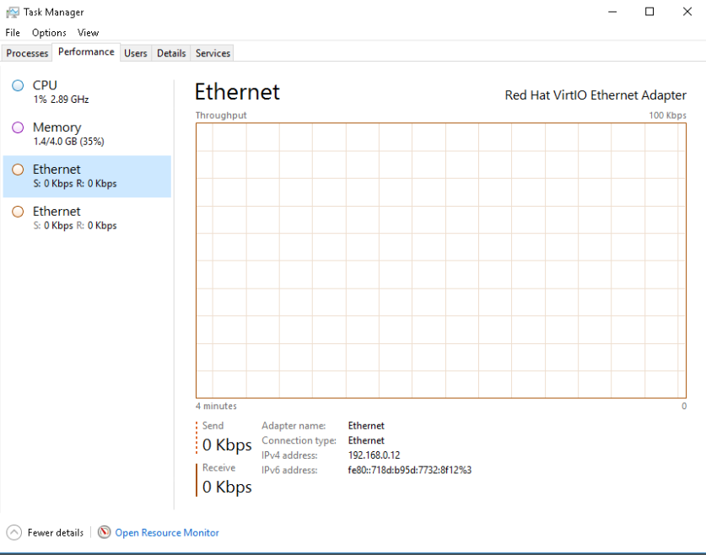
- Click Open Resource Monitor to open the Resource Monitor utility from the Performance tab in Task Manager. 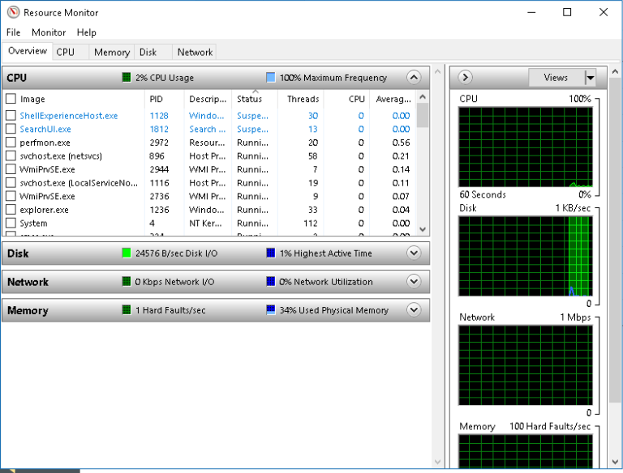

Reflections Questions:
- Why is it important for an administrator to understand how to work with the Task Manager?
  - It is important for an administrator to understand how to work within the Task Manager because it can help with:
    - Troubleshooting Performance Issues: Administrators can identify resource logs by viewing real-time CPU, memory, disk, and network usage to resolve system slowdowns
    - Process Management: It allows administrators to safely force-close frozen, unresponsive, or malfunctioning applications that are impacting user productivity.
    - Security Monitoring: Administrators can spot suspicious background processes or unrecognized programs that might indicate malware or unauthorized activity.
    - Service Control: It provides a direct way to view, start, stop, or restart background services that system applications rely on.
    - Startup Optimization: Administrators can manage startup programs to improve boot times and reduce unnecessary background resource consumption.

